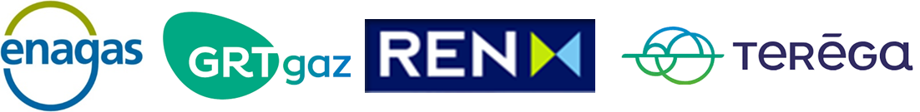

**South Gas Regional Initiative**

**Work Plan**

**1st Target: Use of interconnections**

**Period of analysis**

**[October 2016 to September 2019]**

August 2020

**INDEX**

Background 4

Executive summary 5

1 Current situation of gas interconnections in the Region 7

1.1 Capacities 7

1.2 Capacity calculation methodology 11

1.3 Flows 13

1.4 Available capacity to be auctioned via PRISMA 19

2 Assessment of capacity bookings 24

2.1 Firm booked capacities (bundled/unbundled) 24

2.2 Allocated firm capacity in different time horizons (auctions) 35

2.3 Interruptible capacity 46

2.4 Secondary capacity trade 50

3 Assessment of the use of the interconnections for the period October 2016 – September 2019 52

3.1 Relationship between technical capacity, capacity bookings, use of the booked capacity and flows 52

4 Assessment of the gas flows and the congestion status 64

4.1 Analysis of the VIP’s congestion status 64

4.2 Use of anti-hoarding mechanisms in the region 66

5 Gas prices in the South Region 69

5.1 Gas prices overview 69

5.2 Period 1: January - April 2018 – Low bookings despite the attractive price spread –“Beast from the East” 71

5.3 Period 2: May - October 2018 – Flows from Spain to France 74

5.4 Period 3: November - March 2019 – High increase in daily and within-day bookings due to the price spread 77

5.5 Period 4: April – May 2019 Low use of the LT contracts but daily/within-day bookings due to the price spread 80

5.6 Period 5: June – September 2019 - High daily and within-day bookings despite the LNG oversupply in Spain 82

6 Conclusions 85

6.1 VIP Pirineos 85

6.2 VIP Ibérico 86

6.3 North-South link 86

7 Annex: Nomination/renominations procedures 87

# Background

The South Gas Regional Initiative (`SGRI`) has developed Work Plans since 2011 in order to facilitate the compliance with the provisions of the EU 3rd Energy Package and to promote the early implementation of Network Codes.

In 2011, TSOs of the SGRI committed to develop an early implementation of the [Commission Regulation 984/2013 of 14 October 2013 establishing a Network Code on Capacity Allocation Mechanisms in Gas Transmission Systems and supplementing Regulation (EC) 715/2009 of the European Parliament and of the Council](http://eur-lex.europa.eu/LexUriServ/LexUriServ.do?uri=OJ:L:2013:273:0005:0017:en:PDF) (`CAM NC`)[1] on conditions for access to the natural gas transmission networks. The first CAM NC auctions were carried out in March 2014 for capacities to be used in October 2014. The full implementation of the CAM NC was successfully reached on November 2015.

In 2017, TSOs provided a complete document monitoring the implementation of the Network Codes, in particular the CAM NC and the Congestion Management Procedures Guidelines (CMP Guidelines)[2]. In particular, the document assessed the use of interconnections in the region starting from the date of implementation of the CAM NC up to 30 September 2016.

Due to the success of the monitoring report done by the TSOs, again in 2019 NRAs asked the TSOs to address the current situation of gas interconnection in the region, its usage, the assessment of the capacity allocated, gas flows and the congestion status.

# Executive summary

|  |  |
| --- | --- |
| **Name** | Use of Infrastructures in the Region. South Gas Regional Initiative Work Plan 2019/20 |
| **Date** | August 2020 |
| **Background** | During the early 2019, NRAs and TSOs from the South Region developed the South Gas Regional InitiativeWork Plan 2019/20 that intends to explore 5 different targets.  The first of those targets is entitled “Use of infrastructures in the Region”, focusing on the use of concerned IPs for the specific window: October 2016 to September 2019.  The report developed by the involved TSOs (Teréga, Enagas, REN and GRTgaz) includes an exhaustive range of technical and commercial pieces of information from: Liaison Nord Sud, VIP Pirineos and VIP Ibérico, such as technical capacities, booked capacities, nomination / renomination levels, physical flows, secondary trades, CMP application and assessment. |
| **Conclusions** | **VIP Pirineos**  New market conditions changed the booking and usage behaviour.  The creation of the Trading Region France induced, since 01/11/2018, a single gas price in France. The price spread takes now place at the VIP Pirineos instead of occurring at the north south link which disappeared;  The PEG price decreased below 8 €/MWh with a decreasing trend under the effect of:  Mainly: the abundance of LNG delivered to the European markets at low price;  At a lower scale: the French storage regulation increased the number of market players on the PEG, which helped in increasing the HUB liquidity;  Such price signals have influence on gas routes as observed on analysis shown in this report. Transit quantities can be boosted or reversed, punctually or over long period;  **VIP Ibérico**  Technical capacities kept constant at both directions of the interconnection for the whole period under analysis.  The abundance of LNG delivered to Europe also took effect in the behaviour of usage of the interconnection between Portugal and Spain:   * The utilization in the direction Spain to Portugal prevailed over Portugal to Spain direction until December 2018. A seasonal booking and use during the summer months in Spain to Portugal direction was observed, although less evident during the studied period in respect to the previous exercises. In this direction, booked capacity was practically fully used, and every type of product utilized, until January 2019, when gas started to flow from Portugal to Spain and maintained this direction until June 2019; * In the direction Portugal to Spain, a changing behaviour could be observed during 2019, where bookings reached levels close to the 63% of the daily technical capacity.   **North-South link**  The North-South link was physically congested. Merger of zones as from 1st November 2018 has partially solved the physical congestion issue, thus allowing the removal of the North-South link. Market coupling offer was increased on a daily basis according to available daily capacities in order to anticipate the removal of this link. Since the North-South link does not exist anymore, no further observations need to be made. |

# Current situation of gas interconnections in the Region

## Capacities

### Cross-border interconnections points within the South Region

In the South Region there are several relevant interconnection points, both at country level and balancing zone level.

In October 2014, within the scope of the South Gas Regional Initiative, under the early CAM NC implementation, two ‘virtual interconnection points’ (VIP) were created in order to allocate capacity on an aggregated basis. These VIPs are:

* a virtual interconnection point between Portugal and Spain called ”VIP Ibérico”, gathering the two physical interconnection points “Valença do Minho (PT) / Tuy (ES)” and “Badajoz (ES) / Campo Maior (PT)” (In 2012, a pilot experience of commercial aggregation of capacity was developed between Spain and Portugal).
* a virtual interconnection point between Spain and France called “VIP Pirineos”, gathering the two physical interconnection points “Larrau” and “Biriatou (FR) / Irun (ES)”.

Before November 2018, another important interconnection in the South Region was the link between the two French balancing zones PEG Nord (Point d’Echange Gaz Nord) and TRS (Trading Region South).

Since November 1, 2018, the North-South link in France has disappeared and a single market area called Trading Region France (TRF) has been created.

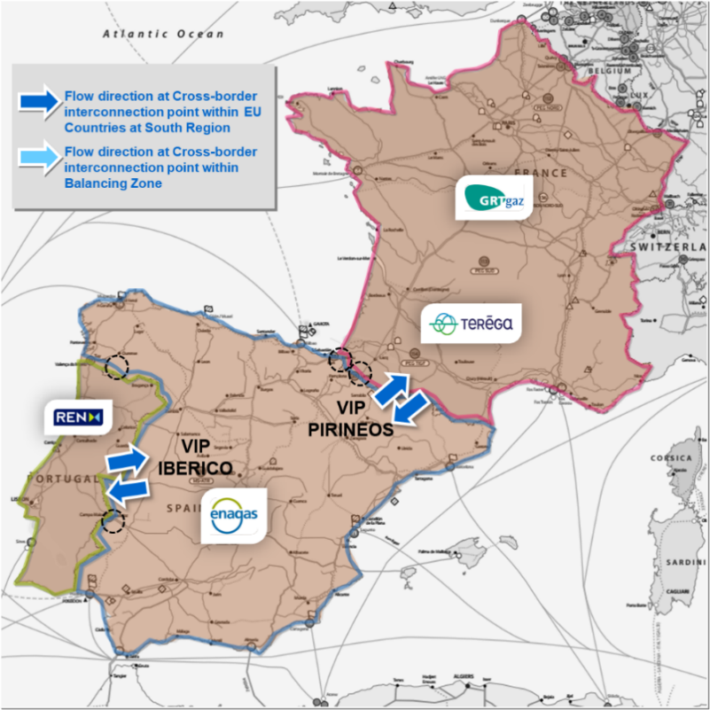

Figure 1: VIPs in the South Region

### Technical Capacities at Cross-border interconnections points within the South Region

#### VIP Pirineos

The common technical capacity (after the lesser rule application) at VIP Pirineos amounts to 165(W)/175(S) GWh/d from France to Spain direction, and to 225 GWh/d from Spain to France direction.

* + France to Spain flow direction

|  |  |
| --- | --- |
|  | **Firm Technical Capacity (GWh/d)** |
| Spanish side | 225 |
| French side | 165 (W) / 175 (S) |
| **Common Technical Firm Capacity (Lesser Rule)** | **165 (W) / 175 (S)** |
| (W) Winter: from November to March // (S) Summer: from April to October | |

Since December 2015 Teréga also offers 60 GWh/d of interruptible capacity unbundled from France to Spain at VIP Pirineos through day-ahead auctions, only when 98% of firm capacity is sold. These 60 GWh/d are offered on Spanish side as firm unbundled capacity from yearly to subsequent shorter horizons auctions until this capacity is sold out.

* + Spain to France flow direction

|  |  |
| --- | --- |
|  | **Firm Technical Capacity (GWh/d)** |
| Spanish side | 225 |
| French side | 225 |
| **Common Technical Firm Capacity** | **225** |
| All year through | |

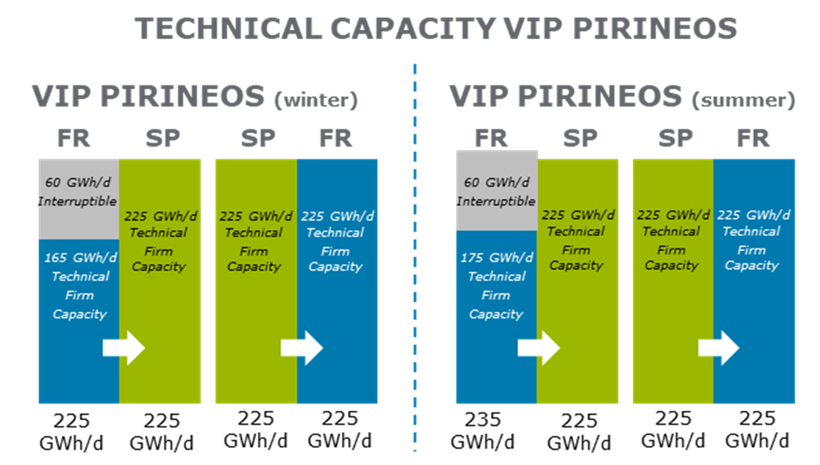Figure 2: Technical capacity at VIP Pirineos

#### VIP Ibérico

During the whole period under review, the technical capacity at VIP Ibérico was 80 GWh/d from Portugal to Spain flow direction and 144 GWh/d from Spain to Portugal flow direction. These capacities were confirmed by TSOs until September 30th, 2024.

* + Portugal to Spain flow direction

|  |  |
| --- | --- |
|  | **Technical Firm Capacity (GWh/d)** |
| Spanish side | 80 |
| Portuguese side | 80 |
| **Common Technical Firm Capacity** | **80** |
| All year through | |

* + Spain to Portugal flow direction

|  |  |
| --- | --- |
|  | **Technical Firm Capacity (GWh/d)** |
| Spanish side | 144 |
| Portuguese side | 144 |
| **Common Technical Firm Capacity** | **144** |
| All year through | |

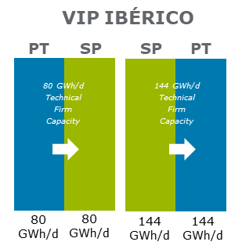

**Figure 3: Technical capacity at VIP Ibérico**

#### North – South Link

From North to South, the liaison Nord-Sud had a firm capacity of 270 GWh/day and an additional interruptible capacity of 180 GWh/d.

From South to North, the liaison Nord-Sud had a firm capacity of 230 GWh/day and an additional interruptible capacity of 350 GWh/d.

This point disappeared on the 1st of November 2018.

## Capacity calculation methodology

### VIP Pirineos and VIP Ibérico

In accordance to article 6 of CAM NC, Enagás and Teréga on the one hand and Enagás and REN on the other hand optimize their level of technical capacity to maximize their offer of bundled capacity at the VIP Pirineos and at VIP Ibérico, respectively.

A common methodology was established by TSOs and validated by the South Region`s NRAs in the framework of the South Gas Regional Initiative, giving details of their calculations and of their maximization process in line with the regulation and the capacities agreed by the TSOs at VIPs.

#### Capacity calculation methodology at VIP Pirineos

Currently, Teréga and Enagás calculate, agree, publish and offer capacity at the VIP Pirineos. This capacity calculation is based on an analysis of the technical capacity at both sides of the interconnection. Revision is carried out whenever required, in case of critical demand changes, both at global and local levels, or in case of commissioning of new infrastructures that might have an impact on cross-border capacities.

This joint method takes into consideration a dynamic approach, re-calculating the technical capacity whenever needed, such as in case of critical demand changes, both at wide level and at local level, or in case of commissioning of new infrastructures that might have an impact in cross-border capacities.

Further steps on the dynamic approach of the technical capacity re-calculation are being explored by TSOs in line with NRAs vision about this topic.

Details of the technical capacity calculation and optimization are available at Teréga[3] and Enagás GTS[4] websites.

#### Capacity calculation methodology at VIP Ibérico

Currently, REN and Enagás calculate, agree, publish and offer capacity at VIP Ibérico. This capacity calculation is based, in a first step, on a deep analysis of the technical capacity of IP Badajoz/Campo Maior and IP Tuy/Valença do Minho on both sides and done whenever needed, such as in case of critical demand changes, both at wide level and at local level, or in case of commissioning of new infrastructures that might have an impact on cross-border capacities.

Each TSO has developed its own methodology for the calculation of the technical capacity, both of single infrastructures or facilities, as well as the wide system capacity that can flow through an Interconnection Point.

The optimization of the technical capacity that can flow through an Interconnection Point in both directions complies with national regulation regarding operation setpoints, as well as with national and European planning criteria and processes.

The joint method applied by Enagás and REN takes into consideration a dynamic approach to re-calculating technical capacity. Whenever an update of capacities is required, a detailed timetable is set up in line with the regulatory requirements and commercial needs, such as auctions.

Further steps on the dynamic approach of the technical capacity re-calculation is being explored by TSOs in line with NRA’s vision about this topic.

Further details of the technical capacity calculation and optimisation can be found on REN[5] and Enagás GTS[6] websites.

### Capacity calculation methodology at North-South Link

The capacity calculation to determine the level of interruptible capacity which was effectively available (i.e. become firm) was done daily in order to maximise the gas flow from North towards South. It depended on the temperature of the day and the flows at some other points of the network (LNG regasification terminal of Montoir and underground storages). Two products were used in addition to the firm and interruptible capacities: Joint Transport Storage mechanism and market coupling.

## Flows

Historical flows at the IPs of the South Region for the period of study (between October 2016 and September 2019) are presented below, as well as an analysis of the physical utilization rate.

### VIP Pirineos

#### France to Spain flow direction

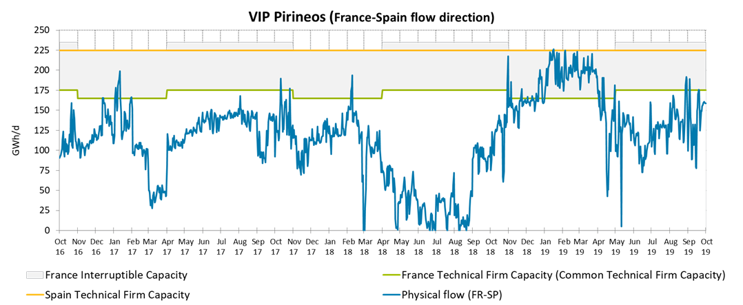

Figure 4: Physical flows at VIP Pirineos from France to Spain

In the gas year 2016-2017, physical use of the interconnection exceeded 90% of the common technical firm capacity [165 GWh/d (W) / 175 GWh/d (S)] during 23 days (6% of the time during the year), During the gas year 2017-2018 a superior use of 90% of the common technical firm capacity [165 GWh/d (W) / 175 GWh/d (S)] of the VIP Pirineos was reached in 15 days. During the two gas year (2016-2017 and 2017-2018) the number of days with a physical use of the interconnection exceeding 100% of the common technical firm capacity (more than 165 GWh/d (W) / 175 GWh/d (S)) was reached during 16 days.

For the gas year 2018–2019, physical use of the interconnection exceeded 90% of the common technical firm capacity [165 GWh/d (W) / 175GWh/d (S)] during 179 days (49% of the time during the year). The physical flow of the interconnection exceeds the common technical firm capacity [165 GWh/d (W) / 175GWh/d (S)] 119 days (usage of the interruptible capacity). On January 16th the physical flow reached 226 GWh/d.

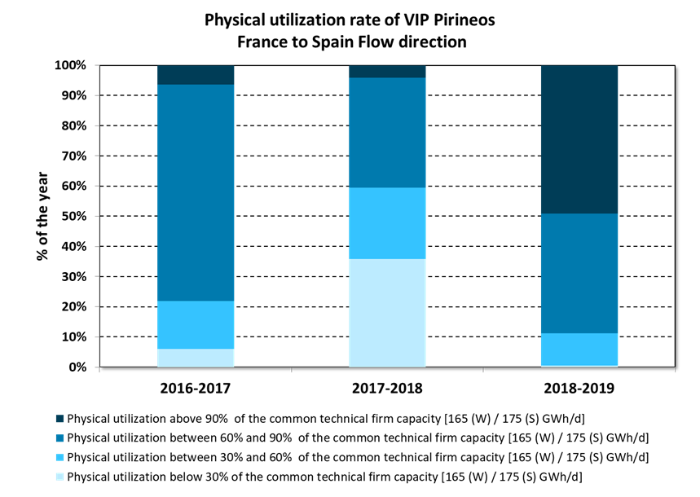

Figure 5: Physical utilization rate of VIP Pirineos from France to Spain [165 GWh/d (W) / 175GWh/d (S)]

#### Spain to France flow direction

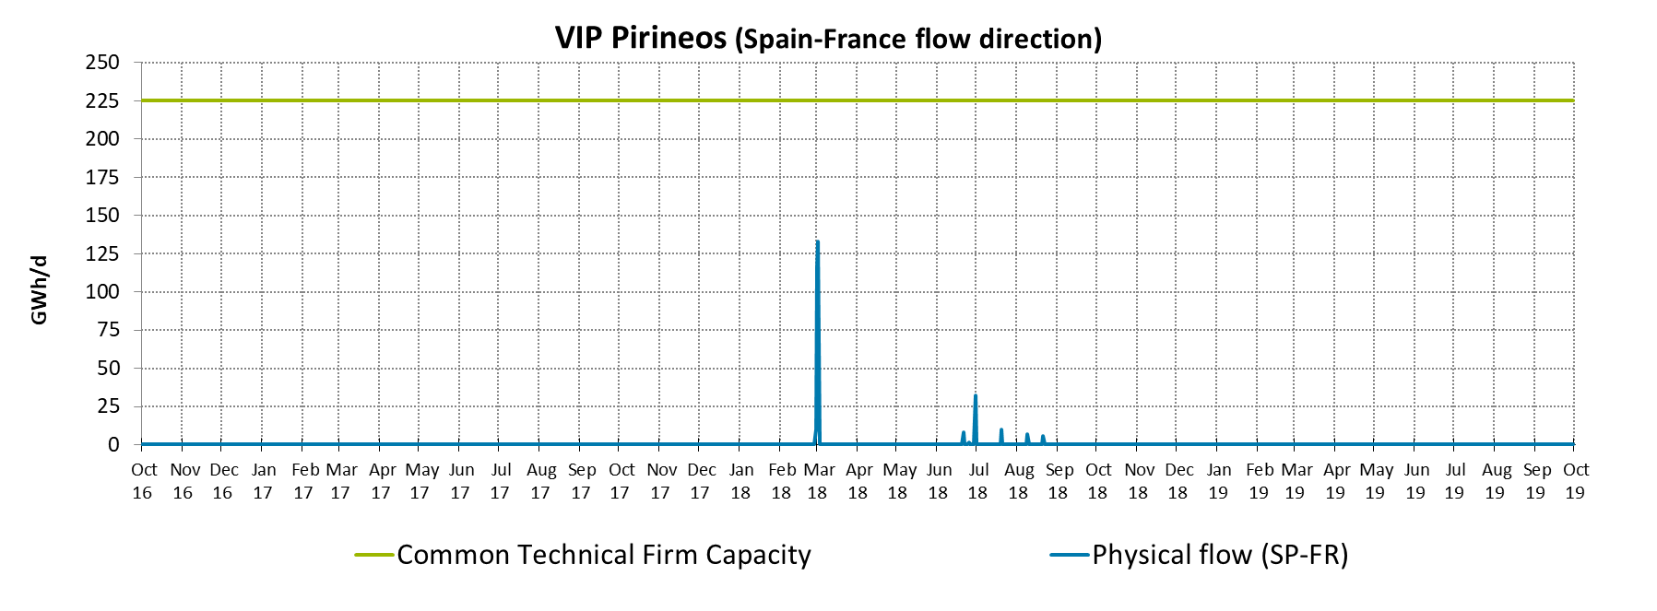

Figure 6: Physical flows at VIP Pirineos from Spain to France

It should be noted that, as a relevant event in the period analysed, the first time that the physical flow was transported by the VIP Pirineros in the direction of Spain toFrance occurs in the gas year of 2018-2019, during 10 days.

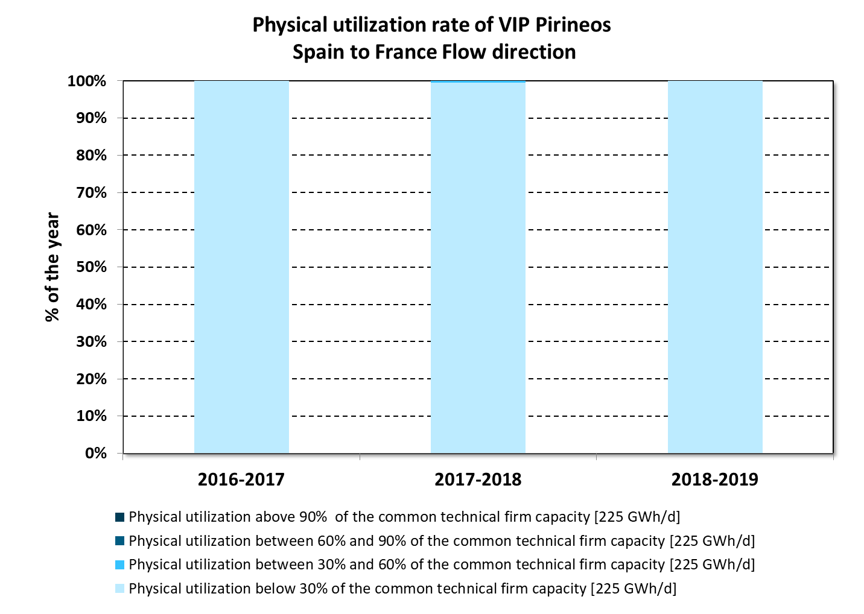

Figure 7: Physical utilization rate of VIP Pirineos from Spain to France (225 GWh/d)

### VIP Ibérico

#### Spain to Portugal flow direction

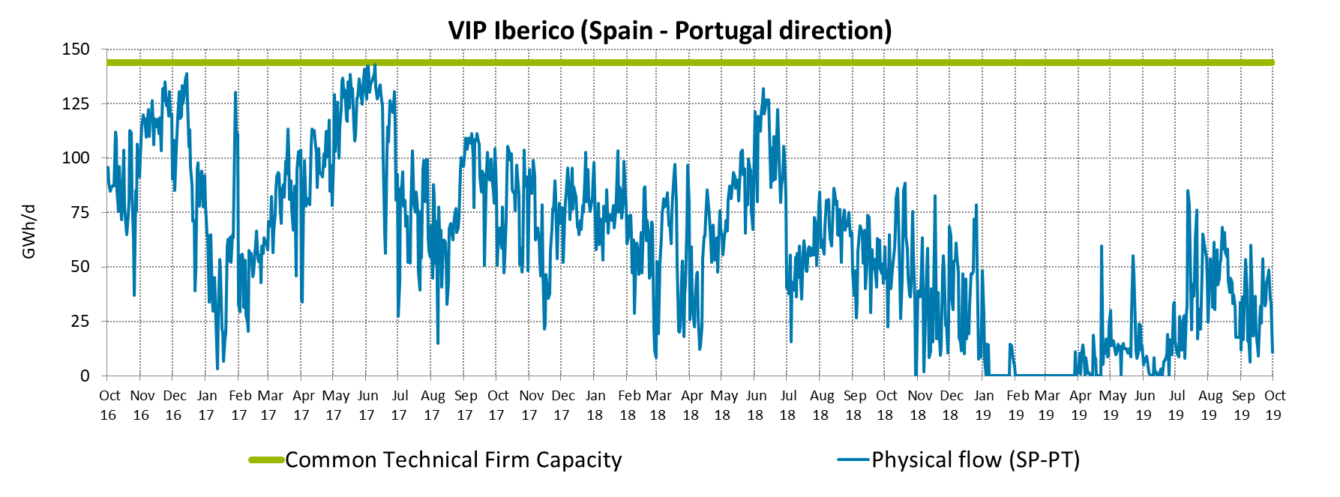

Figure 8: Physical flows at VIP Ibérico from Spain to Portugal

In the gas year 2016-2017, physical use of the interconnection exceeded 90% of the technical capacity during 34 days (9% of the time during the year); this threshold was exceeded only one day during the following two gas years (2017-2018 and 2018-2019).

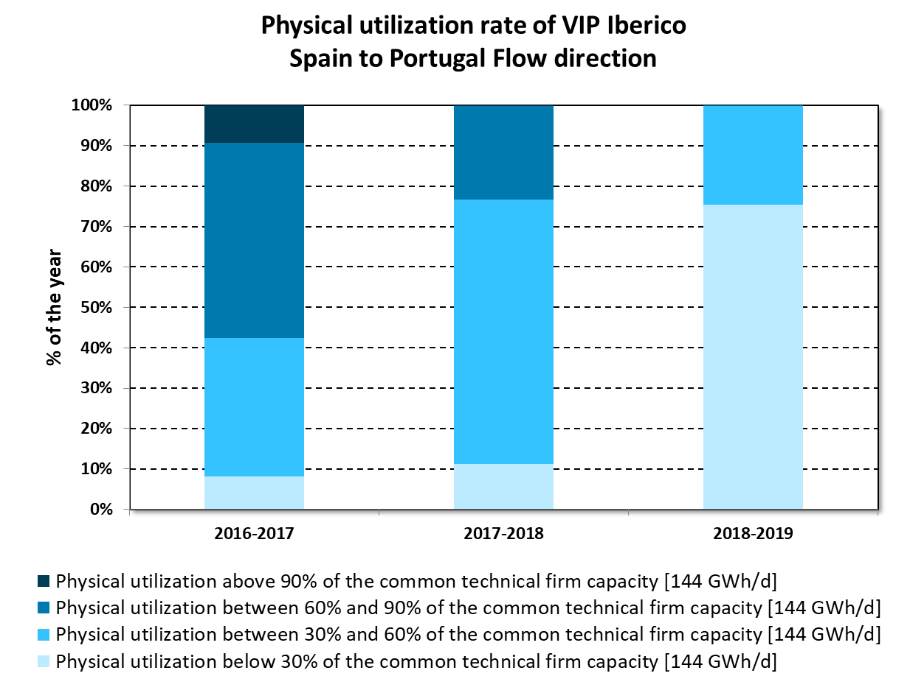

Figure 9: Physical utilization rate of VIP Ibérico from Spain to Portugal (144 GWh/d)

#### Portugal to Spain flow direction

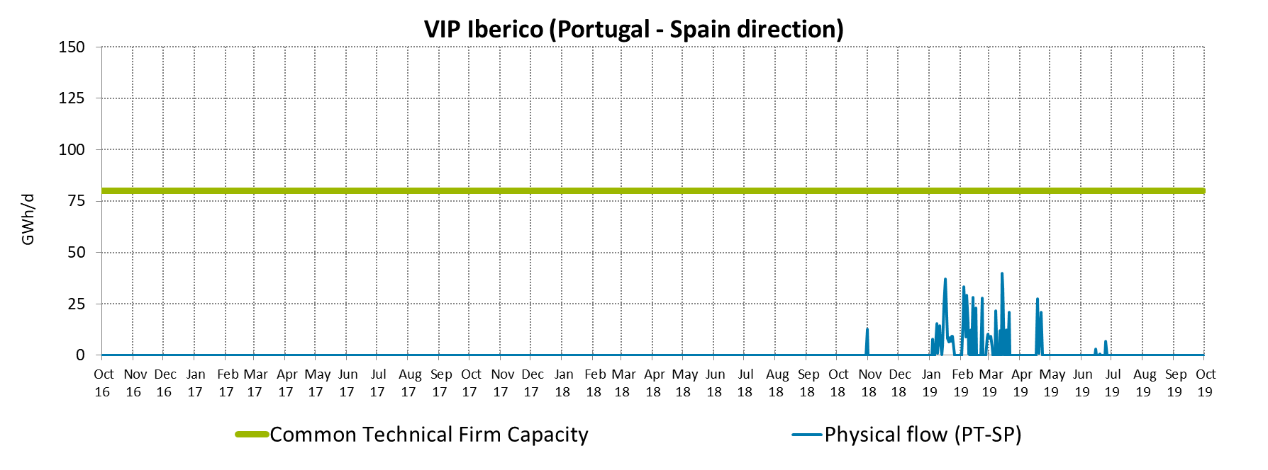

Figure 10: Physical flows at VIP Ibérico from Portugal to Spain

In 2016 and 2017, the interconnection has not been used in the direction from Portugal to Spain. Nevertheless, in the Winter and Spring periods of the gas year 2018-2019, a change in the historical flow direction at the VIP Ibérico could be observed for some days, whereby flows exceeded 60% the interconnection capacity in this direction during 13 days .

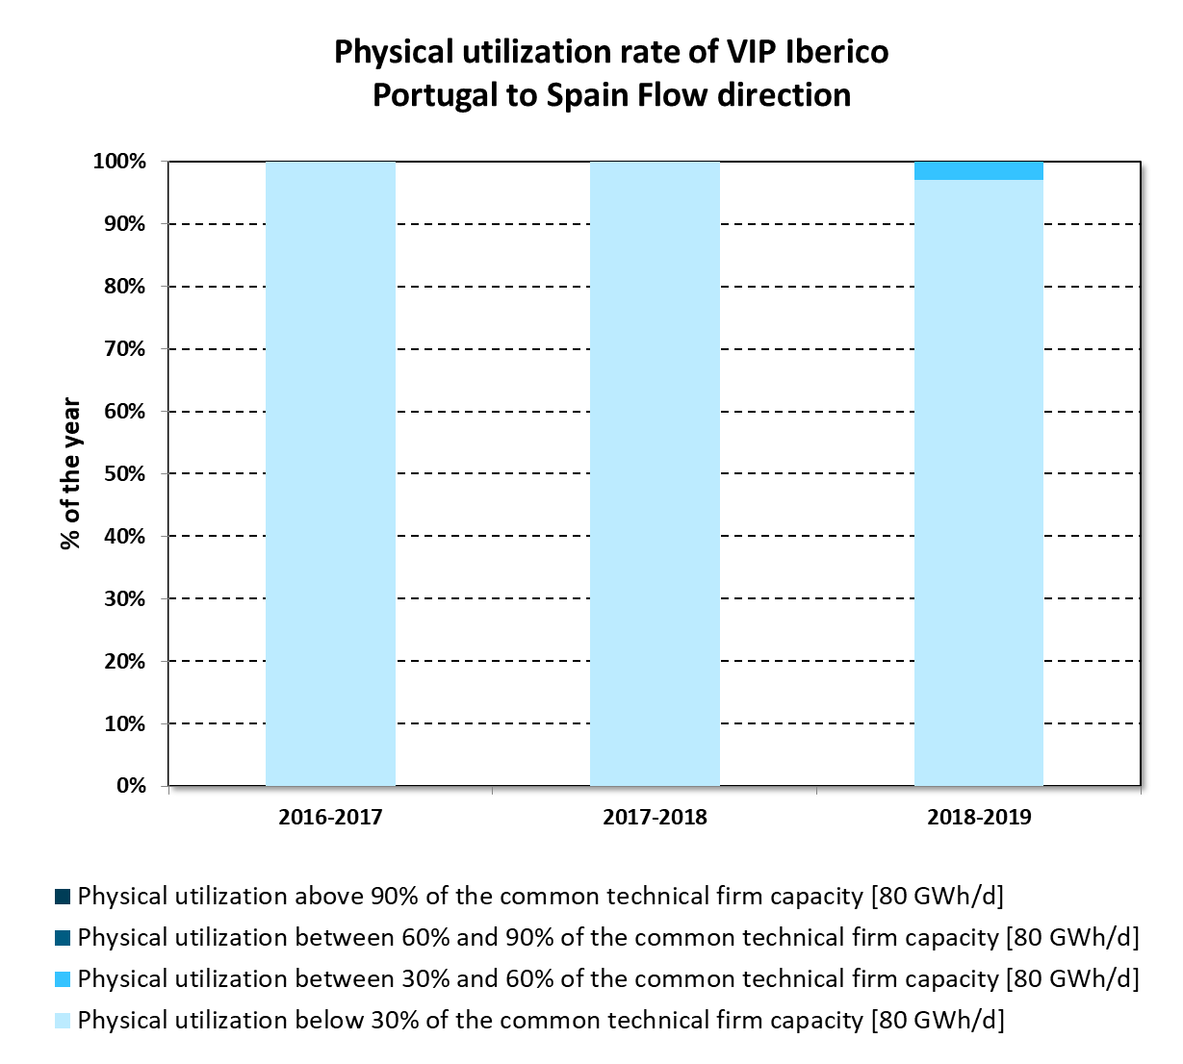

Figure 11: Physical utilization rate of VIP Ibérico from Portugal to Spain (80 GWh/d)

### North-South link

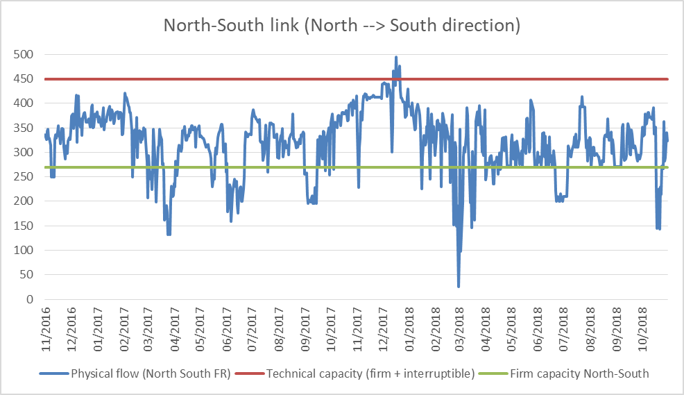

Figure 12: Physical flows at Liaison Nord-Sud from North to South

The Liaison link capacity was heavily used from North towards South, at rates over 100% most of the time, until the removal of the North to South link whereas in the other direction the interconnection was not used most of the time.

## Available capacity to be auctioned via PRISMA

Each TSO calculates the maximum technical capacity and the maximum booked capacity in both directions of the interconnection. The common value is reached in order to identify the maximum bundled capacity that can be offered to the market.

The TSOs consider the maximum technical capacity value for each product. In case of different values in the same period, the TSOs consider the minimum available value to ensure the offer of bundled capacity and offer the additional available capacity as an unbundled product.

Find below the tables summarizing the common capacity to be commercialized at the VIPs:

|  |  |
| --- | --- |
|  | **Teréga-Enagás** |
| **FR-ES** | 165 (W)/175 (S) firm+60 interruptible |
| **ES-FR** | 225 |

Table 1: Bundled capacities at VIP Pirineos (GWh/d 0ºC)

|  |  |
| --- | --- |
|  | **REN-Enagás** |
| **PT-ES** | 80 |
| **ES-PT** | 144 |

Table 2: Bundled capacities at VIP Ibérico (GWh/d 25ºC)

In order to maximise the offered capacity, each TSO considers capacities made available by Congestion Management Procedures (CMP) application.

The calculation of the bundled capacity to be offered starts with the available capacity for the annual yearly capacity auctions. The available capacity not allocated in the yearly auctions will be offered in the upcoming auctions.

According to the results of the yearly capacity products auctions and considering the amount of capacity set aside for this product, TSOs calculate the bundled capacity to be offered in quarterly capacity products auctions.

After that, bundled capacity not allocated in quarterly auctions will be offered in the subsequent auctions (monthly, daily and within-day) until the capacity is sold out.

Article 8 of CAM rules foresees that at least an amount equal to 20% of the technical capacity at each interconnection point shall be set aside and offered as described in the following provisions:

(a) an amount at least equal to 10 % of the existing technical capacity at each interconnection point shall be offered no earlier than in the annual yearly capacity auction as provided for in Article 11 held in accordance with the auction calendar during the fifth gas year preceding the start of the relevant gas year; and

(b) a further amount at least equal to 10 % of the existing technical capacity at each interconnection point shall first be offered no earlier than the annual quarterly capacity auction as provided for in Article 12, held in accordance with the auction calendar during the gas year preceding the start of the relevant gas year.

### VIP Pirineos

In VIP Pirineos, capacity for the next 15 years is offered (except for the unbundled capacity, which will be only offered for the first year). As there is not the same technical capacity in the interconnection point for the France to Spain direction, the capacity set aside (which also includes the capacity set aside on year) is calculated respect to the technical firm common capacity (165 GWh/d for the North to South direction and 225 GWh/d in the South to North direction), following the previous mentioned rules stated on the CAM regulation. The bundled capacity to be auctioned on PRISMA corresponds to the application of the “lesser rule” of the available capacities on both sides for each year, in other words, the resulting capacity of the matching between the difference of the technical capacity of each side of the point and the booked and set aside capacities.

Tables show data available as from October 2019.

|  |  |  |  |  |  |  |  |  |
| --- | --- | --- | --- | --- | --- | --- | --- | --- |
| **VIP PIRINEOS (FR-ES) GWh/d** | **French side** | | | | **Spanish side** | | | |
| Booked Capacity (LT before CAM) | Booked Capacity (after CAM) | Bundled Capacity (to be offered on PRISMA) | Unbundled Capacity (to be offered on PRISMA) | Booked Capacity (LT before CAM) | Booked Capacity (after CAM) | Bundled Capacity (to be offered on PRISMA) | Unbundled Capacity (to be offered on PRISMA) |
| **Oct 2020 to Sept 2021** | 146,52 | 0 | 1,98 | 0 | 146.29 | 0 | 1.98 | 54.23 |
| **Oct 2021 to Sept 2022** | 146,52 | 0 | 1,98 | 0 | 146.29 | 0 | 1.98 | 54.23(*) |
| **Oct 2022 to Sept 2023** | 146,52 | 0 | 1,98 | 0 | 146.29 | 0 | 1.98 | 54.23(*) |
| **Oct 2023 to Sept 2024** | 77,52 | 0 | 70,98 | 0 | 4 | 0 | 70.98 | 127.52(*) |
| **Oct 2024 to Sept 2025** | 77,52 | 0 | 70,98 | 0 | 4 | 0 | 70.98 | 127.52(*) |
| **Oct 2025 to Sept 2026** | 77,52 | 0 | 54,48 | 0 | 4 | 0 | 54.48 | 121.52(*) |
| **Oct 2026 to Sept 2027** | 0 | 0 | 132 | 0 | 4 | 0 | 132 | 44(*) |
| **Oct 2027 to Sept 2028** | 0 | 0 | 132 | 0 | 4 | 0 | 132 | 44(*) |
| **Oct 2028 to Sept 2029** | 0 | 0 | 132 | 0 | 0 | 0 | 132 | 48(*) |
| **Oct 2029 to Sept 2030** | 0 | 0 | 132 | 0 | 0 | 0 | 132 | 48(*) |
| **Oct 2030 to Sept 2031** | 0 | 0 | 132 | 0 | 0 | 0 | 132 | 48(*) |
| **Oct 2031 to Sept 2032** | 0 | 0 | 132 | 0 | 0 | 0 | 132 | 48(*) |
| **Oct 2032 to Sept 2033** | 0 | 0 | 132 | 0 | 0 | 0 | 132 | 48(*) |
| **Oct 2033 to Sept 2034** | 0 | 0 | 132 | 0 | 0 | 0 | 132 | 48(*) |
| **Oct 2034 to Sept 2035** | 0 | 0 | 132 | 0 | 0 | 0 | 132 | 48(*) |

***(*)*** *Although there is unbundled capacity available to offer for the upcoming years, only the capacity for the first year of the next 15 years will be auctioned.*

Table 3: Capacity to be auctioned via PRISMA in the July 2020 yearly auction (France to Spain)

|  |  |  |  |  |  |  |  |  |
| --- | --- | --- | --- | --- | --- | --- | --- | --- |
| **VIP PIRINEOS (ES-FR) GWh/d** | **French side** | | | | **Spanish side** | | | |
| Booked Capacity (LT before CAM) | Booked Capacity (LT after CAM) | Bundled Capacity (to be offered on PRISMA) | Unbundled Capacity (to be offered on PRISMA) | Booked Capacity (LT before CAM) | Booked Capacity (LT after CAM) | Bundled Capacity (to be offered on PRISMA) | Unbundled Capacity (to be offered on PRISMA) |
| **Oct 2020 to Sept 2021** | 176,799 | 0 | 25.701 | 0 | 126.43 | 0 | 25.70 | 50.4 |
| **Oct 2021 to Sept 2022** | 176,799 | 0 | 25.701 | 0 | 126.43 | 0 | 25.70 | 50.4(*) |
| **Oct 2022 to Sept 2023** | 176,799 | 0 | 25.701 | 0 | 126.43 | 0 | 25.70 | 50.4(*) |
| **Oct 2023 to Sept 2024** | 61,307 | 0 | 141.193 | 0 | 61.3 | 0 | 141.19 | 0.0 |
| **Oct 2024 to Sept 2025** | 47,387 | 0 | 155.113 | 0 | 47.39 | 0 | 155.11 | 0.0 |
| **Oct 2025 to Sept 2026** | 47,387 | 0 | 132.613 | 0 | 47.39 | 0 | 132.61 | 0.0 |
| **Oct 2026 to Sept 2027** | 2,587 | 0 | 177.413 | 0 | 2.59 | 0 | 177.41 | 0.0 |
| **Oct 2027 to Sept 2028** | 2,587 | 0 | 177.413 | 0 | 2.59 | 0 | 177.41 | 0.0 |
| **Oct 2028 to Sept 2029** | 2,587 | 0 | 177.413 | 0 | 2.59 | 0 | 177.41 | 0.0 |
| **Oct 2029 to Sept 2030** | 0 | 0 | 180.00 | 0 | 0 | 0 | 180.00 | 0.0 |
| **Oct 2030 to Sept 2031** | 0 | 0 | 180.00 | 0 | 0 | 0 | 180.00 | 0.0 |
| **Oct 2031 to Sept 2032** | 0 | 0 | 180.00 | 0 | 0 | 0 | 180.00 | 0.0 |
| **Oct 2032 to Sept 2033** | 0 | 0 | 180.00 | 0 | 0 | 0 | 180.00 | 0.0 |
| **Oct 2033 to Sept 2034** | 0 | 0 | 180.00 | 0 | 0 | 0 | 180.00 | 0,0 |
| **Oct 2034 to Sept 2035** | 0 | 0 | 180.00 | 0 | 0 | 0 | 180.00 | 0,0 |

***(*)*** *Although there is unbundled capacity available to offer for the upcoming years, only the capacity for the first year of the next 15 years will be auctioned.*

Table 4. Capacity to be auctioned via PRISMA in the July 2020 yearly auction (Spain to France)

### VIP Ibérico

In VIP Ibérico capacity is annually offered for a five-year period. Consequently, in accordance with CAM regulation, capacity is set aside only for quarterly auctions. In addition, note that long term contracts are only booked in the Spain to Portugal flow direction on the Spanish side and the resulting unbundled capacity is offered on the Portuguese side. Capacity set aside is calculated with respect to the technical firm common capacity (144 GWh/d in the Spain to Portugal direction and 80 GWh/d in the Portugal to Spain direction). The bundled capacity to be auctioned on PRISMA follows the same procedure as in the case of VIP Pirineos.

The following tables show data available as from October 2019:

|  |  |  |  |  |  |  |  |  |
| --- | --- | --- | --- | --- | --- | --- | --- | --- |
| **VIP Ibérico (ES-PT) GWh/d** | **Portuguese side** | | | | **Spanish side** | | | |
| Booked Capacity (LT before CAM) | Booked Capacity (LT after CAM) | Bundled Capacity (to be offered on PRISMA) | Unbundled Capacity (to be offered on PRISMA) | Booked Capacity (LT before CAM) | Booked Capacity (LT after CAM) | Bundled Capacity (to be offered on PRISMA) | Unbundled Capacity (to be offered on PRISMA) |
| **Oct 2020 to Sept 2021** | - | 0 | 36,8 (***) | 2 (***) | 93 | 0 | 36.6 | 0(*) |
| **Oct 2021 to Sept 2022** | - | 0 | 127.6 8 (***) | 0 (***) | 2 | 0 | 127.6 | 0(*) |
| **Oct 2022 to Sept 2023** | - | 0 | 129.6 | 0(**) | 0 | 0 | 129.6 | 0(*) |
| **Oct 2023 to Sept 2024** | - | 0 | 129.6 | 0(**) | 0 | 0 | 129.6 | 0(*) |
| **Oct 2024 to Sept 2025** | - | 0 | 129.6 | 0(**) | 0 | 0 | 129.6 | 0(*) |

***(*)*** *There is no unbundled capacity offer on the Spanish side of VIP Ibérico.*

***(**)*** *There is no unbundled capacity offer on the Portuguese side of VIP Ibérico*

*(***) Due to the ending of some LT contracts (before CAM) during the year, unbundled capacity will gradually be offered on PRISMA as bundled capacity, as LT contracts reach an end on the Spanish side. Hence, the available capacity to be booked through gas years 2020-2021 and 2021-2022 is as follows, on table 6 and 7.*

Table 5. Capacity to be auctioned via PRISMA in the July 2020 yearly auction (Spain to Portugal)

Table 6. Detail of the capacity to be auctioned throughout gas year 2021-2022

|  |  |  |  |  |  |  |  |  |
| --- | --- | --- | --- | --- | --- | --- | --- | --- |
| **VIP Ibérico (PT-ES) GWh/d** | **Portuguese side** | | | | **Spanish side** | | | |
| Booked Capacity (LT before CAM) | Booked Capacity (LT after CAM) | Bundled Capacity (to be offered on PRISMA) | Unbundled Capacity (to be offered on PRISMA) | Booked Capacity (LT before CAM) | Booked Capacity (LT after CAM) | Bundled Capacity (to be offered on PRISMA) | Unbundled Capacity (to be offered on PRISMA) |
| **Oct 2020 to Sept 2021** | - | 0 | 72 | 0(*) | 0 | 0 | 72 | 0(*) |
| **Oct 2021 to Sept 2022** | - | 0 | 72 | 0(*) | 0 | 0 | 72 | 0(*) |
| **Oct 2022 to Sept 2023** | - | 0 | 72 | 0(*) | 0 | 0 | 72 | 0(*) |
| **Oct 2023 to Sept 2024** | - | 0 | 72 | 0(*) | 0 | 0 | 72 | 0(*) |
| **Oct 2024 to Sept 2025** | - | 0 | 72 | 0(*) | 0 | 0 | 72 | 0(*) |

*(*) There is no unbundled capacity offer on either side of VIP Ibérico.*

Table 7. Capacity to be auctioned via PRISMA in the July 2020 yearly auction (Portugal to Spain)

### North – South Link

Not applicable. Since November 2018, no auctions have taken place as the North-South link has been removed.

# Assessment of capacity bookings

In this part of the report, capacity bookings will be analyzed distinguishing between bundled and unbundled capacity, different time horizons (Long term, Yearly, Quarterly…) and firm and interruptible capacity. Also, a brief summary of the secondary market is included.

## Firm booked capacities (bundled/unbundled)

The purpose of this section is to analyse the firm capacity bookings of the two VIPs in comparison with the technical capacity, distinguishing between bundled and unbundled capacity. It must be noted that interruptible capacity will not be taken into account in this part of the report, as it will be analysed in its specific chapter.

The concept of bundled capacity is defined in Article 3 (4) of CAM NC in the following way:

*«‘Bundled capacity’ means a standard capacity product offered on a firm basis which consists of corresponding entry and exit capacity at both sides of every interconnection point».*

Before the “early implementation” of the CAM NC, capacity was booked in an unbundled way, through the South Region TSOs` allocation capacity platforms. The Ministerial Order ITC/2607/2008 defines these procedures for the interconnection points between Spain and France.

After the entry into force of CAM NC, available capacity is offered preferably as bundled capacity, or unbundled if it is not possible to offer it as bundled, in auctions held on PRISMA platform. Despite the fact that according to the article 21(3) of the CAM NC Amendment the conversion of unbundled capacity into bundled capacity for network users that hold mismatched unbundled capacity at one side of the interconnection point is allowed, there is still unbundled capacity contracted due to LT contracts previous to the CAM Network Code implementation. However, it should be noted that most of this unbundled LT contracts work as if they were bundled. Most shippers contracted the same amount of capacity at both sides of the VIP in order to use these contracts as if they were bundled.

Due to the fact that in the period analyzed the existing LT contracts represent a significant percentage of the technical capacity bookings, the amount of bundled capacity offered in the auctions is quite limited.

### VIP Pirineos

The following tables show the booked capacity (on average) on the total technical firm capacity per gas year of the period under study, considering LT before CAM NC implementation capacity, unbundled capacity after CAM NC implementation (as the one that the shippers can contract through the PRISMA platform) and the bundled capacity for each side of the VIP.

#### North to South flow direction

|  |  |  |  |  |  |  |  |  |
| --- | --- | --- | --- | --- | --- | --- | --- | --- |
| **VIP PIRINEOS**  **(FR-ES)**  **GWh/d** | **French side** | | | | **Spanish side** | | | |
| LT before CAM Capacity | Unbundled after CAM | Bundled Capacity | Booked capacity | LT before CAM Capacity | Unbundled after CAM | Bundled Capacity | Booked capacity |
| **2016-17** | 63% | 0,4% | 2,3% | 66% | 65% | 3% | 2% | 70% |
| **2017-18** | 63% | 0,3% | 1,6% | 65% | 65% | 4% | 2% | 71% |
| **2018-19** | 63% | 4,4% | 6,2% | 74% | 65% | 12% | 6% | 83% |

Table 8. Booked capacities VIP Pirineos on technical firm capacity – France to Spain

It should be mentioned that on 2nd of March 2018 gas year, a total amount of 21.9 GWh/d were booked via OSBB, representing a bundled capacity and making the total capacity bookings to raise above the total technical firm capacity on the Spanish side.

**French side**

+ 8% increase over the studied period for the booked capacity.

Since the entry into force of the TRF on the 1st of November 2018, booking and flow level from France to Spain have been maintained at a high level. The subscription rate at the exit firm capacity has increased to 100% over 6 months, from October 2018 to March 2019, triggering daily interruptible capacity each day of that period. For the period Jan-March 2019, the Total technical capacity was reached 10 times (100%), with an average subscription of 90%.

This effect was induced by the decrease of the PEG price, which accentuated the France-Spain spread and triggered opportunities for market players.

Over the first quarter of 2019, commercial flows reached a historically high level, with an average of 201 GWh/day.

In 2016, the interruptible capacity was booked for 27 days.

In 2017, interruptible capacity were booked for only 10 days.

In 2018 the number of days during which interruptible capacities were marketed increased to 131 days.

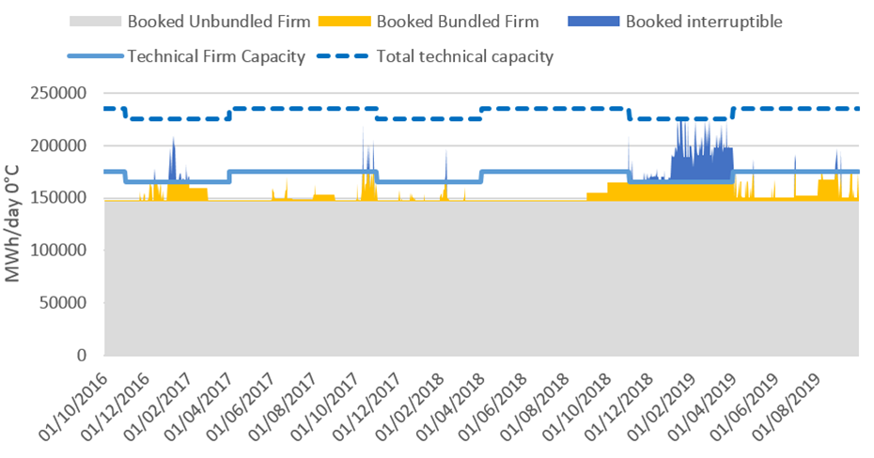

Figure 13. Capacity bookings on VIP Pirineos - France to Spain direction (French side)

The fraction of firm capacity booking related to unbundled capacity prevails (grey : 86%). The remaining firm capacity is sold as bundled thru PRISMA (yellow). As shown earlier in the report, bundling of firm capacities will occur gradually with the end of the long term contracts.

The interruptible capacity (unbundled, blue), is used as an optimization of the total technical capacity, consecutively to the booking saturation of the firm capacity.

**Spanish side**

The next figure show the evolution of the different types of capacities through the studied period, namely, the capacity of the LT contracts before the CAM NC implementation and the bundled and unbundled capacity bookings after the CAM NC.

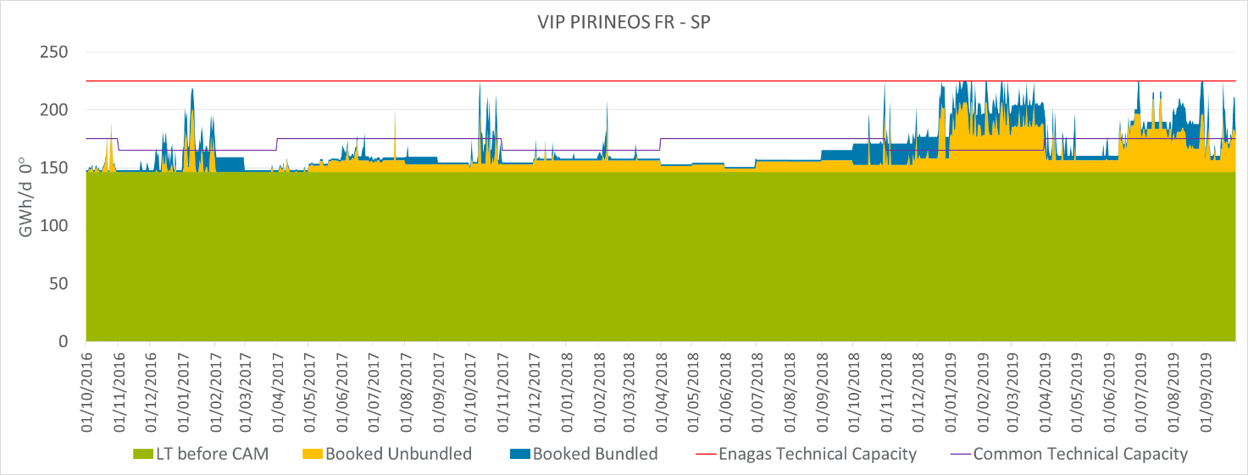

Figure 14. Capacity bookings on VIP Pirineos - France to Spain direction (Spanish side)

As it can be seen, capacity bookings via LT contracts represent a significant percentage of the technical capacity in the period analysed (65%), and so, the amount of bundled capacity offered in the auctions is limited.

Particularly noteworthy is the increase in the 2018 gas year bookings (18.3% more compared to 2016 and 17.3% more compared to 2017). To understand the reason, see Chapter 5, “Gas prices in the South Region” to find the reason of these increases.

As technical firm capacity in French side is 165/175 GWh/d, the remaining capacity in the Spanish side until 225 GWh/d is offered in an unbundled way, and matched with the interruptible unbundled capacity at the French side.

During the 2016 gas year, total booked capacity has been above 90% of the technical capacity (225 GWh/day) for 3 days (1% of the year), while as in the 2017 gas year they were 6 days (2% of the year). In the gas year of 2018, the number of days with more of 90% booked capacity increased notably to 95 (26% of the year).

During the 2016 gas year, total booked capacity has been above 90% of the common firm technical capacity (165 GWh/day) for 263 days (72% of the year), while as in the 2017 gas year they were 365 days (100% of the year). In the gas year of 2018, this tendency continued as the whole year (the 365 days) had the capacity booked for each day above 90% of the common firm technical capacity.

#### South to North flow direction

|  |  |  |  |  |  |  |  |  |
| --- | --- | --- | --- | --- | --- | --- | --- | --- |
| **VIP PIRINEOS**  **(ES-FR)**  **GWh/d** | **French side** | | | | **Spanish side** | | | |
| LT before CAM Capacity | Unbundled after CAM | Bundled Capacity | Booked capacity | LT before CAM Capacity | Unbundled after CAM | Bundled Capacity | Booked capacity |
| **2016-17** | 79% | 0,00% | 0,00% | 79% | 55.81% | 0.00% | 0.38% | 56.19% |
| **2017-18** | 79% | 0,00% | 0,22% | 79% | 55.81% | 0.13% | 0.60% | 56.54% |
| **2018-19** | 79% | 0,00% | 0,20% | 79% | 55.81% | 0.30% | 0.59% | 56.70% |

Table 9. Booked capacities on VIP Pirineos vs technical firm capacity – South to North direction

As shown on the figures hereafter, flow direction from France to Spain prevails in terms of booked capacity.

**French side**

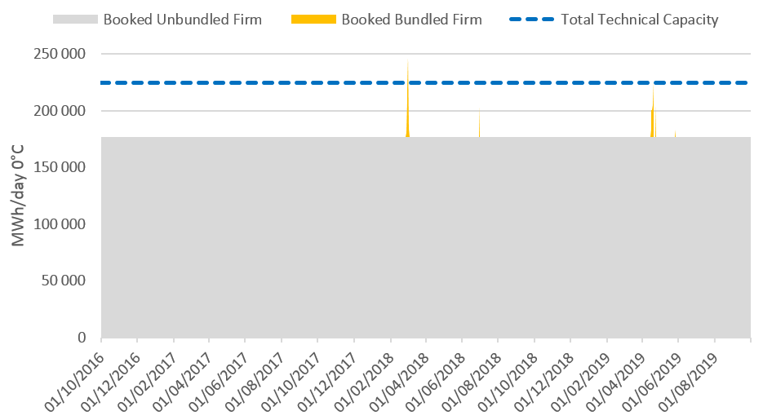

**Table 10. Booked capacities on VIP Pirineos vs technical firm capacity – South to North direction**

The same remark can be made for the Firm Unbundled capacity booked via long term contracts, it represents the majority of the marketed capacity.

However, price signals due to particular events induced – for the first time – total booking of the interconnection. For example, on the 1st of March 2018, physical flow has been observed due to the shutdown of Gasco terminal. Hub prices kicked off in the northern Europe and gas transited from Spain to France.

Note: at the end of 2019, massive delivery of LNG at global scale set a price taker position for Europe that decreased gas hub prices. A permanent south to north physical flow is observed in November and December 2019 (out of the period of study but relevant to be mentioned).

**Spanish side**

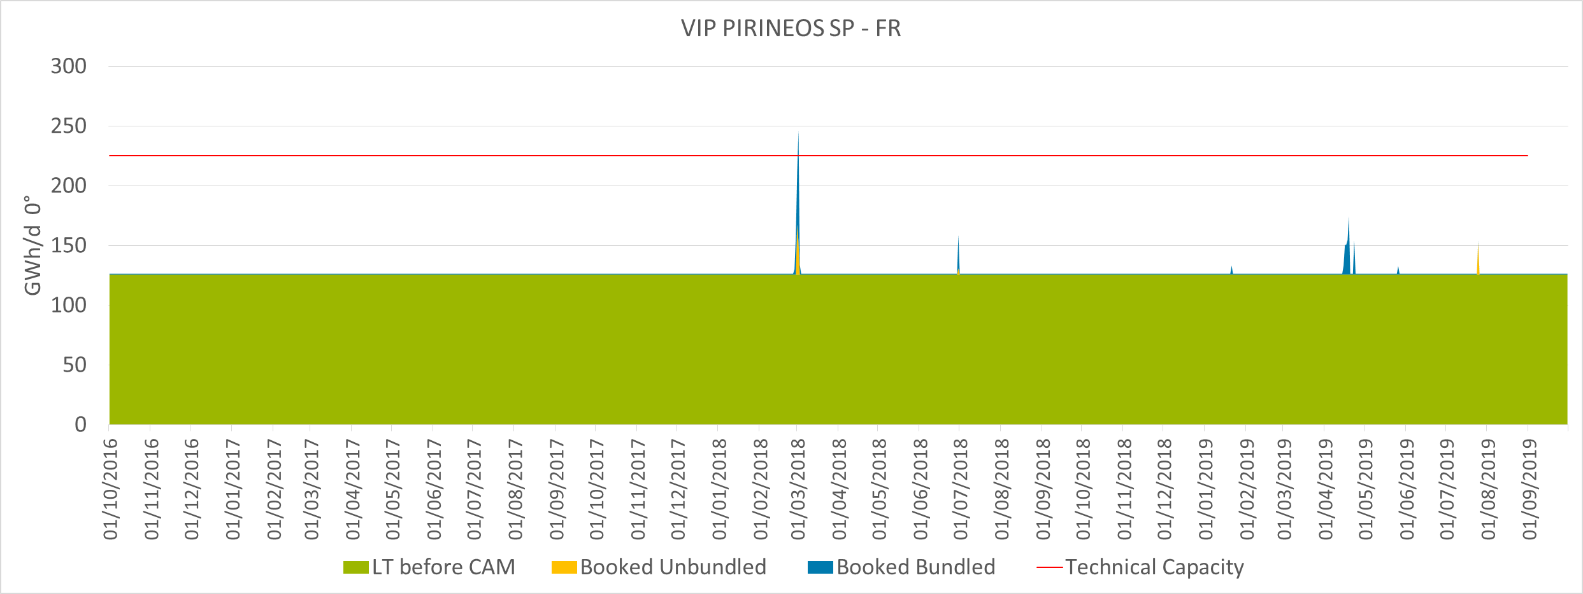

Figure 15. Capacity bookings on VIP Pirineos - Spain to France (Spanish side)

Regarding the booked capacity, there are hardly any changes in the three gas years under study. This is because there are hardly any bookings after the Open Season. Around 99 % (125 GWh) of the allocated capacity was booked during the Open Seasons (unbundled) and only 1% (0.85 GWh/d) of the booked capacity was allocated on Prisma (Bundled). In addition, it should be mentioned that the 2nd of March, 2018 gas year, a total amount of 21.9 GWh/d were booked via OSBB, nonetheless, and despite the fact that firm capacity bookings were above the technical capacity that day, the physical flow did not exceeded the total technical capacity. The reason lying behind of this capacity bookings is explained in the chapter 3.1.1.2.

As it can be observed, unbundled LT booked capacity on French side is 50 GWh/d higher than on the Spanish side. This is because one shipper booked 50 GWh/d on the Open Season 2013 at both sides of the interconnection, but this shipper reduced this capacity on the Spanish side before the “early implementation” of the CAM NC. Therefore, the status of booked capacity during this period is different at each side of the interconnection point.

Unbundled LT contracts represent 56% of the technical capacity so that there is still an important amount of capacity that could be booked in a bundled way.

On the studied period, they were only 2 days (<1% of a year), both in the gas year of 2017, in which the total booked capacity has been above 90% of the total technical capacity.

### VIP Ibérico

At this interconnection point, flow direction from Spain to Portugal prevails over Portugal to Spain direction. However, the flow at this VIP has changed its behaviour during the last year, even reverting the physical flow.

#### Spain to Portugal flow direction

The following table shows the booked capacity (on average) per gas year of the period under study.

|  |  |  |  |  |  |  |  |  |
| --- | --- | --- | --- | --- | --- | --- | --- | --- |
| **VIP Iberico**  **(ES-PT)**  **GWh/d** | **Spanish side** | | | | **Portuguese side** | | | |
| LT before CAM Capacity | Unbundled after CAM (*) | Bundled Capacity | Booked capacity | LT before CAM Capacity | Unbundled after CAM | Bundled Capacity | Booked capacity |
| **2016** | 64,41% | 0 | 19.40% | 83.81% | - | 61,12% | 19.40% | 80,44% |
| **2017** | 64,41% | 0 | 12.46% | 76.87% | - | 60,95% | 12.46% | 73,41% |
| **2018** | 64,41% | 0 | 4.55% | 68.96% | - | 60,95% | 4.55% | 65,5% |

*(*) Unbundled capacity is not offered in the Spanish side of VIP Ibérico.*

Table 11. Booked capacities on VIP Ibérico on technical firm capacity – Spain to Portugal direction

**Portuguese side**

A decrease in bookings is observed for bundled capacity for 2018, and especially for 2019. This may be related with the increase in LNG supply into Iberia in 2018 and 2019, in the context of a global increase of liquefaction capacity outpacing global demand growth. New LNG supply volumes were mostly driven by new production from the United States, Russia and Australia. Since then, shippers in the Iberian market have prioritised LNG over Algerian gas, increasing the activity of almost all LNG terminals across the Peninsula. At roughly the same time new tariffs were established for Sines LNG terminal and for the interconnection point from Portugal to Spain. Therefore, LNG supply through Sines to the Iberian market increased, resulting in a significant reduction of usage of the interconnection point, from Spain to Portugal and an increase from Portugal to Spain.

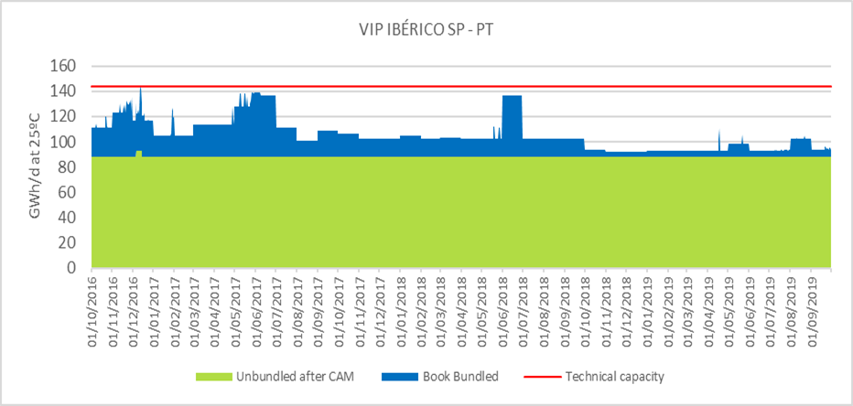

Figure 16: Capacity bookings VIP Ibérico – Spain to Portugal direction (Portuguese side)

Long-term capacity in the Spanish side was still dominant, representing an average of roughly 61% of the technical capacity. The total amount of booked capacity reached an average of 80.4% of the technical capacity in 2016, 73.4% in 2017 and 65.5% in 2018. Regarding capacity booking throughout the year, it is possible to see that booked capacity tends to peak in the summer. These peaks happen due to the dispatch of natural gas-fired power plants, which play a significant role in dry summers with little to no wind.

The difference between the Spanish and the Portuguese side is due to the lower bookings of unbundled capacity on the Portuguese side, when compared with the “LT contracts before CAM” that are in force on the Spanish side.

**Spanish side**

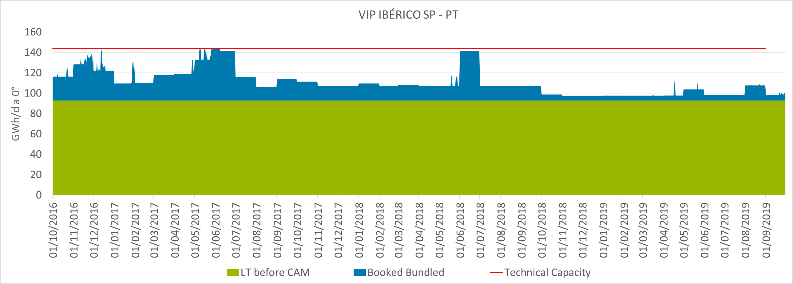

Figure 17: Capacity bookings VIP Ibérico – Spain to Portugal direction (Spanish side)

As it can be observed, there are peaks of bundled capacity bookings during summer months (from June to September). The total amount of unbundled booked capacity comes from LT contracts. These contracts represent 64.42% of the technical capacity, so there is still enough bundled capacity that can be offered and allocated at PRISMA.

It should be noted the decrease in the bookings of the last two years, but especially during 2018. This corresponds with the increase of bookings in the opposite flow direction, as explained before.

During the 2016 gas year, total booked capacity has been above 90% of the technical capacity for 84 days (23% of the year), while as in the 2017 gas year they were only 29 days (8% of the year). There were not any days in which booked capacity exceeded 90% of the technical capacity in 2018.

Regarding bundled and unbundled capacity, due to the existing bookings previous to the entry into force of the CAM NC, again unbundled booked capacity prevails over bundled booked capacity. Unbundled capacity comes from a transit contract and two LT contracts signed between two shippers and both TSOs. This transit was booked by a shipper at both sides of the interconnection and until January 2015 was out of the Third Party Access System. Since then, Enagás integrated it into the Third Party Access System, in order to accomplish the requirement established by the European regulators (according to the [“*Informe sobre la propuesta de adecuación del contrato de tránsito de gas a Portugal a la normativa europea”*](https://www.cnmc.es/sites/default/files/1514268_1.pdf) of the CNMC on the 5th September 2014). On the other hand, REN offers this capacity in an unbundled way via auctions held on the PRISMA Platform.

#### Portugal to Spain flow direction

The following tables show the booked capacity (on average) per gas year of the period under study.

|  |  |  |  |  |  |  |  |  |
| --- | --- | --- | --- | --- | --- | --- | --- | --- |
| **VIP Ibérico**  **(PT-SP)**  **GWh/d** | **Spanish side** | | | | **Portuguese side** | | | |
| LT before CAM Capacity | Unbundled after CAM(*) | Bundled Capacity | Booked capacity | LT before CAM Capacity | Unbundled after CAM | Bundled Capacity | Booked capacity |
| **2016** | 0 | 0 | 0.08% | 0.08% | 0 | 0 | 0.08% | 0.08% |
| **2017** | 0 | 0 | 0.16% | 0.16% | 0 | 0 | 0.16% | 0.16% |
| **2018** | 0 | 0 | 7.03% | 7.03% | 0 | 0 | 7.03% | 7.03% |

*(*) Unbundled capacity is not offered in the Spanish side of VIP Ibérico.*

Table 12. Booked capacities VIP Ibérico on technical firm capacity – Portugal to Spain direction

**Portuguese side**

No long-term contracts exist in either side of the border regarding flow direction Portugal to Spain (see table 10). Hence, only bundled capacity is presented. Gas years 2016-2017, and 2017-2018 are in line with the historic usage in this direction, with low to no bookings at all. However, in gas year 2018-2019 bookings for capacity in the direction Portugal to Spain saw a significant increase. It should be highlighted the 30th October 2018, when for the first time it was witnessed the inversion of booked flows through the interconnection. Then, bookings reached 40 GWh/d, or 50% of the technical capacity, establishing a new trend that would evolve to a sustained increased use of the interconnection in this direction, mainly from the beginning of 2019 onwards. As explained previously (see 2.1.2.1), it became more profitable for some network users to supply gas to some of its clients in Spain through Portugal, using the interconnection.

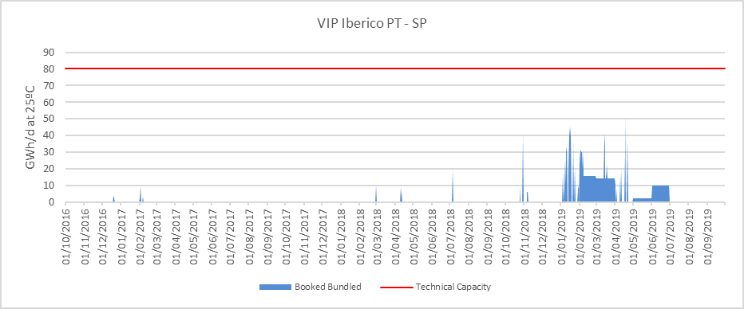

Figure 18: Capacity bookings VIP Ibérico – Portugal to Spain direction (Portuguese side)

**Spanish side**

As it was stated in the abovementioned table, there are not LT contracts in the Portugal to Spain flow direction in the Spanish side of the VIP Ibérico. For this reason, the only capacity present on this side is bundled capacity. The next figure shows the evolution of the different types of capacities through the studied period.

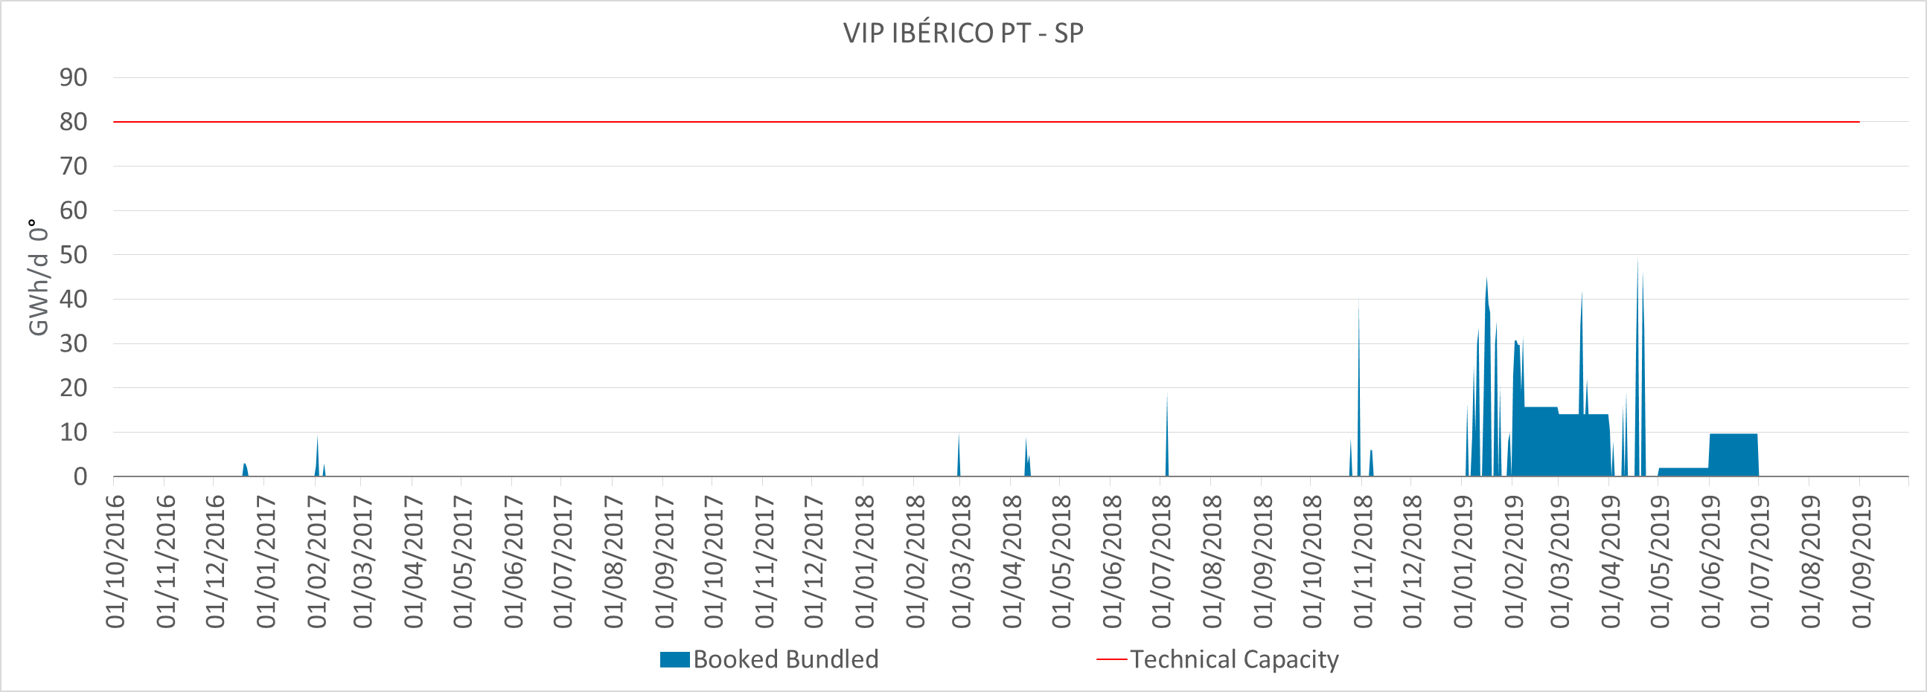

Figure 19. Capacity bookings VIP Ibérico – Portugal to Spain direction (Spanish side)

It should be particularly noted the increase in the 2018 gas year bookings.

Historically, the VIP Ibérico has behaved in a similar way to 2016 and 2017 (there were hardly any bookings in the Portugal to Spain flow). However, during the gas year 2018, the bookings in the Portugal to Spain flow experimented a significant increase. The reason is the decrease of the tariffs in Sines LNG terminal that made more profitable to supply both, Portuguese and Spanish Power plants, from Portugal than from Spain. This combined with an exit tariff from the Portuguese network of 0 €/MWh, provoked the inversion of flows (from Portugal to Spain).

During the period analysed capacity has been booked only in short term basis, daily contracts in 2016 and 2017 and daily and monthly contracts in the gas year 2018, especially during winter. There were not any days on the studied period in which booked capacity exceeded 90% of the technical capacity.

During the last quarter of 2019, the level of utilization have decreased due to the high level of LNG stocks all around Europe, and the “*Contango Effect*” (future prices of gas are higher than the spot price).

Booked capacity has never exceeded the technical capacity.

On 18th April 2019 the capacity bookings in Portugal to Spain direction reached 50 GWh/d, around 62% of the technical capacity.

### North-South link

The capacity has always been offered as a bundled product since it is the same TSO on both side of the IP. The IP was only booked and used to ship gas from PEG Nord to TRS.

## Allocated firm capacity in different time horizons (auctions)

The purpose of this section is to distinguish the origin of the firm booked capacity shown on point *2.1 Firm booked capacities (bundled/*unbundled). As explained, unbundled capacity comes mostly from LT contracts signed during the Open Seasons, while bundled capacity only comes from bundled auctions performed on PRISMA Platform.

Capacity on PRISMA is offered on a standard basis via the standard products included in Article 9 of the CAM NC: Yearly standard capacity products, Quarterly standard capacity products, Monthly standard capacity products, Daily standard capacity products and Within-day standard capacity products

Since November 2015, all these products are offered on the PRISMA platform by the TSOs.

Next figures show, for each VIP and direction, the origin of the firm booked capacity in regard with the time horizon. As the previous chapter, interruptible capacity is not included in calculations and figures.

### VIP Pirineos

#### North South Flow Direction

In this direction, hereafter is a representation of all kinds of products, i.e. LT contracts, Yearly, Quarterly, Monthly, Daily and Within-Day products.

**French side**

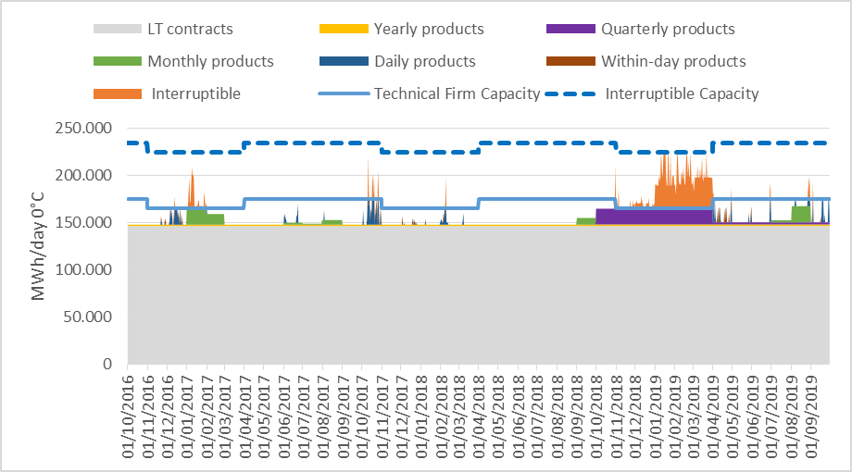

**Figure 20: Status of booked capacity at VIP Pirineos, France to Spain direction**



**Figure 21: Booked capacities / capacity type and products from France to Spain on the French side**

Capacity booked via OSP (Open Seasons) is the most important in terms of quantity.

Some points to be noticed over the studied period:

1. Yearly products are consecutively booked because the capacity volume proposed in line with CAM code is very low: 1,9 GWh/day;
2. The Quaterly products were totally marketed for the first 2 quarters of the TRF (trading Region France) anticipating the decrease of the PEG price in France;
   1. The auction of Q1 2019 (January-March) quarterly capacity product ended after two weeks and 50 auction rounds. The 16.675 GWh/day offered in the direction France to Spain were fully allocated, with a premium of around €52/MWh/day over and above the quarterly tariff of €154/MWh/day. As a result, the interruptible capacity band of 60 GWh/day was commercialized for each gas day of the two quarters and part of this capacity was booked all days from December 27th to March 31st. It is worth noting that interruptible capacity in France is only offered on day-ahead and within-day basis.
3. The Interruptible capacity thru Daily product were booked as an optimization of the total capacity, only when firm capacity was saturated.
4. The global booking has increased by 8% of the total technical capacity.

Here is the vision focusing on the Firm capacities:



**Figure 22: Booked capacities / capacity type and products from France to Spain on the French side**

Firm capacity subscription level has increased from 89 to 94% thanks to bundled capacity over the studied period: stable 86% with unbundled capacity associated with an increase of 3 to 8% of bundled capacity.

**Spanish side**

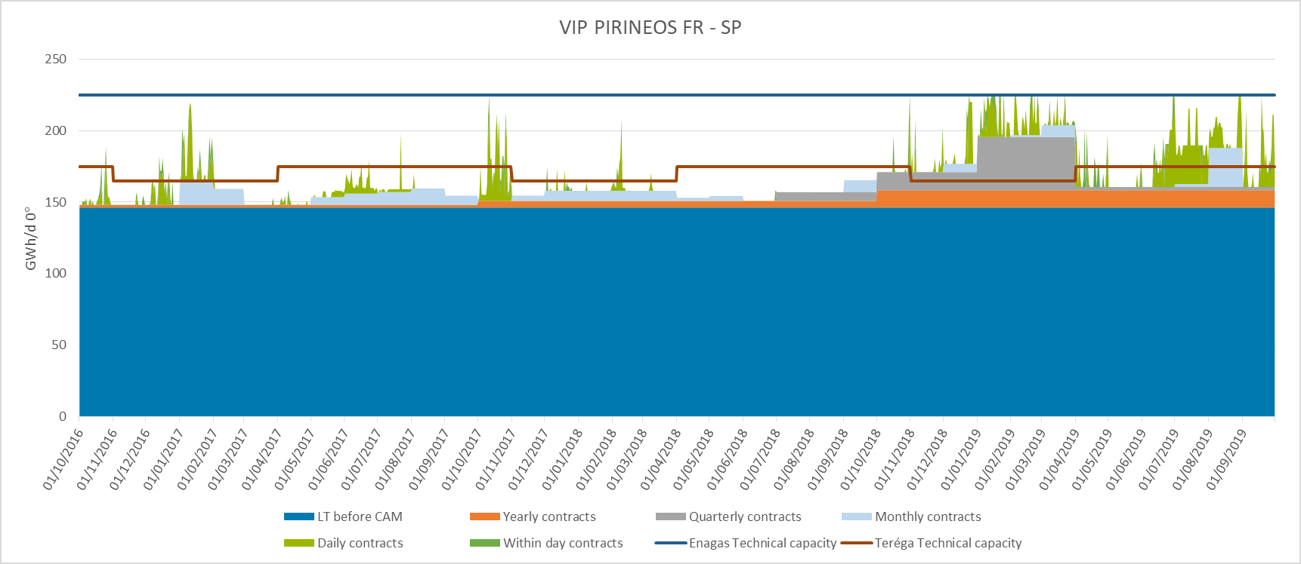

Figure 23: Status of booked capacity by product at VIP Pirineos, France to Spain direction

As it can be seen, LT contracts previous to CAM NC prevail over the rest of the products during the whole period, representing 87% of the total booked capacity in this direction.

Furthermore, during the last year there was more participation on the Yearly and Quarterly auctions than during the first two years.

Regarding daily products, it should be noted the increase in the bookings of this type of product in 2018 (5.2% of the total booked capacity) compared with the first two years (1.99% and 1.40% of the total booked capacity). The same conclusion applies to the within-day product, 0.68% of the total booked capacity in 2018 compared with 0.58% and 0.28% respectively.

The next table shows the percentage that each kind of product represents within the total booked capacity at this interconnection point on the Spanish side.

|  |  |  |  |  |  |  |
| --- | --- | --- | --- | --- | --- | --- |
|  | **% Booked capacity by time horizon versus total booked capacity** | | | | | |
|  | **LT contracts** | **Yearly product** | **Quarterly product** | **Monthly product** | **Daily product** | **Within-day product** |
| **2016** | 92.75% | 1.11% | 0.00% | 3.57% | 1.99% | 0.58% |
| **2017** | 91.99% | 2.84% | 0.97% | 2.43% | 1.49% | 0.28% |
| **2018** | 78.40% | 6.49% | 7.21% | 2.03% | 5.20% | 0.68% |
| **Average** | 87.71% | 3.48% | 2.73% | 2.68% | 2.89% | 0.51% |

**Table 13: Booked capacities from France to Spain on the Spanish side**

As it can be seen, there was a higher assignment in yearly, quarterly, daily and within-day products during the last year than during the first two years.

Until November 2018, the date on which the French Market Merger took place, daily and within-day bookings were done only in the winter period, however, after the French Market Merger, daily and within-day bookings are much more frequent, especially when the price spread between the two markets was attractive enough (see Chapter 5).

#### South North Flow Direction

**French side**

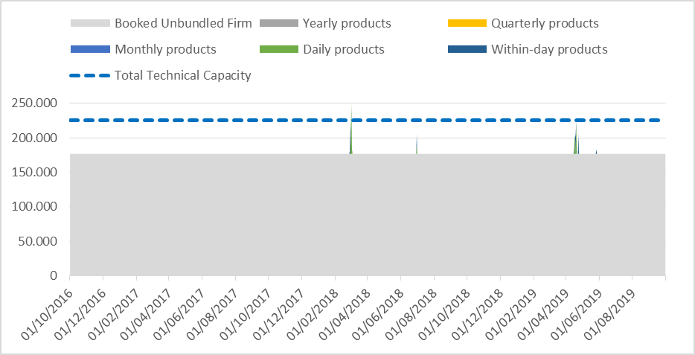

Figure 24: Status of booked capacity by product at VIP Pirineos, Spain to France direction

Status of booked capacity at VIP Pirineos, Spain to France direction



**Table 14: Booked capacities from Spain to France on the French side**

Booked capacities from Spain to France on the French side

In Spain to France direction, 79% of the total firm capacity is booked OSP contracts. The rest of the bookings remain marginal and concerns particular events with price signals, on short-term products (daily and intraday).

Note: at the end of 2019, massive delivery of LNG at global scale set a price taker position for Europe that decreased gas hub prices. A permanent south to north physical flow is observed in November and December 2019 (out of the period of study but relevant to be mentioned).

**Spanish side**

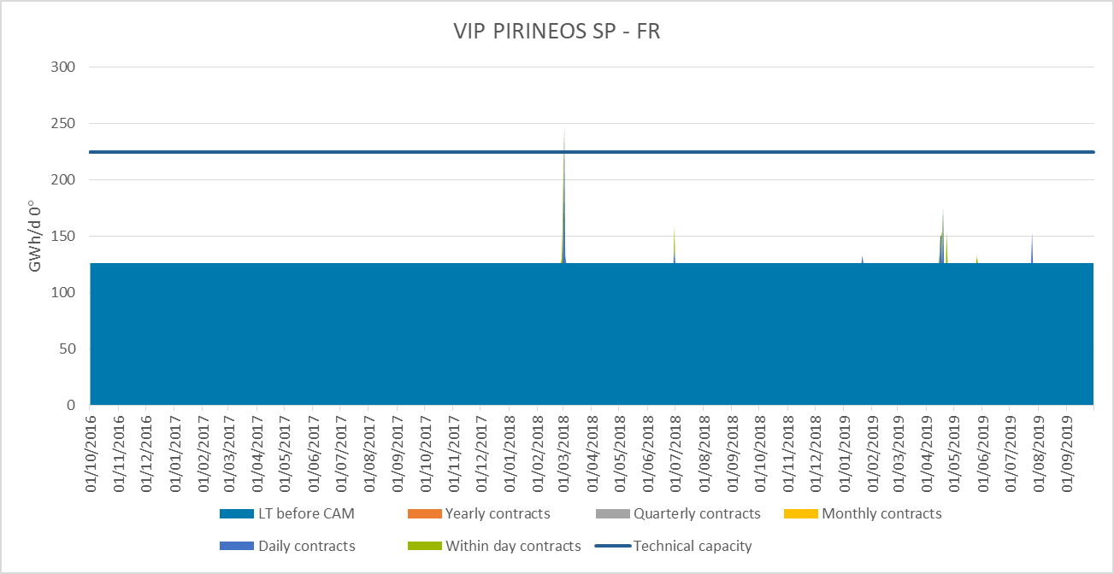

Figure 25: Status of booked capacity by product at VIP Pirineos, France to Spain direction

In this direction 99.65%, on average for the whole studied period, of the booked capacity was allocated during the Open Season. Furthermore an insignificant amount of capacity was booked in yearly auctions (2016 and 2017). Finally, daily products were only allocated in 10 days of the period under study and within-day products in 12 days.

|  |  |  |  |  |  |  |
| --- | --- | --- | --- | --- | --- | --- |
|  | **% Booked capacity by time horizon versus total booked capacity** | | | | | |
|  | **LT contracts** | **Yearly product** | **Quarterly product** | **Monthly product** | **Daily product** | **Within-day product** |
| **2016** | 100% | 0.00% | 0.00% | 0.00% | 0.00% | 0.00% |
| **2017** | 99.37% | 0.00% | 0.00% | 0.00% | 0.39% | 0.24% |
| **2018** | 99.57% | 0.00% | 0.00% | 0.00% | 0.28% | 0.15% |
| **Average** | 99.65% | 0.00% | 0.00% | 0.00% | 0.22% | 0.13% |

**Table 15: Capacity bookings from Spain to France on the Spanish side by time horizon**

In addition, and as it was commented on previous chapters, it should be mentioned that in the 2nd of March, 2018 gas year, a total amount of 21.9 GWh/d were booked via OSBB, which is the reason why booked capacity is above the technical capacity. The reason lying behind of this capacity bookings is explained in the chapter 3.1.1.2.

### VIP Ibérico

As in the case of VIP Pirineos, hereafter is a representation of all kinds of products, i.e. LT contracts, Yearly, Quarterly, Monthly, Daily and Within-Day products per side and direction.

#### Spain to Portugal direction

**Portuguese side**

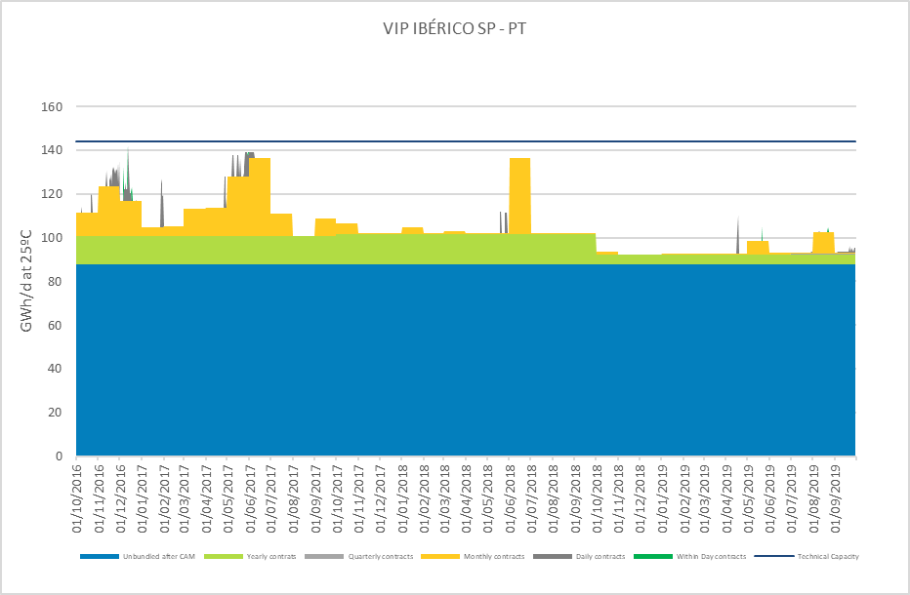

Figure 26: Status of booked capacity by product at VIP Ibérico, Spain to Portugal direction

By looking at figure 21, it is clearly noticeable how long-term contracts dominated the booking during the analyzed period. Yearly (bundled) bookings show themselves stables through gas year 2016-2017 and 2017-2018, but with a significant drop in 2018-2019. As explained previously in 2.1.2.1, the increase in LNG supply, mainly US driven, meant a reduction in its price, which made LNG deliveries at Iberia more competitive than Algerian Gas. The same trend happened as well for the rest of the products (Q, M, D, WD), due to the same reason of less dependence on Algerian NG (and more on LNG). One can also find that the peak demands in the summer are mostly covered resorting to monthly booking (short-term solution) with daily bookings complementing the rest.

In table 17, one can find a quantified approach to the depiction of booked capacity, presenting the weight of each product within the booked capacity.

|  |  |  |  |  |  |  |
| --- | --- | --- | --- | --- | --- | --- |
|  | **% Booked capacity by time horizon versus total booked capacity** | | | | | |
|  | **Unbundled after CAM** | **Yearly product** | **Quarterly product** | **Monthly product** | **Daily product** | **Within-day product** |
| **2016-2017** | 75,77% | 11,27% | 0,03% | 11,73% | 1,10% | 0,10% |
| **2017-2018** | 83,03% | 13,17% | 0,00% | 3,66% | 0,14% | 0,00% |
| **2018-2019** | 93,05% | 4,91% | 0,06% | 1,77% | 0,18% | 0,03% |
| **Average** | 83,95% | 9,79% | 0,03% | 5,72% | 0,47% | 0,04% |

**Table 16: Capacity bookings from Spain to Portugal on the Portuguese side by time horizon**

**Spanish side**

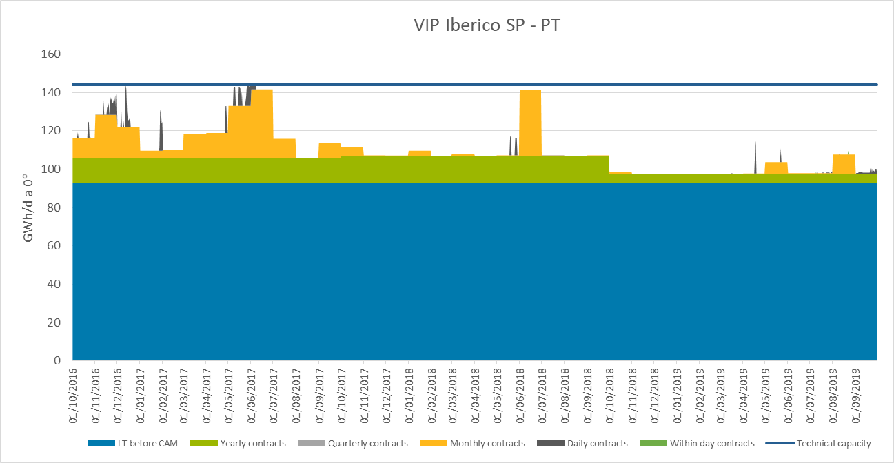

Figure 27: Status of booked capacity by product at VIP Ibérico, Spain to Portugal direction

Again, the capacity that prevails over the rest is the one coming from LT contracts previous to CAM (85% of total booked capacity), followed by capacity booked through yearly auctions (9% of total booked capacity) and monthly auctions (5% of total booked capacity). Shippers used to book capacity in the monthly auctions, mostly in summer (June). However, in 2018, there was a change in trend because of the lower tariffs in the Sines LNG terminal and the increment of the global liquefaction capacity driven by the US which eventually resulted in a decrease of the capacity allocated on PRISMA (Y, Q, M, D, WD) in this direction and an increase in the capacity allocated in the Portugal to Spain direction. In fact, during the last year, the capacity booked in yearly and monthly auctions experimented and important drop.

It has to be considered that at this direction only one year has offered until 2018, due to Portuguese national regulation.

The next table shows the percentage of each product within the total booked capacity on the Spanish side.

|  |  |  |  |  |  |  |
| --- | --- | --- | --- | --- | --- | --- |
|  | **% Booked capacity by time horizon versus total booked capacity** | | | | | |
|  | **LT contracts** | **Yearly product** | **Quarterly product** | **Monthly product** | **Daily product** | **Within-day product** |
| **2016** | 76.85% | 10.82% | 0.03% | 11.26% | 1.04% | 0.00% |
| **2017** | 83.80% | 12.58% | 0.00% | 3.49% | 0.13% | 0.00% |
| **2018** | 93.41% | 4.69% | 0.06% | 1.65% | 0.19% | 0.01% |
| **Average** | 84.68% | 9.36% | 0.03% | 5.47% | 0.46% | 0.00% |

**Table 17: Capacity bookings from Spain to Portugal on the Spanish side by time horizon**

#### Portugal to Spain direction

**Portuguese side**

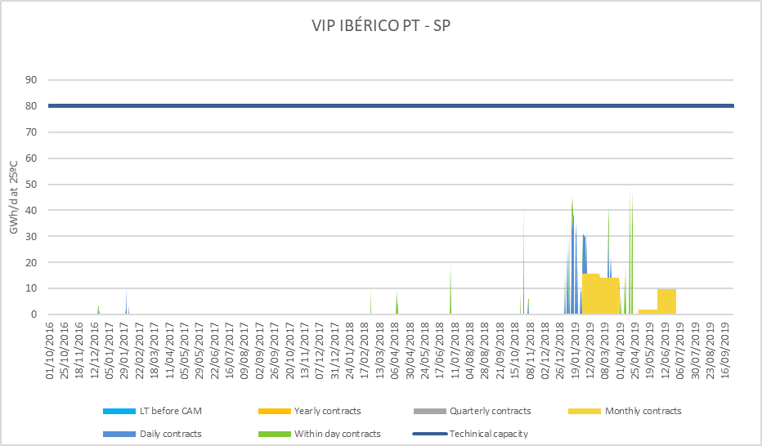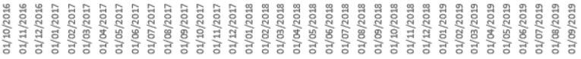

**Figure 28: Status of booked capacity by product at VIP Ibérico, Portugal to Spain direction**

From figure 23, one can observe that the increase in activity of capacity booking in the direction from Portugal to Spain relied mostly on short term bookings. Starting from within day, daily and evolving eventually to monthly bookings. Therefore, it is possible to notice how the use of the interconnection in this direction became more regular and sustained, resulting in prolonged periods of booked flow inversion.

Table 17 presents the weight of each product within the booked capacity on the Portuguese side:

|  |  |  |  |  |  |  |
| --- | --- | --- | --- | --- | --- | --- |
|  | **% Booked capacity by time horizon versus total booked capacity** | | | | | |
|  | **LT contracts** | **Yearly product** | **Quarterly product** | **Monthly product** | **Daily product** | **Within-day product** |
| **2016-2017** | 0,00% | 0,00% | 0,00% | 0,00% | 86,84% | 13,16% |
| **2017-2018** | 0,00% | 0,00% | 0,00% | 0,00% | 10,87% | 89,13% |
| **2018-2019** | 0,00% | 0,00% | 0,00% | 59,98% | 24,54% | 15,48% |
| **Average** | 0,00% | 0,00% | 0,00% | 19,99% | 40,75% | 39,26% |

Table 18: Booked capacities from Portugal to Spain on the Portuguese side

**Spanish side**

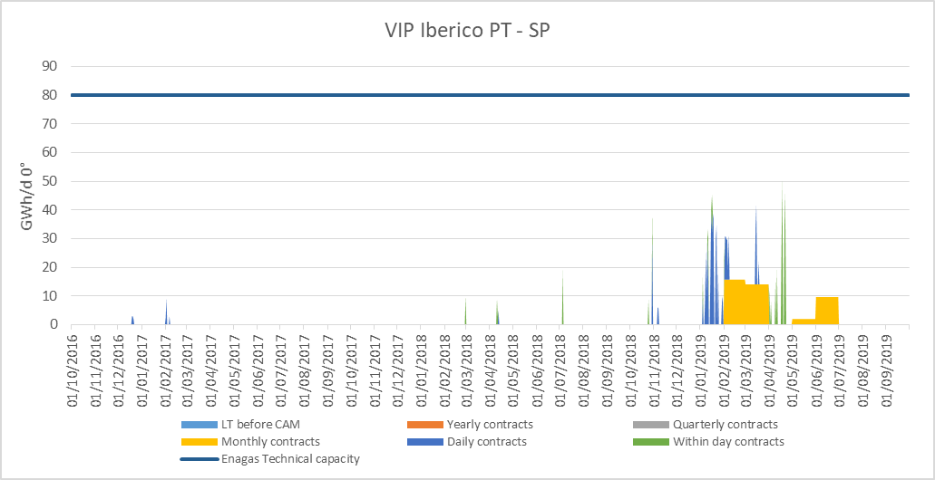

Figure 29: Status of booked capacity by product at VIP Ibérico, Portugal to Spain direction

During the period analysed capacity was booked only in short term basis and very few days:

1. Capacity booked in daily auctions: 12 days in the period between October 2016 and 31 December 2018 and 25 days from January to September 30th 2019.
2. Capacity booked in within-day auctions: 7 days in the period between October 2016 and 31 December 2018 and 12 days from January to September 30th 2019.
3. From January 2019, shippers also booked capacity on a monthly basis: February, March, May and June. This corresponds to the drop in the Sines tariffs, so that there was reversed flow for the first time.

The next table shows the percentage of each product within the total booked capacity on the Spanish side.

|  |  |  |  |  |  |  |
| --- | --- | --- | --- | --- | --- | --- |
|  | **% Booked capacity by time horizon versus total booked capacity** | | | | | |
|  | **LT contracts** | **Yearly product** | **Quarterly product** | **Monthly product** | **Daily product** | **Within-day product** |
| **2016** | 0.00% | 0.00% | 0.00% | 0.00% | 98.92% | 1.08% |
| **2017** | 0.00% | 0.00% | 0.00% | 0.00% | 10.87% | 89.13% |
| **2018** | 0.00% | 0.00% | 0.00% | 59.98% | 26.68% | 13.34% |
| **Average** | 0.00% | 0.00% | 0.00% | 19.99% | 45.49% | 34.52% |

**Table 19: Booked capacities from Portugal to Spain on the Spanish side**

However, during the last quarter of 2019, capacity bookings in the Spain to Portugal direction decreased again.

### North-South Link

Not applicable as there were no unbundled capacity products and no long-term contracts.

## Interruptible capacity

### VIP Pirineos

#### North to South direction

**French side**

On the French side, an extra 60 GWh/day of interruptible capacity is offered thru daily product only when 98% of the technical firm capacity is booked.

Triggering of interruptible capacity per gas year:

|  |  |
| --- | --- |
| GY 2016-17 | 27 days |
| GY 2017-18 | 10 days |
| GY 2018-19 | 131 days |

For the gas year 2018-2019 (TRF effect), the subscription level reached 4% (10 GWh/day on average) of the total technical capacity, concentrated over the first two quarters.

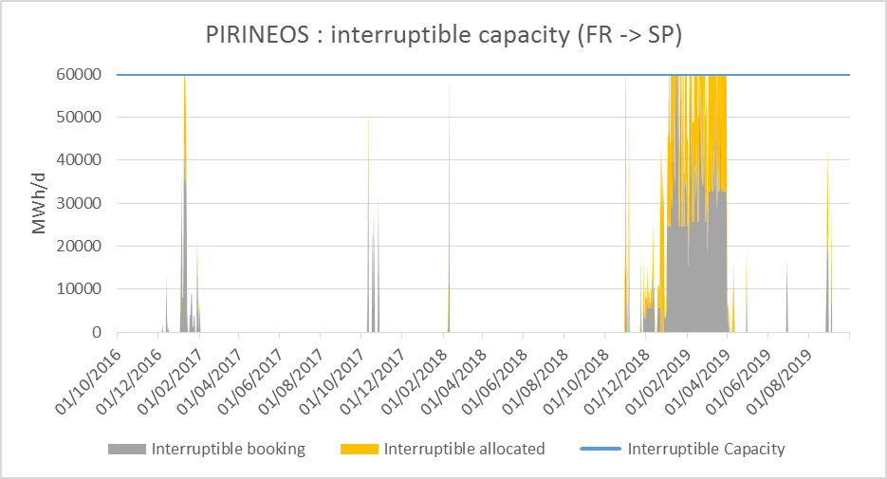

**Figure 30: Status of interruptible booked capacity by product at VIP Pirineos, France to Spain direction**

**Spanish side**

For this period, following the [Commission Regulation (EU) 2017/459 of the 16th of March 2017](https://eur-lex.europa.eu/legal-content/EN/TXT/PDF/?uri=CELEX:32017R0459&from=es), contractual interruptible capacity was offered on the Spanish side. This interruptible capacity is only offered if 100% of the firm daily capacity has already been contracted. The amount of capacity to be offered as contractual interruptible capacity will be calculated taking into account nominations by network users.

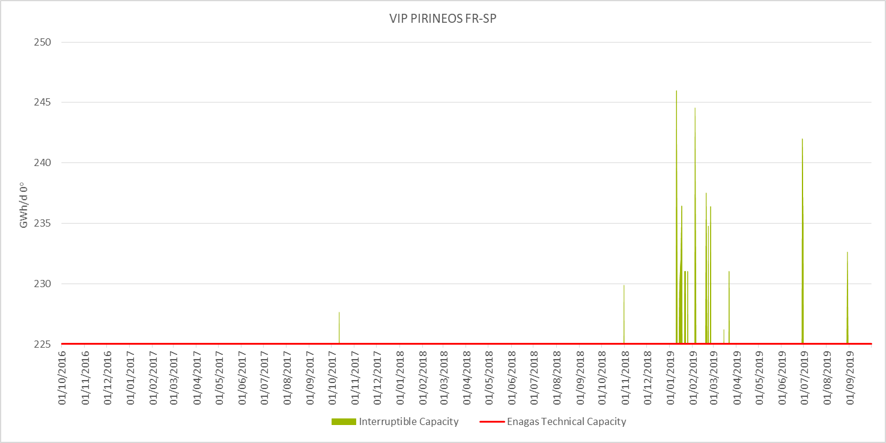

Figure 31. Interruptible capacity booked on VIP Pirineos - France to Spain direction

The following table shows the number of days in which interruptible capacity has been booked per year.

|  |  |  |  |
| --- | --- | --- | --- |
| **VIP PIRINEOS  (FR-ES) GWh/d** | **Spanish side** | | |
| Days with Interruptible Capacity bookings | Maximum Interruptible capacity booked | Maximum vs Technical capacity |
| **2016** | 0 | 0 | 0% |
| **2017** | 1 | 2.63 | 1.2% |
| **2018** | 20 | 20.97 | 9.3% |

As it can be seen, there have been interruptible capacity bookings for each gas year of the studied period. The highest peak was registered on 10th of January, 2018 gas year, when interruptible capacity bookings ascended up to 20.97 GWh/d (9.3% of technical firm capacity). The peak for the 2017 gas year was registered on 11th of November.

#### South to North direction

**French side**

No interruptible capacity proposed on the French side.

UBI (Use-it and Buy-it) available.

**Spanish side**

The interruptible capacity offer follows the same methodology as the one described for the North to South direction on the Spanish side previously.

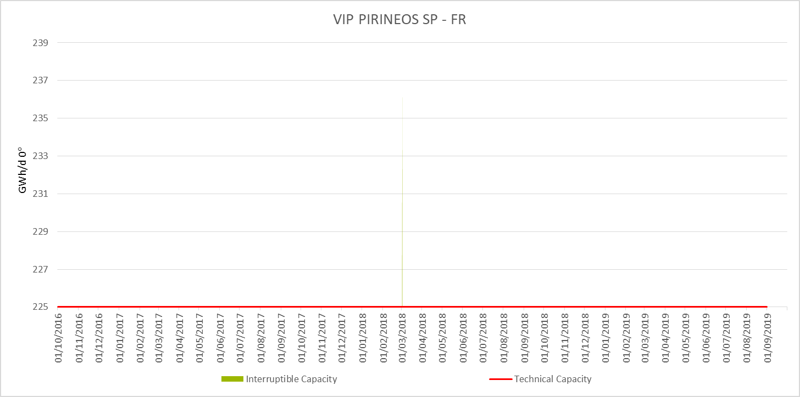

Figure 32. Interruptible capacity booked on VIP Pirineos - Spain to France direction

There was only one day in 2017 gas year in which interruptible capacity was booked: 2nd of March 2018. The peak reached on when interruptible capacity bookings ascended up to 12 GWh/d (5.3% of technical firm capacity). No interruptible capacity bookings were registered during the 2016 and 2018 gas years.

### VIP Ibérico

#### Spain to Portugal direction

**Spanish side**

As it occurred on VIP Pirineos, interruptible capacity on VIP Ibérico on the Spanish side is offered when there is contractual congestion (not physical congestion). The offered capacity is calculated according to the same algorithm and the same variables that apply to the calculations on VIP Pirineos.

There has not been any interruptible capacity bookings at VIP Ibérico in the Spain to Portugal direction on the studied period.

**Portuguese side**

Interruptible capacity was offered on the Portuguese side in compliance with the [Commission Regulation (EU) 2017/459 of the 16th of March 2017](https://eur-lex.europa.eu/legal-content/EN/TXT/PDF/?uri=CELEX:32017R0459&from=es). Interruptible capacity is only offered once if firm daily capacity is totally booked. The capacity to be offered as interruptible capacity corresponds to the idle capacity of the network users who booked firm capacity.

There has not been any interruptible capacity bookings at VIP Ibérico in the Spain to Portugal direction on the studied period.

#### Portugal to Spain direction

**Spanish side**

The interruptible capacity offer follows the same methodology as the one described for the Spain to Portugal direction on the Spanish side previously.

There has not been any interruptible capacity bookings at VIP Ibérico in the Spain to Portugal direction on the studied period.

**Portuguese side**

Interruptible capacity was offered on the Portuguese side in compliance with the [Commission Regulation (EU) 2017/459 of the 16th of March 2017](https://eur-lex.europa.eu/legal-content/EN/TXT/PDF/?uri=CELEX:32017R0459&from=es). Interruptible capacity is only offered once, if firm daily capacity is totally booked. The capacity to be offered as interruptible capacity corresponds to the idle capacity of the network users who booked firm capacity.

There has not been any interruptible capacity bookings at VIP Ibérico in the Spain to Portugal direction on the studied period.

## Secondary capacity trade

### VIP Pirineos

**Teréga´s secondary Market**

The Secondary Market takes place on the PRISMA Platform.

35 trades were posted on the secondary market over the studied period.

The exchange of capacities is below 5% of technical capacity (CTN) and preferentially concerns long term contracts capacities.

It is worth noting that Spain to France capacity was exchanged in March 2019 for future periods up to 2023 (22% of CTN).

**Enagas´ Secondary Market**

In Enagas’ side 32 trades were posted on PRISMA platform during the studied period. From those 32 trades, 27 were accepted and concluded, 1 was expired and 4 were rejected. All trades were OTC (Over-The-Counter). In addition, more than 96% of the trades were related to unbundled capacity, with more than 77% percent of them associated with the South to North direction. Vast majority of the operations were carried out in 2017 (65%).

Overall, and by the total volume that was negociated and the number of trades on the platform, the secondary market does not seem to be claiming for the attention of the shippers. Rather than that, and as most of the capacity offered is unbundled, the platform seems to be more a “last resource” to get capacity if required.

### VIP Ibérico

No trades were received for the VIP Ibérico.

### North-South link

There were no exchanges on the secondary market, except a particular case (for certain intensive industrial consumers). On the North → South link, around 7 GWh/day were usually exchanged during the period considered in this study.

# Assessment of the use of the interconnections for the period October 2016 – September 2019

The purpose of this section is to analyse the use of the booked capacity. For the abovementioned reason, all calculations and percentages represented on this part are calculated with respect to the total booked capacity of each side of the VIP.

## Relationship between technical capacity, capacity bookings, use of the booked capacity and flows

### VIP Pirineos

#### North South flow direction

Hereafter you can find graphs on the technical capacity, capacity bookings, use of the booked capacity and flows at both French and Spanish sides.

**Analysis on the utilization of booked capacity (French side)**

Figure 33: Booked capacity, allocation from France to Spain

|  |  |  |  |
| --- | --- | --- | --- |
| **Utilization rate of Firm capacity at VIP Pirineos Exit France** | | | |
|  | Minimum | Average | Maximun |
| **Gas year 2016-17** | 35% | 79% | 100% |
| **Gas year 2017-18** | 16% | 66% | 100% |
| **Gas year 2018-19** | 49% | 96% | 100% |
|  |  |  |  |
| **Utilization rate of total capacity at VIP Pirineos Exit France** | | | |
|  | Minimum | Average | Maximun |
| **Gas year 2016-17** | 23% | 52% | 85% |
| **Gas year 2017-18** | 10% | 43% | 86% |
| **Gas year 2018-19** | 31% | 67% | 100% |

**Table 20: Utilisation rates at VIP Pirineos on the French side**

**Comment:** Utilization rates from above tables show that the capacity booked at the VIP Pirineos is used with an increasing trend over the period. The firm capacity booked is used with an average of 96% (+17% in 3 years) with several days of saturation (100% of 170 GWh/day). The global technical capacity is used with an average of 67% (+15% in 3 years) with some days of saturation (100% of 230 GWh/day) when interruptible was triggered.

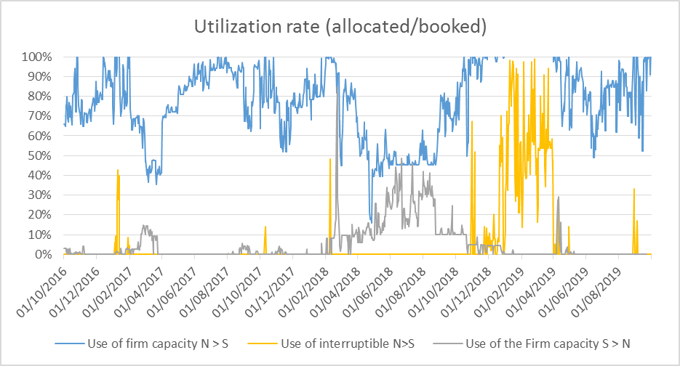

**Figure 34: Allocation vs booked capacity**

**Analysis on the utilization of booked capacity (Spanish side)**

Compared to the data of the previous gas years, in the gas year 2018 the utilization of the capacity significantly increased. The average rate of utilization raised up to 82% and the maximum utilization rate was 97%. In deeper detail, 64% of the days the utilization rate was at least 80% and 44% of the days it was above 90%.

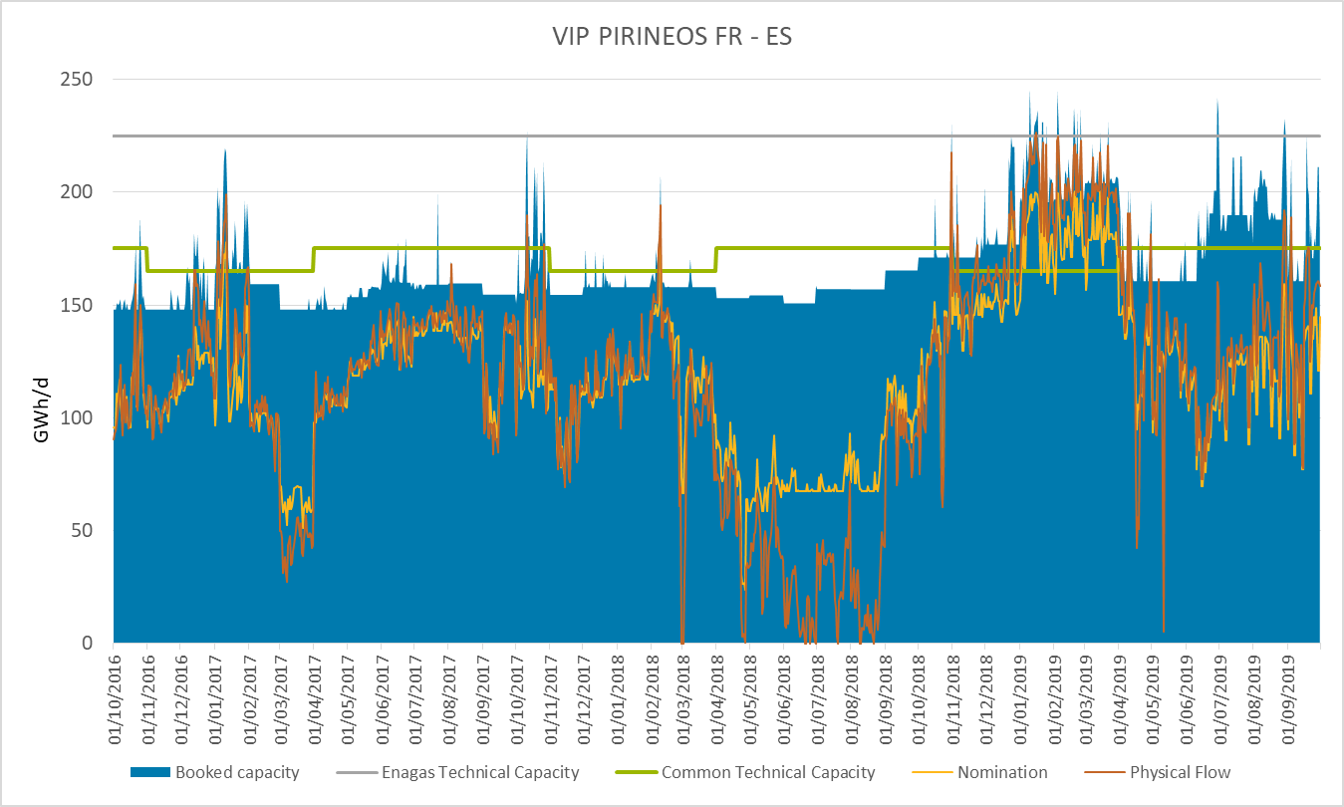

Figure 35: Booked capacity, nomination and physical flow from Spain to France on the Spanish side

|  |  |  |  |
| --- | --- | --- | --- |
| Utilization rates at VIP Pirineos versus booked capacity | | | |
| Period | Minimum | Average | Maximum |
| Gas year 2016 | 36% | 76% | 95% |
| Gas year 2017 | 16% | 62% | 94% |
| Gas year 2018 | 43% | 82% | 97% |

**Table 21: Utilization rates from Spain to France on the Spanish side**

Specifically, the graph shows a high utilization during the period between November 2018 and March 2019 (both months included). There was an enormous interest in importing gas from France to Spain. In this period, the minimum utilization rate was 84%, the average utilization rate was 94%, the maximum utilization rate was 97% and, for 91% of the days, the utilization rate was above 90%. See chapter *0* for more details related about market conditions.

Besides, a seasonal effect can be also seen through a slightly decrease of the utilization during the summer period. However, this effect was less pronounced than the last year studied.

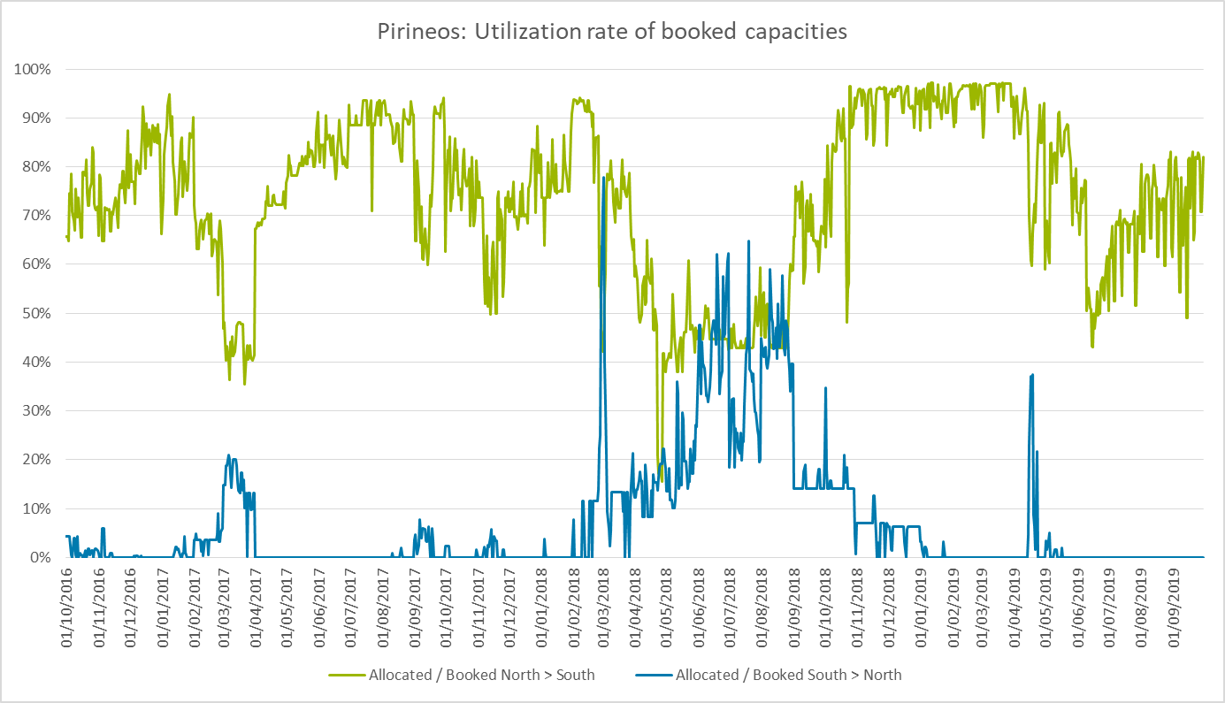

Figure 36: Indicators at VIP Pirineos (Spanish side)

#### South-North flow direction

**Analysis of the utilization of the booked capacity in the French side**

Figure 37: Booked capacity, allocation from Spain to France on the French side

|  |  |  |  |
| --- | --- | --- | --- |
| **Firm Utilization rates at VIP Pirineos** | | | |
|  | Minimum | Average | Maximun |
| **Gas year 2016-17** | 0% | 1% | 15% |
| **Gas year 2017-18** | 0% | 12% | 85% |
| **Gas year 2018-19** | 0% | 2% | 29% |
| *in this direction : total capacity is firm* | |  |  |

Remark: the reverse flow event in March 2018 must be highlightled - a net physical flow from Spain to France on the 1st of March (115 GWh/day) and on the 2nd of March (133 GWh/day) was recorded.

**Analysis on the utilization of the booked capacity in the Spanish side**

VIP Pirineos is usually set as an entry point for the Spanish gas system and then, utilization rate in the South to North direction is rare. Actually, the average value in the studied period is 7%. However, during summer 2018, the utilization increased significantly, arriving to levels above 60% of utilization.

Nevertheless, under specific market conditions, the capacity of the interconnection is highly booked and used. Here, it is worth mentioning March 2nd 2018. That day, in the French side, the booked capacity was 247.5 GWh/d (225 technical capacity + 22.5 OSBB) and in the Spanish side was 259 GWh (225 technical capacity + 21.9 OSBB + 12.4 interruptible). In spite of the fact that the booked capacity was +34 GWh over the firm technical capacity, it was not necessary to interrupt any capacity as the nominations accounted only for 77.8% of the total booked capacity. This episode took place due to an unexpected cold snap at the end of the winter that led to a drop in LNG levels and underground stocks in central Europe. That is why, during the following summer, shippers used the IP in the Spain to France direction to refill the underground storages.

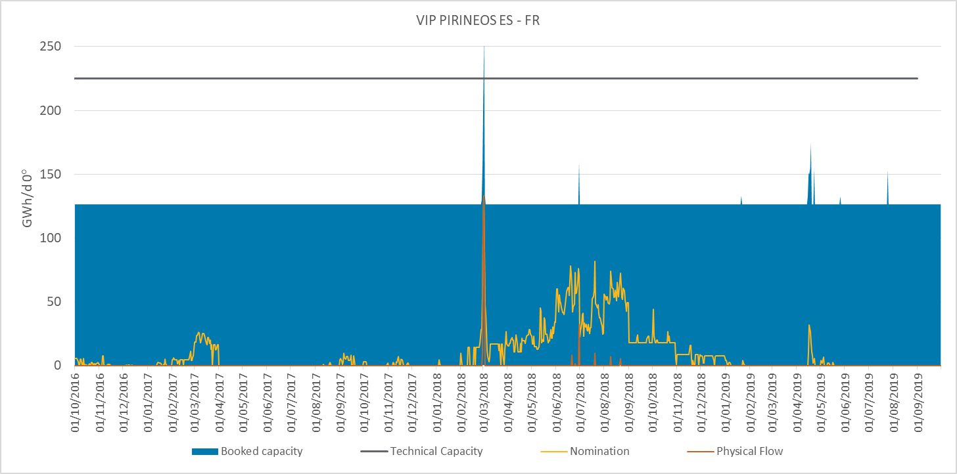

Figure 38: Booked capacity, nomination and physical flow from Spain to France on the Spanish side

There was also another period with some commercial activity in the South to North direction: April 2019. In that case, the spread between markets was attractive enough to make shippers look for opportunities in France. Please see chapter *0* for more details on the market conditions these days.

### VIP Ibérico

#### Spain to Portugal direction

As in previous sections, hereunder there is a representation of the technical capacity, capacity bookings, use of booked capacity and flows in both the Portuguese and the Spanish side.

**Analysis of the capacity utilization in the Spanish side**

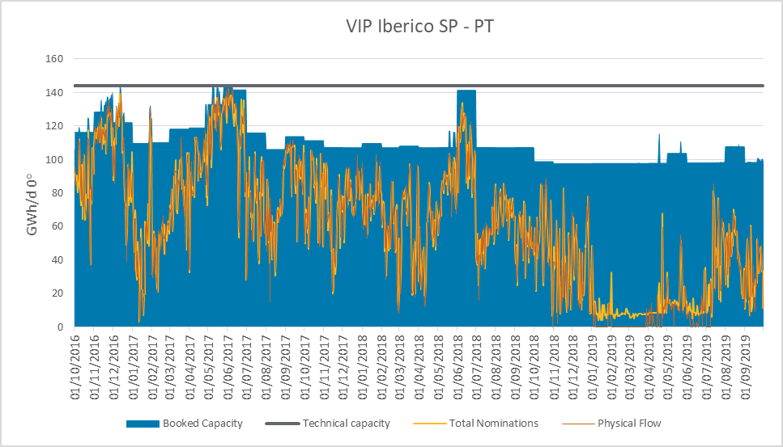

Figure 39: Use of the interconnection Spain to Portugal direction

In the last gas year studied there was an overall decrease in the amount of the capacity booked (see chapter 2 for more details) and in the utilization of that capacity. Even if the maximum utilization in each gas year still remains quite high (above 85%), the average utilization shows a substantial fall in the interest of exporting gas from Spain to Portugal (from 72% in the gas year 2016 to 26% in the gas year 2018). Indeed, after the approval of the new Portuguese tariffs in mid-2018, there was a plunge in the use of the interconnection in the Spain to Portugal direction (other factors might also have some impact, such as: price balance between LNG and pipeline). As it can be observed, the use of the capacity increased during the months of June and July in 2019 respect to the lower nominations of the previous months.

|  |  |  |  |
| --- | --- | --- | --- |
| Utilization rates at VIP Ibérico versus booked capacity | | | |
| Period | Minimum | Average | Maximum |
| Gas year 2016-2017 | 3% | 72% | 100% |
| Gas year 2017-2018 | 10% | 62% | 95% |
| Gas year 2018-2019 | 4% | 26% | 86% |

**Table 22: Utilisation rates from Spain to Portugal on the Spanish side**

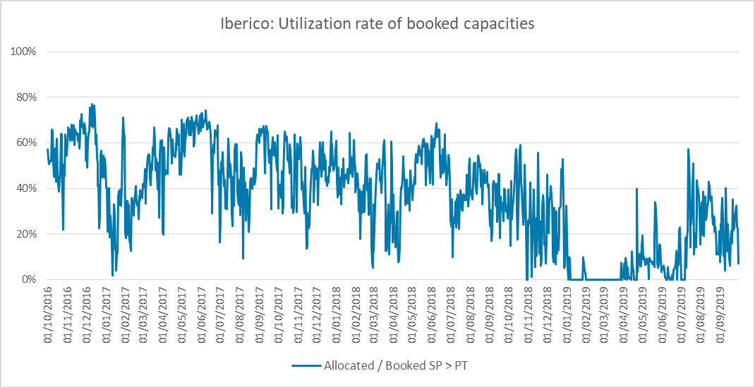

Figure 40: Indicators at VIP Ibérico (Spanish side)

Regarding the utilization rates of the booked capacities, it should be noted that the lower peaks of utilization rates in the Spain to Portugal direction occurred during the first half of the 2019 year, which corresponds to the inversion of the flow direction in the interconnection due to the LNG supply increase from Sines LNG plant (for the previously commented reasons).

**Analysis of the capacity utilization in the Portuguese side**

As explained previously in 2.1.2.1, the increase in LNG supply, mainly US driven, meant a reduction in its price, which made LNG deliveries at Iberia more competitive than Algerian Gas. As such, Iberian demand saw an increase in supply from LNG as compared to the Algerian Gas. Together with small edge given by the reduction in tariffs at Sines, made it more profitable to some network users to supply gas to some of its clients in Spain through Portugal, using the interconnection. The same reduction behavior happened as well on the rest of the products (Q, M, D, WD), due to the same reason of less dependence on Algerian NG, and more on LNG. One can also find that the peak demands in the summer are mostly covered resorting to monthly booking (short-term solution) with daily bookings complementing the rest.

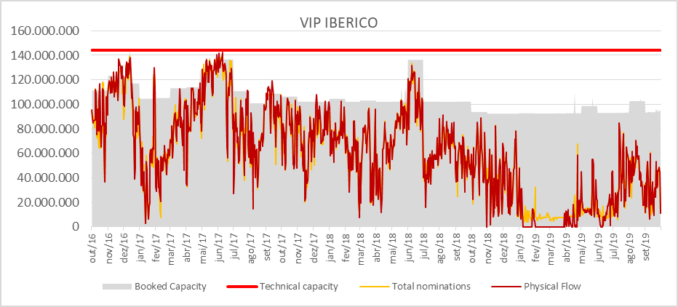Figure 41: Booked capacity, nomination and physical flow from Spain to Portugal on the Portuguese side

|  |  |  |  |
| --- | --- | --- | --- |
| Utilization rates at VIP Ibérico | | | |
|  | Minimum | Average | Maximun |
| Gas year 2016-2017 | 3% | 75% | 100% |
| Gas year 2017-2018 | 10% | 65% | 99% |
| Gas year 2018-2019 | 4% | 27% | 91% |

**Table 23: Utilisation rates at VIP Ibérico on the Portuguese side**

Table 24 presents the utilization levels of VIP Ibérico.

#### Portugal to Spain direction

Again, hereunder there is a graph on the capacity booked, the utilization of the capacity and the physical flow in the interconnection, in the Portugal to Spain direction.

**Analysis of the capacity utilization in the Spanish side**

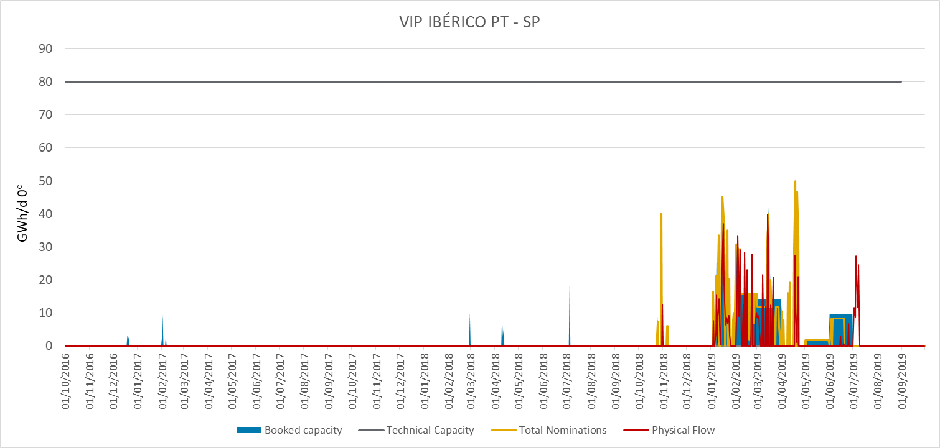

Figure 42: Use of the interconnection, Portugal to Spain direction

Traditionally, this interconnection has been an entry point to the Portuguese gas system and therefore, there have not been any contract or nomination in that direction. However, during the first semester of 2019, the overall trend changed and an interesting activity was registered. If we look deeper into the details, between January and April 2019 (both months included):

* The flow reversed 49 days (41% of the time)
* The average utilization rate was 60%
* Shippers used monthly products (see chapter 2 for more information about capacity booking)

|  |  |  |  |
| --- | --- | --- | --- |
| Utilization rates at VIP Ibérico  Spain to Portugal direction  January-April 2019 | | | |
|  | Minimum | Average | Maximun |
| Allocations vs Booked Capacity | 0% | 87% | 100% |

**Table 24: utilization rates from November 2018 to March 2019**

The reason is the approval of the above-mentioned lower tariffs in Portugal and the previously commented reasons (LNG supply increase, increment of global liquefaction capacity…) which was so attractive that allocation started diminishing and finally the flow reversed.

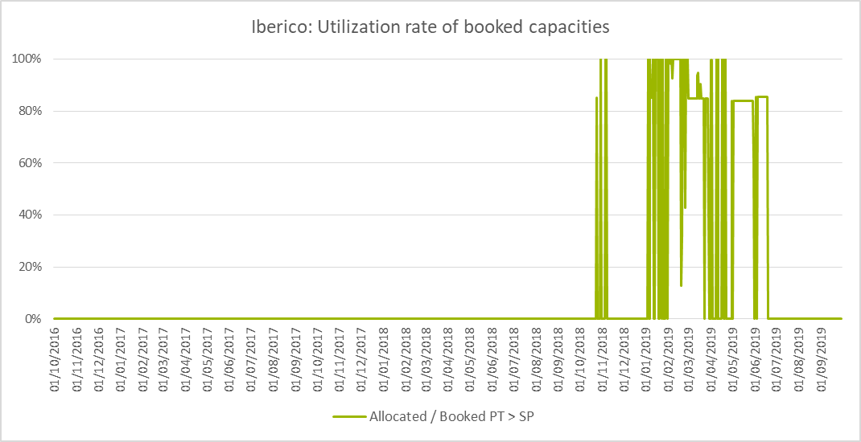

Figure 43: Allocated vs booked capacity, Portugal to Spain direction

Regarding the utilization rates of the booked capacities, it should be noted that the high peaks of utilization rates in the Portugal to Spain direction that occurred during November 2018and the first half of the 2019 year corresponds to a high usage of the short term contracts signed during that period, namely, due to the daily and within-day capacity usage with some presence of monthly capacity bookings (February, March, May and June of 2019).

**Analysis of the capacity utilization in the Portuguese side**

A reduction behavior happened for all non-long-term products (Q, M, D, WD), for the reasons explained above. One can also find that the peak demands in the summer are mostly covered resorting to monthly booking (short-term solution) with daily bookings complementing the rest.

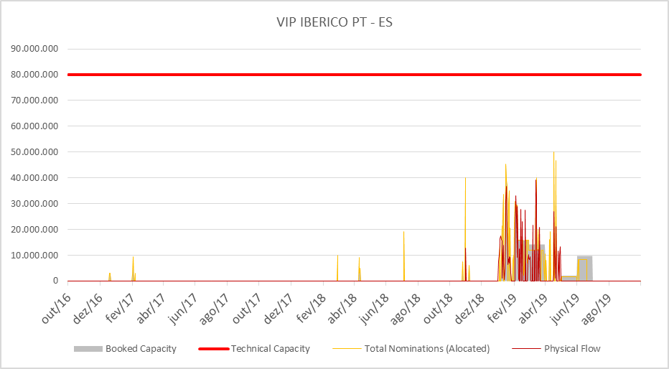 Figure 44: Booked capacity, nomination and physical flow from Portugal to Spain on the Portuguese side

|  |  |  |  |
| --- | --- | --- | --- |
| Utilization rates at VIP Ibérico  Spain to Portugal direction  January-April 2019 | | | |
|  | Minimum | Average | Maximun |
| Allocations vs Booked Capacity | 0% | 87% | 100% |

Table 25: Utilisation rates at VIP Ibérico on the Portuguese side

# Assessment of the gas flows and the congestion status

## Analysis of the VIP’s congestion status

### VIP Pirineos: France to Spain direction

According to ACER’s Annual Report on Contractual Congestion, an IP is considered congested whether at least one of the criteria set out in paragraph 2.2.3(1) of the Commission Guidelines on Congestion Management Procedures (“CMP GL”) is fulfilled. That is, an IP is considered congested when demand exceeds offer at the reserve price:

(a) for at least three firm capacity products with a duration of one month or

(b) for at least two firm capacity products with a duration of one quarter or

(c) for at least one firm capacity product with a duration of one year or more or

(d) where no firm capacity product with a duration of one month or more has been offered

In order to assess whether or not VIP Pirineos is congested, the results of the auctions that cleared with a premium price in the last gas years are listed below.



Table 26: Auctions that cleared with a premium price (duration equal than or greater than a month) at VIP Pirineos France to Spain direction

In view of the data, it can be set that VIP Pirineos in France to Spain direction was congested in the gas years 2016 and 2018 according to ACER’s definition.

* Two consecutive firm capacity auctions with a duration of one quarter cleared with a premium price in the gas year 2018-2019 so criteria b) was fulfilled that year.
* The three firm capacity auctions with a duration of one year cleared with a premium price so criteria c) is fulfilled in the three gas years.

Indeed, ACER’s Annual report on contractual congestion at IP (period covered 2018) included VIP Pirineos France to Spain direction as a congested IP side, for which the FDA UIOLI mechanism needs to be implemented according to paragraph 2.2.3(1) of the CMP GL, unless it is shown that a congested situation is unlikely to reoccur in the following three years.

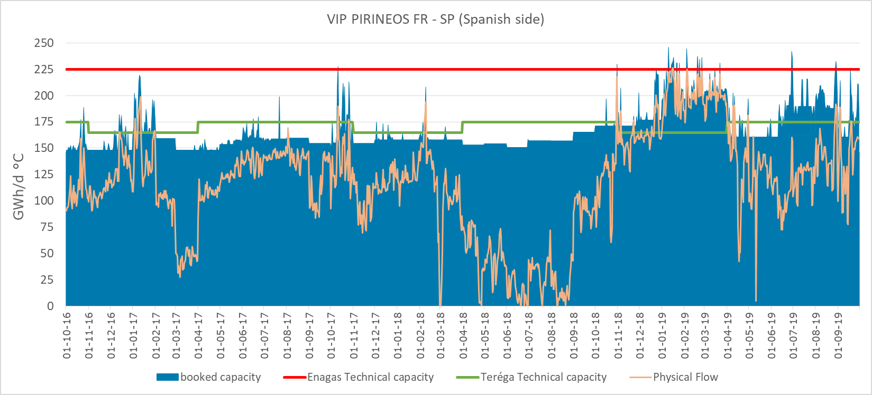

Figure 45: Booked capacity at VIP Pirineos

On the studied period, there were only 29 days (2.6% of the time) with a firm booked capacity above 98% of the technical capacity at VIP Pirineos, North South flow direction.

### VIP Pirineos: Spain to France direction

In this side of the IP, only a daily and a within day auction resulted with premium in the studied period.



Table 27: Auctions that cleared with a premium price at VIP Pirineos Spain to France direction

None of the criteria set out in paragraph 2.2.3(1) of the Commission Guidelines on Congestion Management Procedures have been fulfilled. Therefore, that IP side cannot be considered congested.

### VIP Ibérico: Spain to Portugal direction



Table 28: Auctions that cleared with a premium price at VIP Ibérico Spain to Portugal direction

During the analyzed period, there have been few days when booked capacity represented 100% of the total bundled offered capacity at VIP Ibérico Spain to Portugal direction.

As no such event occurred since May 2017, that IP cannot be actually considered congested..

### VIP Ibérico: Portugal to Spain direction

On the studied period, none of the auctions resulted with premium. None of the criteria set out in paragraph 2.2.3(1) of the Commission Guidelines on Congestion Management Procedures have been fulfilled and therefore that IP side cannot be considered congested.

## Use of anti-hoarding mechanisms in the region

### Long Term Use-It-Or-Lose-It

#### VIP Pirineos

In April 2017, April 2018 and April 2019 Enagas and Teréga performed the calculations according to regulation [*Circular 1/2013, de 18 de diciembre, de la Comisión Nacional de los Mercados y la Competencia, por la que se establecen los mecanismos de gestión de congestiones a aplicar en las conexiones internacionales por gasoducto con Europa*](https://www.boe.es/boe/dias/2014/01/17/pdfs/BOE-A-2014-459.pdf)*.*.

At Spanish side, contracted capacity shall be considered systematically underutilized, in particular, if at least one of the following conditions is met:

1. If, for two successive periods of six (6) consecutive months, starting on the first (1) October or the first (1) April, the utilization rate of the contract (calculated as the average used capacity per day in each period divided by the average booked capacity) is less than 80%, or
2. If, in both analysed periods, there are at least 60 days in which the shipper nominates above the 80% of its booked capacity and then renominates half or less of the capacity initially nominated.

If underutilization is detected in the previous analysis, it is checked if the shipper has offered capacity in the secondary market under reasonable conditions (in terms of price and amount of capacity offered). If that is not the case, capacity is susceptible of being withdrawn.

At French side, the Long-Term UIOLI procedure can be implemented if at least one of the following conditions are met:

1) same as first condition in the Spanish side

2) if Teréga has not been able to fulfil at least one duly justified request from another shipper for an annual subscription for a Daily Entry or Exit Capacity at the aforementioned Network Interconnection Point.

Regarding VIP Pirineos, the underused capacity in the North to South direction has been progressively reduced during the past two years, while in the South to North direction the tendency seems more irregular.

The LT UIOLI mechanism has not been applied due to the different triggering conditions in both countries. Further coordination in the application of this mechanism should be explored in order to keep moving forward in the regulatory harmonization in the Region.

#### VIP Ibérico

At the Spanish side, the Long-Term UIOLI procedure can be triggered if the same conditions as explained for the VIP Pirineos are fulfilled.

At the Portuguese side, the Long-Term UOILI wasn´t implemented during the covered period. However, with the establishment of Commission Regulation (EU) 2017/459 of 16th March 2017, yearly auction must offer capacity for, at least, the five upcoming years. This long-term capacity first started with gas year 2018-2019 yearly auction on 2nd July 2018, thus creating conditions for UIOLI mechanism to be applied first for gas year 2020-2021, in compliance with Commission Regulation (CE) 715/2009 of 13th July 2009. The procedure between REN and ENAGÁS, that describes the mechanism and its application at VIP IBÉRICO, was recently approved and can be consulted through the following link:

[https://www.acer.europa.eu/en/Gas/Regional_%20Intiatives/South_GRI/Documents/LT_UIOLI_VIP_Iberico-Final.pdf](https://extranet.acer.europa.eu/en/Gas/Regional_%20Intiatives/South_GRI/Documents/LT_UIOLI_VIP_Iberico-Final.pdf)

### Surrender capacity

#### Enagás

Although this mechanism has been implemented in Enagás since March 2014 (for the assignment of the gas year October 2014-2015), no shippers have requested to surrender their capacity so far.

#### Teréga

Following the application of the CRE’s Deliberation dated on27/06/2013, Teréga may accept any request to return Firm Capacity of one or several months held by a Shipper.

The request to return Firm Capacity specifies the interconnection point (PITT) in question, the quantity and the start and end dates.

This mechanism has not been required by the market for the concerned period.

#### REN

Although this mechanism has been implemented by REN since March 2014 (for the assignment of the gas year October 2014-2015), no shippers have requested to surrender their capacity so far.

### Oversubscription and Buy-Back

#### VIP Ibérico

This mechanism was implemented in April 2017 at VIP Ibérico. Oversubscription was offered 272 days in the direction from Spain to Portugal and 235 days in the [opposite direction](https://www.linguee.es/ingles-espanol/traduccion/opposite+direction.html).

OSBB was never been booked in this VIP in the period analysed because, since this implementation, and as stated before in this document, the interconnection’s technical capacity has not been fully booked.

#### VIP Pirineos

This mechanism was implemented in November 2017 at VIP Pirineos.

OS was offered 488 days in the South to North direction and 160 days in the North to South direction. OS was booked only one time on the studied period, in the South-North direction. On the 02/03/2018, it led to an additional subscription of 22500 MWh for that day without activation of buy back phase.

# Gas prices in the South Region

In this chapter, it will be carried out an analysis on how the gas prices in the French and Spanish markets affect the usage of the VIP Pirineos.

The period under study, from January 1, 2018 until September 30, 2019 includes the main relevant market variables that could affect the IP.

## Gas prices overview

In the following graph it is represented the use of the VIP Pirineos in comparison with the spread between Spanish and French gas markets and also, the evolution of the gas prices in both markets and in absolute terms.

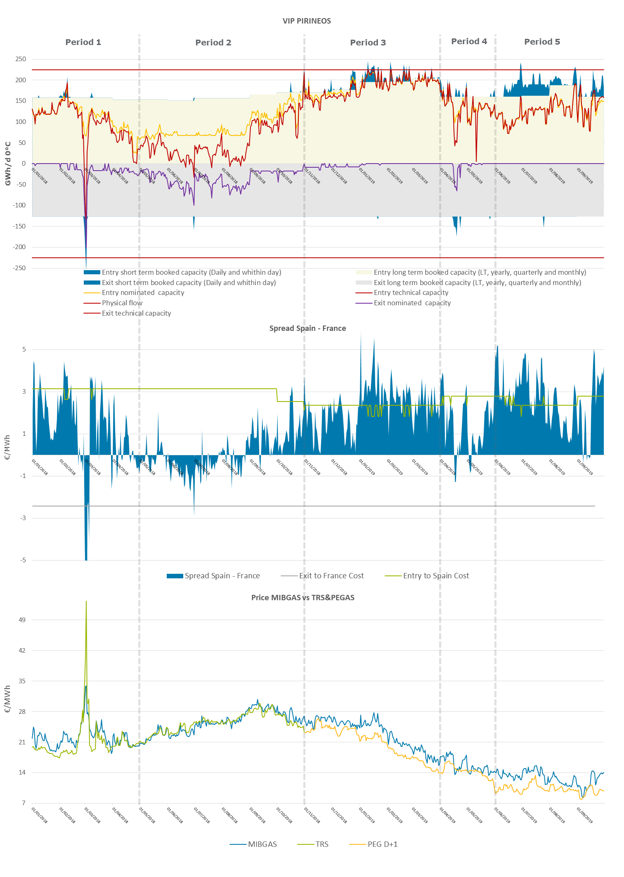

Figure 46: Use of the VIP Pirineos and gas prices (01/01/2018 – 31/10/2019)

When analyzing the graph, 5 different study periods are clearly identified:

1. Low bookings despite the attractive spread -cold spell “Beast from the East”-.
2. Flows from Spain to France.
3. High increase in daily and within-day bookings due to prices spread.
4. Low use of the LT contracts but daily/within-day bookings due to the price spread.
5. High daily and within-day bookings despite the LNG oversupply in Spain.

Next, each period is analyzed in depth.

## Period 1: January - April 2018 – Low bookings despite the attractive price spread –“Beast from the East”

Although the price spread between TRS and MIBGAS was higher than the cost of transport from France to Spain, there are hardly any daily and within-day bookings due to the low liquidity in MIBGAS at that time. The start of the organized market took place in December 2015, but liquidity did not gain strength until Oct 2018. It was from then on that traders who previously did not operate in Spain because they did not have contacts to negotiate in OTC, begin to make use of MIBGAS and the interconnection to sell or buy gas in Spain depending on the price spread.

On the other hand, the arrival of the cold spell called “Beast from the East” with very cold temperatures in Europe and at a time when LNG and natural gas European stocks were very low, resulted in dramatically increased of central Europe prices. The price in Spain became lower that in France, so Shippers took advantage of that and booked (in a daily and within-day basis) capacity to flow gas from Spain to France.

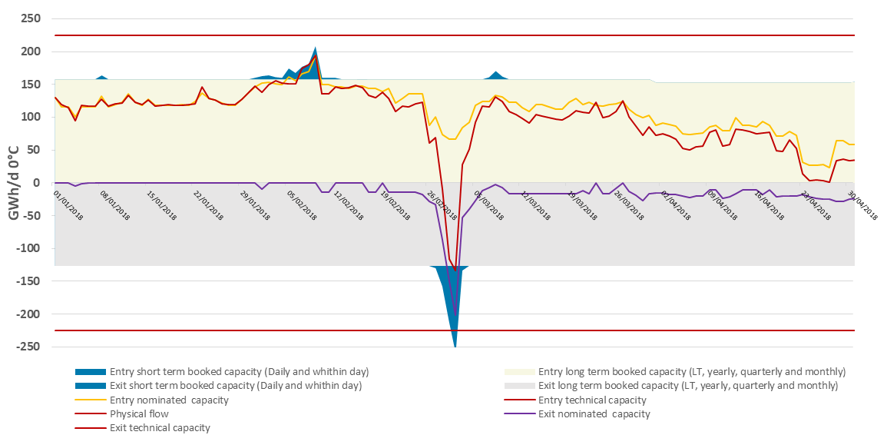

**Figure 47: Use of the VIP Pirineos GWh/d (01/01/2018 – 30/04/2018)**

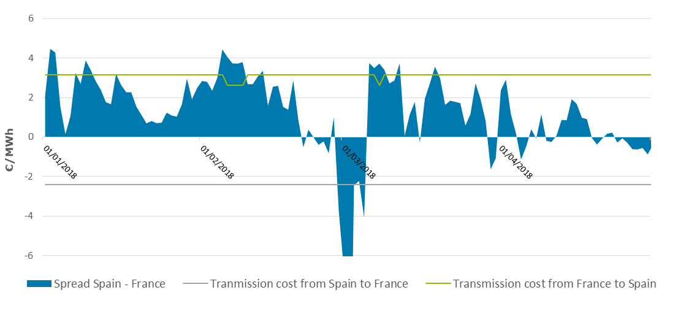

**Figure 48: Spread between Spain and France €/MWh (01/01/2018 – 30/04/2018)**

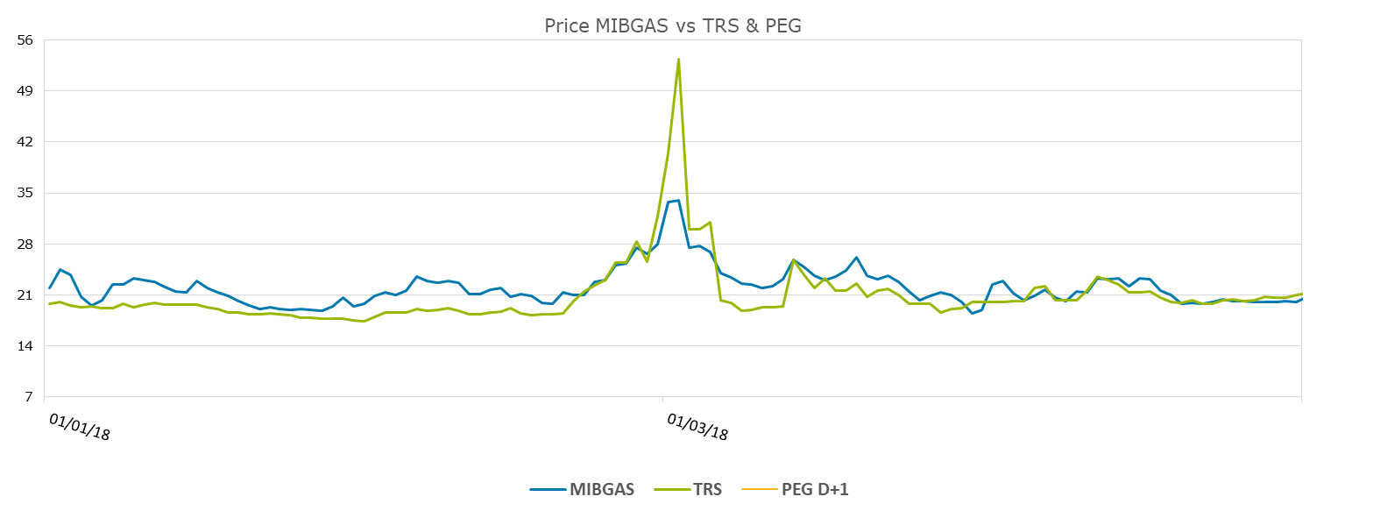

**Figure 49: Gas prices €/MWh MIBGAS, TRS, PEG (01/01/2018 – 30/04/2018)**

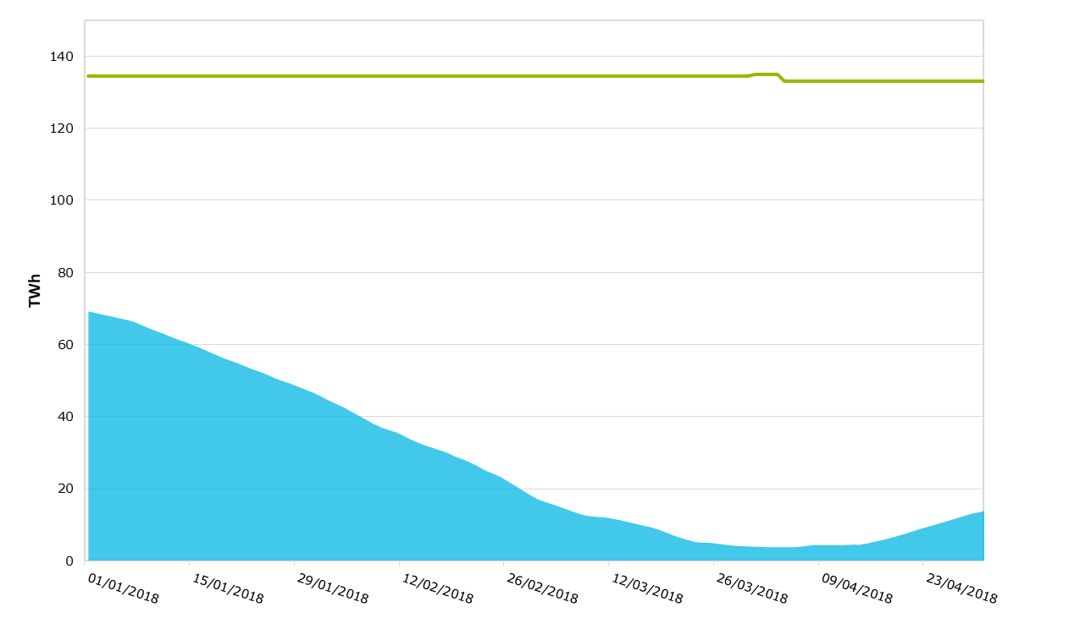

**Figure 50: UGS stock in France TWh (01/01/2018 – 30/04/2018)**

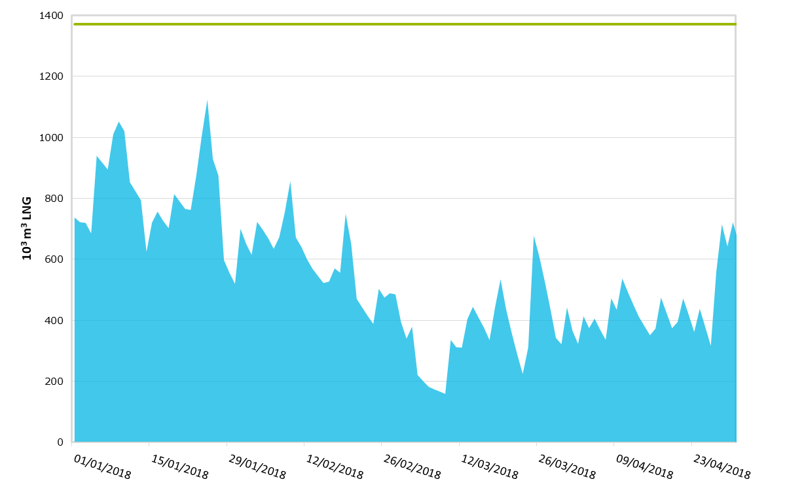

**Figure 51: LNG stock in France 103 m3 LNG (01/01/2018 – 30/04/2018)**

## Period 2: May - October 2018 – Flows from Spain to France

After the Beast from the East, France´s stocks of both, LNG and Natural Gas, were very low. Because of it, prices in France rose sharply, becoming even higher than those in Spain.

Despite a decreasing demand in France, there were flows from Spain to France (lower prices), which shows that the country was getting gas to recover the low levels reached in the previous period.

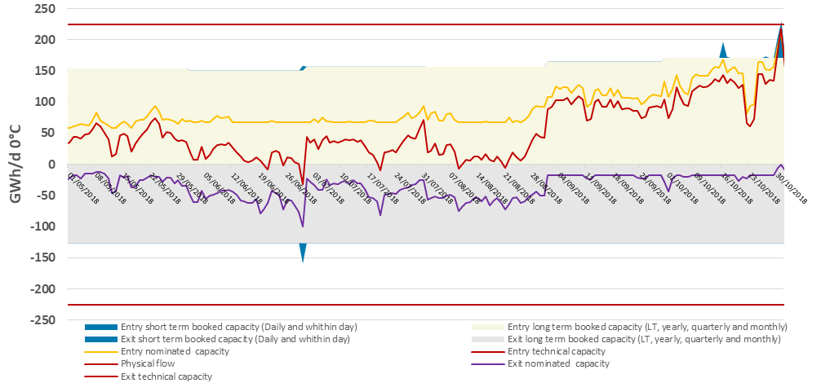

Figure 52: Use of the VIP Pirineos GWh/d (01/05/2018 – 31/10/2018)

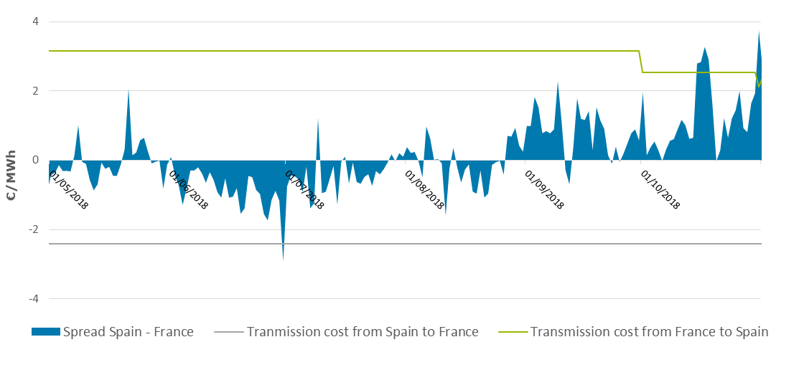

Figure 53: Spread between Spain and France €/MWh (01/05/2018 – 31/10/2018)

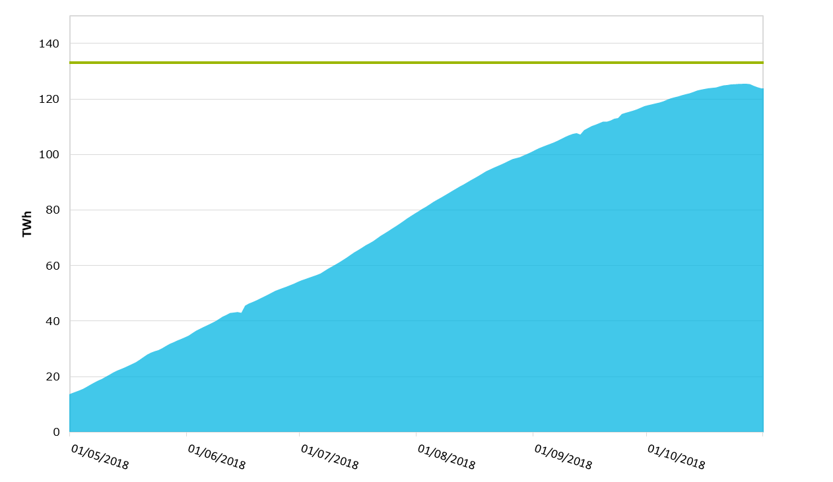

**Figure 54: UGS stock in France TWh (01/05/2018 – 31/10/2018)**



**Figure 55: LNG stock in France (01/05/2018 – 31/10/2018)**

## Period 3: November - March 2019 – High increase in daily and within-day bookings due to the price spread

The Market Integration in France boosted the liquidity of its market, and lowered prices in the French market. It, combined with other factors, also contributed to low prices in the Spanish market. However, the prices drop was greater in France than in Spain, resulting in a wider price spread between the two markets. In fact, before the French market integration, the price spread was higher that the transport costs from France to Spain, only in 7.5% of the days. However, after the market merger, this percentage rises to 44%.

|  |  |
| --- | --- |
| Spread TRS-MIBGAS before the market merger | 0.52 |
| Spread PEG-MIBGAS before the market merger | 1.57 |
| Spread TRF-MIBGAS after the market merger | 2.24 |

Most of the time, the price of the Spanish market followed the movements of the French market and in many occasions, the spread was above the transport costs. For the above reasons, it can be concluded that the French price has a strong influence over the Spanish price.

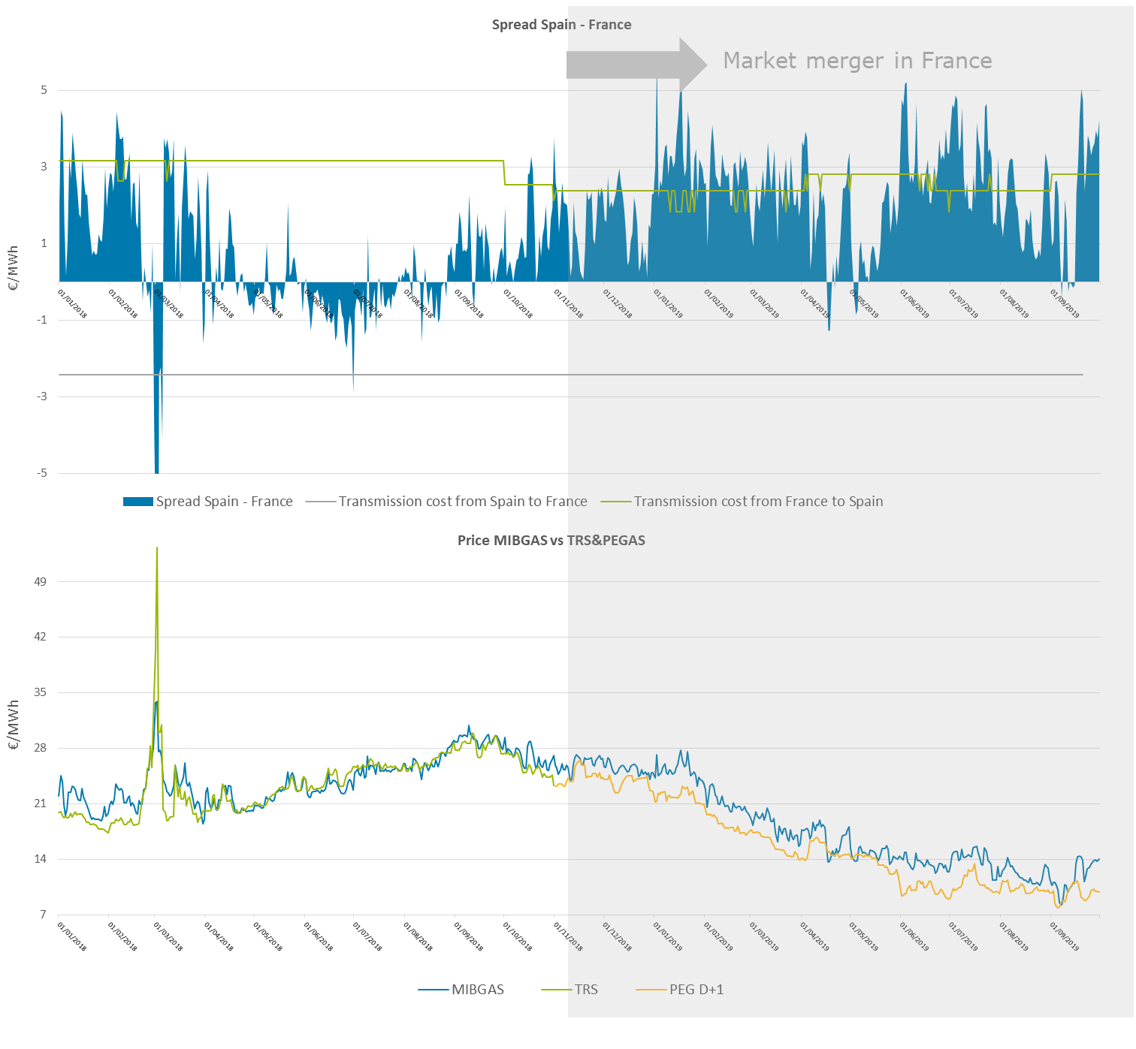

**Figure 56: Gas prices ES-FR (01/01/2018 – 31/10/2019)**

By this period, the liquidity of MIBGAS already reached higher values. Such is the case that traders who didn´t previously operate in Spain, began to make use of the VIP taking advantage of the price spread, not only to cover the demand but for trading operations. Both, capacity booking and its usage reach very high values (83% of nomination).

Figure 57: Use of the VIP Pirineos GWh/d (01/11/2018 – 31/03/2019)

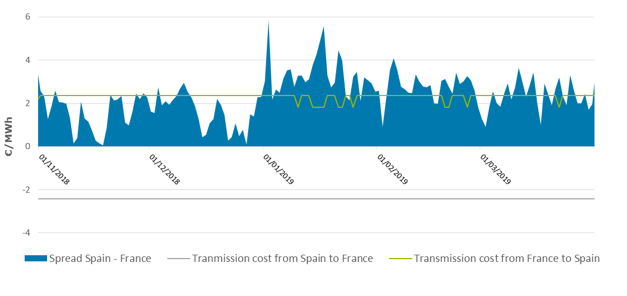

Figure 58: Spread between Spain and France €/MWh (01/11/2018 – 31/03/2019)

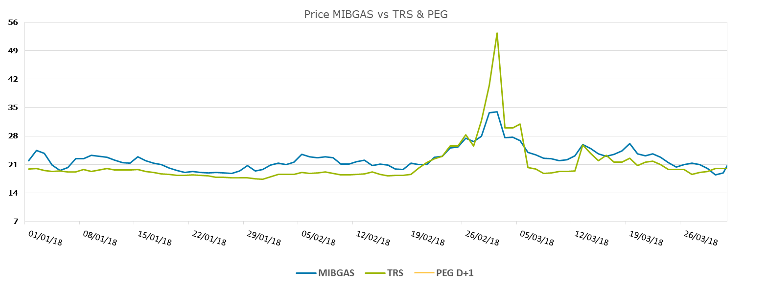

**Figure 59: Gas prices €/MWh MIBGAS, TRS, PEG (01/11/2018 – 31/03/2019)**

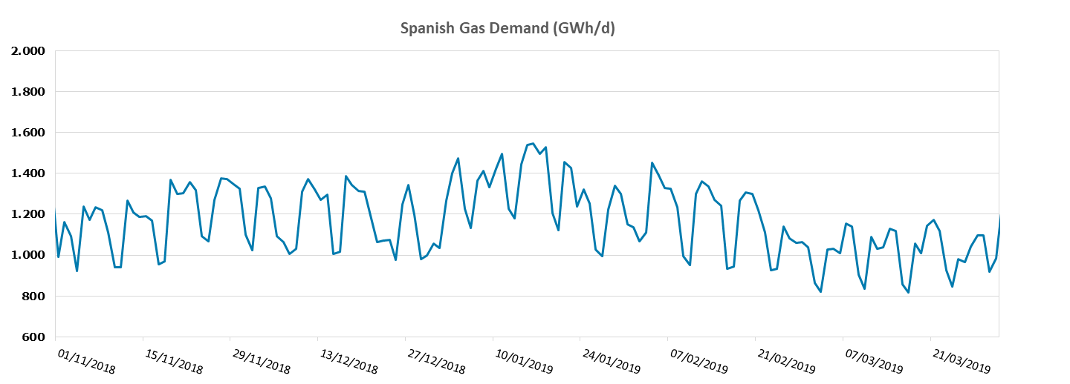

**Figure 60: Spanish gas demand (01/11/2018 – 31/03/2019)**

## Period 4: April – May 2019 Low use of the LT contracts but daily/within-day bookings due to the price spread

As usual during summer periods, a decrease in the use of the long-term booked capacity is appreciated in this period. However, when the spread was attractive enough, shippers booked capacity in a daily and within-day basis.

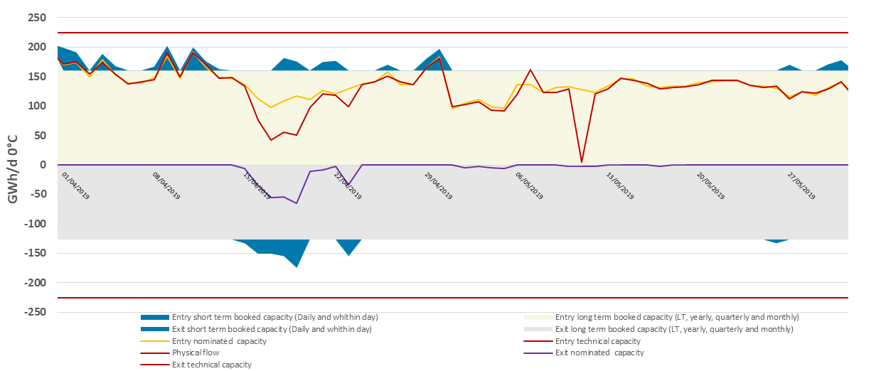

Figure 61: Use of the VIP Pirineos GWh/d (01/04/2019 – 31/05/2019)

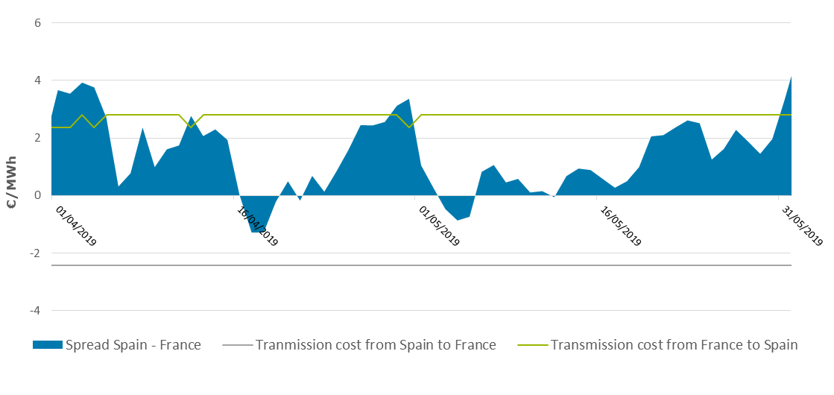

Figure 62: Spread between Spain and France €/MWh (01/04/2019 – 31/05/2019)

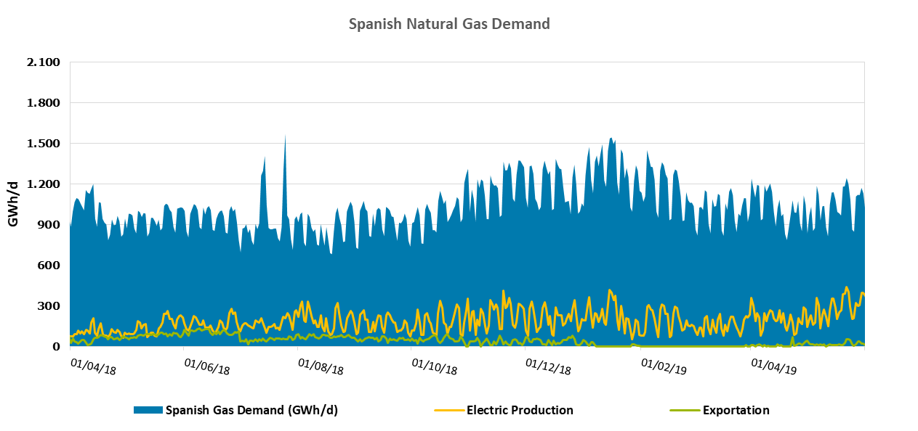

**Figure 63: Spanish natural gas demand (01/04/2018 – 31/05/2019)**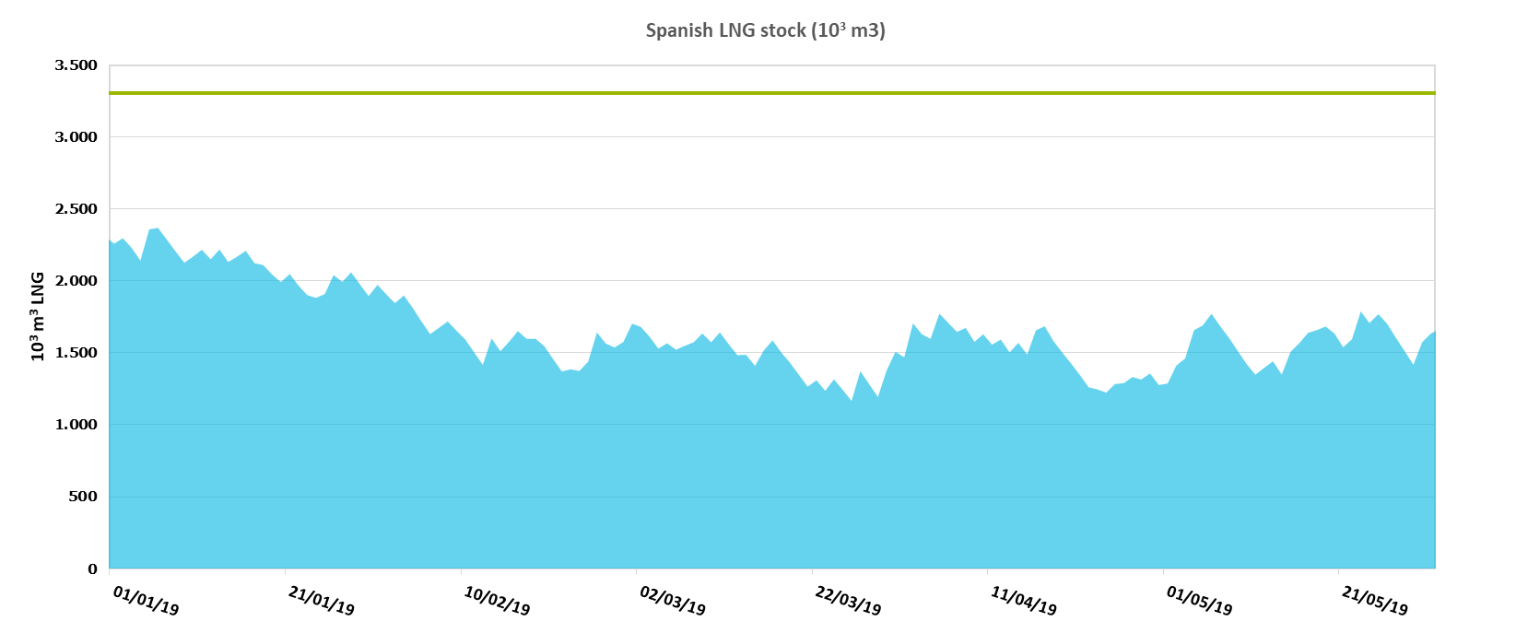

**Figure 64: Spanish LNG stock (01/01/2019 – 31/05/2019)**

## Period 5: June – September 2019 - High daily and within-day bookings despite the LNG oversupply in Spain

One of the most important events of this period was the unexpected increase in the gas demand for power generation in Spain. Despite of this, and the LNG oversupply in Spain, many shippers prefered to keep their LNG in tank waiting for attractive prices spread between summer and winter (Contango effect). As a result, MIBGAS liquidity during this period was low and the prices were relatively high.

Shippers took advantage of this situation and the consequent price spread to flow gas from France to Spain (an important number of daily and within-day contracts were signed by this period).

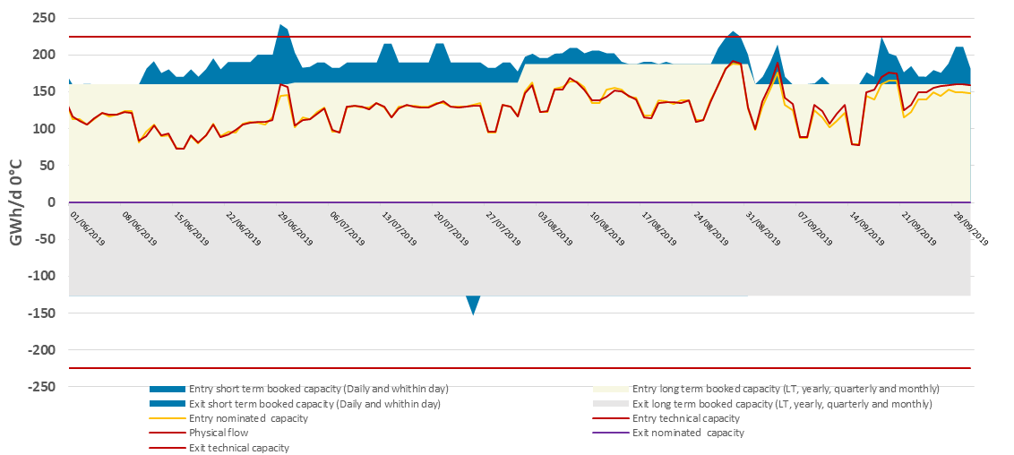

Figure 65: Use of the VIP Pirineos GWh/d (01/06/2019 – 30/09/2019)

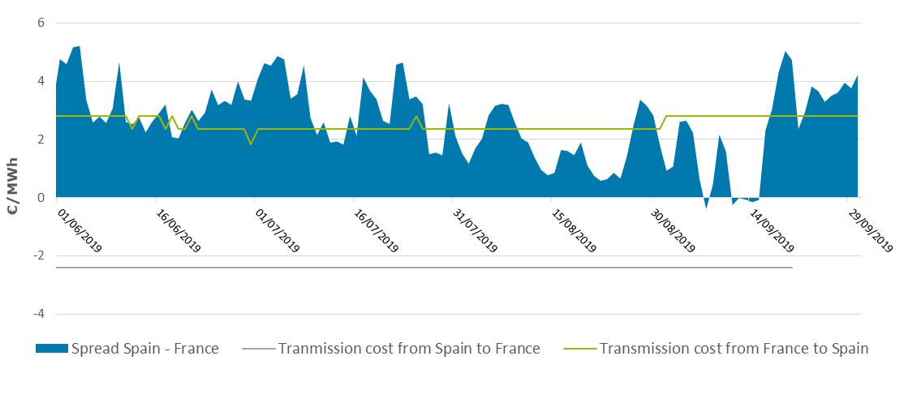

Figure 66: Spread between Spain and France €/MWh (01/06/2019 – 30/09/2019)

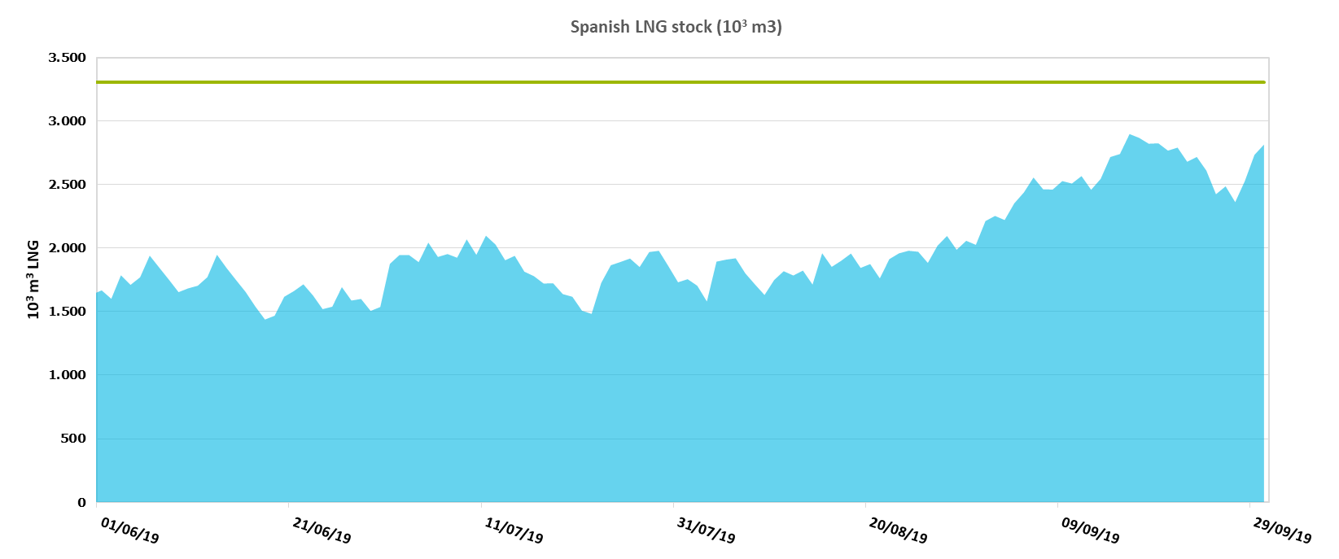

**Figure 67: Spanish LNG stock (01/06/2019 – 30/09/2019)**

# Conclusions

In the Region of the South Gas Regional Initiative (France, Spain and Portugal), the gas flow direction from North to South prevails over the South North direction in terms of net physical flow, as well as the direction from Spain to Portugal.

The capacity offered to the market at each interconnection is calculated by adjacent TSOs with a common methodology based on CAM NC.

At both points, VIP Pirineos and VIP Ibérico, the unbundled capacity booked with LT contracts, subscribed before the implementation of the CAM NC, represents the largest part of the booked capacity at each point and direction, except for the Portugal to Spain flow direction at VIP Ibérico. Consequently, the remaining capacity offered and booked in a bundled way on PRISMA is minor. This state of fact will continue till 2023 for VIP Pirineos and until end of 2020 at VIP Ibérico, where the first LT contracts will end.

## VIP Pirineos

New market conditions changed the booking and usage behaviour.

* The creation of the Trading Region France induced, since 01/11/2018, a single gas price in France. The price spread takes now place at the VIP Pirineos instead of occurring at the north south link which disappeared;
* The PEG price decreased below 8 €/MWh with a decreasing trend under the effect of:
  + Mainly : the abundance of LNG delivered to the European markets at low price;
  + At a lower scale : the French storage regulation increased the number of market players on the PEG which helped in increasing the HUB liquidity;

Such price signals have influence on gas routes as observed on analysis shown in this report. Transit quantities can be boosted or reversed, punctually or over long period;

## VIP Ibérico

The direction Spain to Portugal prevails over Portugal to Spain direction. A seasonal booking and use during the summer months in the Spain to Portugal direction is observed that is less evident during the studied period in respect to the previous exercises. In this direction, booked capacity is practically fully used, and every type of product is utilized, except for the period January to June 2019, when the flow reverted due to the price advantages of accessing the Spanish gas market from the Portuguese LNG plant instead of the Spanish LNG plants.

In the direction Portugal to Spain, we can observe a change in shipper’s behaviour during 2019, as explained here above, where the bookings reached levels close to the 63% of the technical capacity.

## North-South link

The North-South link was physically congested. Merger of zones as from 1st November 2018 has solved the physical congestion issue, thus allowing the removal of the North-South link. Market coupling offer was increased on a daily basis according to available daily capacities in order to anticipate the removal of this link.

Since the North-South link does not exist anymore, no further observations need to be made.

RECOMMENDATIONS

By TEREGA

Adapting rules of regulation to the changes observed on the transmission activity matters.

An IP can be declared “congested” with both a small premium (1 round with Small Price Step) and a very low quantity sold as observed at the Yearly auction Exit Pirineos in July 2019. (*Note: same sequence occurred at the yearly auction in July 2020)*

This status impacts directly TSO incomes as it changes the level of Tariff thru “coefficients of congestion”. The situation observed at the last Yearly auction (July 2019 and 2020) demonstrates that the rules should be changed to match the reality of facts. (cf PRISMA auctions ID 30412363 and ID 25753333).

As a relevant change proposed, applying a coefficient of congestion on tariffs only when a significant amount of the capacity is proposed and effectively marketed thru yearly auctions.

This approach brings consistency to the rules, and is applicable in a short period of time.

Example: In the mentioned case, 0,8% (1980 MWh/day) of the total technical capacity was marketable thru the concerned yearly product and 0,024 MWh/day was marketed with a premium. This is not representative of a “congested” status.

Proposal: consider a threshold of 98% of marketed capacity to stamp a status of congestion.

If 0,98 x 1980 MWh/day = 1940 MWh/day are marketed, then the status of congested is given.

# Annex: Nomination/renominations procedures

Nomination and re-nomination procedures are regulated by Chapter IV of [*Commission Regulation (EU) No 312/2014, of 26 March 2014, establishing a Network Code on Gas Balancing of Transmission Networks*](http://eur-lex.europa.eu/legal-content/EN/TXT/PDF/?uri=CELEX:32014R0312&from=EN) (BAL NC) and BRS Nominations.

* + Nominations are allowed until 13:00 h PT / 14:00 h CET of D-1. Any notification received after by the TSO shall be considered as a revised notification.
  + Re-nomination period starts immediately after the nomination confirmation deadline and ends no later than 3 hours before the end of gas day D.

These procedures are performed automatically by TSO’s systems.

Nominations for the entry and exit of both interconnection points can be sent in accordance with the rules put in place for single-sided nomination. For this purpose, the role of initiator is assigned to Teréga at the VIP Pirineos and to REN at the VIP Ibérico.

The matching procedure consists on the following steps:

* Step 1: Teréga/REN will forward to ENAGAS GTS all received and not rejected single-sided nominations.
* Step 2: Teréga/REN and ENAGAS GTS will calculate for each received (re-)nomination the Processed Quantities, in order to determine if the (re-)nominated quantity by the Shipper can be totally or only partially accepted.

For each (re-)nomination cycle, only the last applicable (re-)nomination (including nominations generated with default rule) that was sent before the Shipper deadline will be taken into account.

In the event that there were constraints in any of the upstream or downstream VIP Pirineos/VIP Ibérico systems, the affected Party will communicate their Shippers a notification considering the limitations arisen not later than forty-five (45) minutes after the Shippers’ (re-)nomination cycle. This Party will also proceed to calculate the Processed Quantities as described in Exceptional Event Situation.

* Step 3: Teréga/REN will send ENAGAS GTS the Processed Quantities based on the nominated quantities.
* Step 4: ENAGAS GTS shall perform the “Matching Process’’ by using the criteria of the lesser rule.
* Step 5: ENAGAS GTS will send the matching result to Teréga/REN.

More information about nomination, re-nomination and matching procedures is included in the Interconnection Agreement published on Enagas[7] site and REN[8] site.

1. Note that Regulation 984/2013 was repealed by [Commission Regulation (EU) 2017/459 of 16 March 2017](http://eur-lex.europa.eu/legal-content/EN/TXT/PDF/?uri=CELEX:32017R0459&from=EN)
2. [Commission Decision of 24 August 2012 on amending Annex I to Regulation (EC) No 715/2009](http://eur-lex.europa.eu/legal-content/EN/TXT/PDF/?uri=CELEX:32012D0490&from=EN)
3. https://www2.terega.fr/en/what-we-can-offer/transport/capacity-trading/capacity-calculation.html
4. <http://www.enagas.es/stfls/ENAGAS/Gesti%C3%B3n%20T%C3%A9cnica%20del%20Sistema/Pdf%204.pdf>
5. <https://www.ign.ren.pt/web/guest/gestao-tecnica>
6. <http://www.enagas.es/stfls/ENAGAS/Gesti%C3%B3n%20T%C3%A9cnica%20del%20Sistema/Pdf%203.pdf>
7. <http://enagas.es/stfls/ENAGAS/Gesti%C3%B3n%20T%C3%A9cnica%20del%20Sistema/Documentos/Consulta%20p%C3%BAblica%20Interconnection%20agreement%20Enagas%20REN.pdf>

   <http://enagas.es/stfls/ENAGAS/Gesti%C3%B3n%20T%C3%A9cnica%20del%20Sistema/Documentos/Consulta%20p%C3%BAblica%20Interconnection%20agreement%20TIGF-ENAGAS.pdf>
8. <https://www.ign.ren.pt/web/guest/interconnection-agreement-vip-iberico>