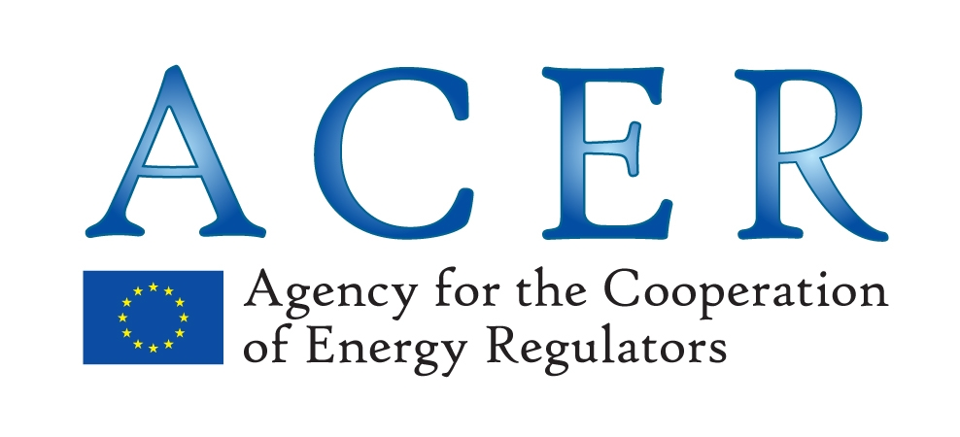

Information note on survey to NRAs on Balancing NC implementation
Summary of views collected by 11 February 2014

General findings
Implementation work is underway in most countries who responded to the survey. Whilst many markets with developed balancing regimes expect to make minor changes between now and the 2015 deadline, those with greater challenges in implementing have already begun work on aspects such as developing trading platforms and improving the provision of information to market participants. Given the differing paces of change there is merit in sharing lessons learnt from TSOs amongst neighbouring countries. In the responses collected so far, NRAs overall agree with the expected timings for implementation of the NC in the different countries, as described by ENTSOG on page 7 of its document.
Organisation of work and monitoring during the early implementation stage
The majority of respondents highlighted that unlike for NC CAM the focus of the NC BAL is not so much cross-border, but more within Member States, and as such a formal ‘roadmap’ procedure is not necessary. However, it was highlighted that as cross border balancing is an aspect of the code, and given the need to coordinate certain features of the balancing regime with adjacent countries, neighbouring NRAs should seek to work together collaboratively through consultation. NRAs have expressed through the GRI group and the BAL TF that it is more appropriate to adopt a ‘light touch’ approach. It remains to be discussed the details of such approach, with reporting on issues, as they arise and a framework to monitor key implementation areas. It remains to be discussed the frequency and the topics for such reporting.
NRAs’ preliminary views on implementation of the NC provisions
Coordination at a basic level, concerning the appropriate harmonisation of standard products (to allow cross border trade) is expected, however most NRA respondents felt that there would not be problems developing standard products. Coordination between neighbouring trading platforms and hubs was highlighted as being necessary for a well-functioning internal market and to allow the possibility for cross border balancing by TSOs. There was concern that some less developed markets are not currently liquid, and whilst respondents felt they would become more liquid by 2015, this is an area for further observation and development. In order for TSOs to perform residual balancing efficiently through market mechanisms it is necessary for them to have confidence that the products will be available on trading platforms and hubs when required.
Information exchange in the nomination procedure between TSOs, also covered in NC Interoperability and Data Exchange, will require a high level of coordination. In particular, some respondents found nominations and renominations rules and schedules being challenging in terms of implementation and requiring some coordination with the neighbouring systems.
It was also noted that some degree of harmonisation of imbalance charging is desirable to ensure a level playing field. As NC BAL requires users to be responsible for their balance position it is important that the imbalance charging regimes do not create perverse incentives between market areas. Finally, most NRAs do not envisage at this stage changing the current arrangements regarding within-day obligations (WDOs).
Next planned actions and interim measures
No NRA currently foresees changing the number of balancing zones within the timeframe of the implementation of NC BAL. It should be noted that many respondents, rightly, said that they would review them at a later stage.
Finally, the NRAs having answered to the survey have not decided or planned at this stage to take interim measures until full implementation, although in some cases, the NRA is still analysing the need for such measures. One NRA rightly pointed out that it is up to the TSO to propose such interim measures in the annual report they may prepare pursuant to Chapter X of the NC.

