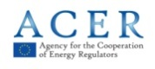
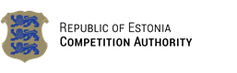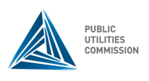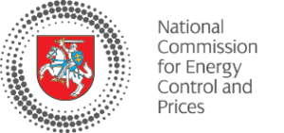
18th Baltic Electricity Market Forum
WG meeting

Monday, 18th May 2015
Tallinn, Estonia

Radisson Blu Hotel Olümpia, Tallinn
Liivalaia 33

Hosted by the
Estonian Competition Authority

AGENDA

12:30 – 13:00 Welcome coffee

13:00 – 14:00 Common coordinated cross-border capacity calculation and allocation procedure in the Baltic region
Lead by Alnis Bāliņš, Latvian TSO

14:00 – 15:15 Network Code on Capacity Allocation and Congestion Management and NEMO designation process
Lead by Dace Bite, Latvian NRA

15:15 – 15:30 Coffee break

15:30 – 15:45 BEMIP implementation update
Lead by Aistija Zubaviciute, Lithuanian NRA

15:45 – 16:15 Harmonised imbalance settlement and imbalance pricing
Lead by Aistija Zubaviciute, Lithuanian NRA

16:15 – 16:45 REMIT implementation (only for NRA‘s)
Lead by Marilin Tilkson, Estonian NRA

