HOTELS NEAR AERS

http://www.lifedesignhotel.rs/
Located in the heart of Belgrade, in Balkanska Street, hotel LifeDESIGN 4**** have 67 rooms.

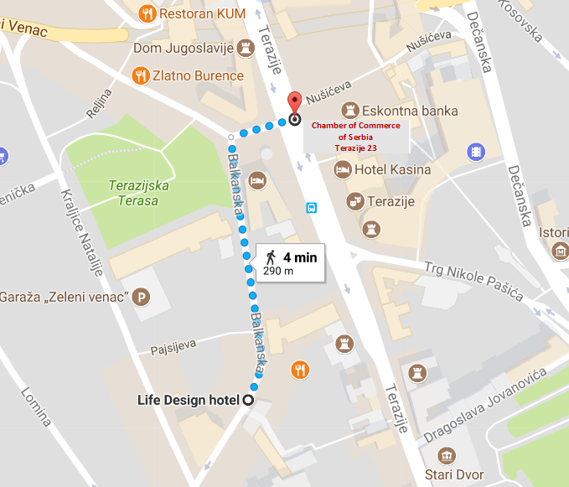

http://www.hotelmoskva.rs/
“Moskva” Hotel, a landmark of Belgrade, one of the most important architectural gems of the Serbian capital, built in the style of the Russian secession which has been under state protection since the second half of the previous century.

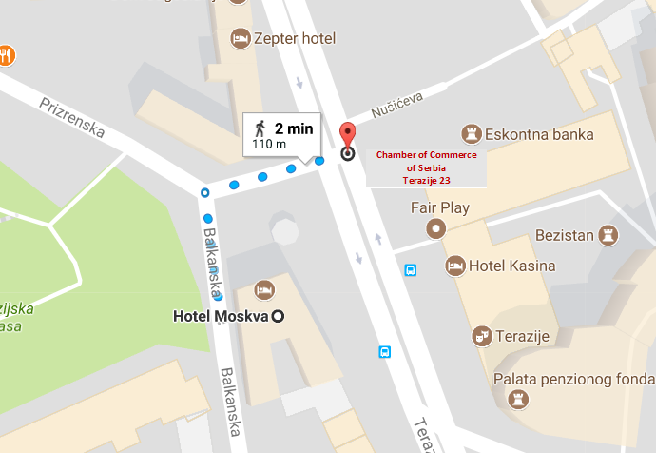

http://www.hotelzepter.rs/
Located in one of the most famous Belgrade streets - Terazije No. 10. It is situated only 50 m from the pedestrian zone (the most attractive shopping street, Knez Mihailova), 150 m from Trg Republike (Republic Square), 500 m from the Zepter Museum and at the same distance from Skadarlija, the bohemian quarter. In the vicinity of the hotel is Kalemegdan Park, the most important cultural and historical site, domineered by Belgrade Fortress.

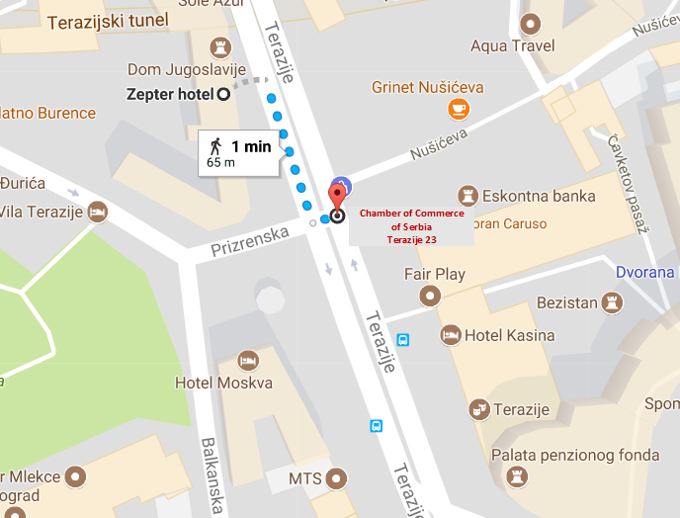

http://www.hotelkasina.rs/
Hotel "Kasina" (3 *) is located in downtown Belgrade, across Terazijska famous fountain.
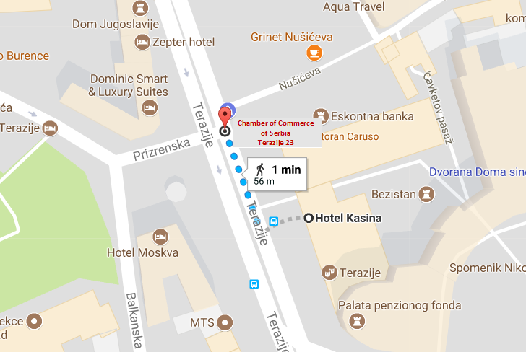

http://www.hotelevropa.rs/
Hotel Evropa in the Belgrade city centre, at the beginning of the pedestrian zone of Knez Mihailova Street. The entrance of the building is in 1, Sremska Street.
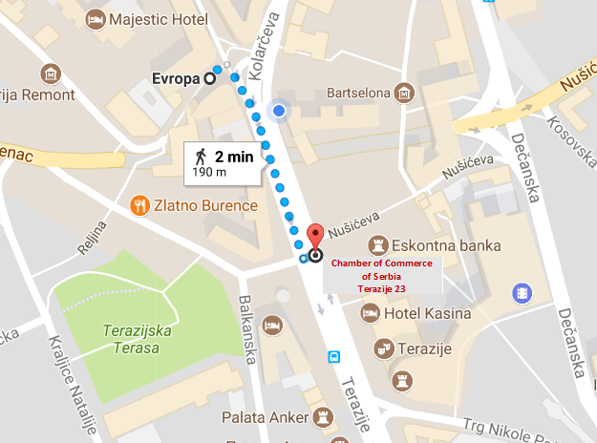

http://www.majestic.rs/
Hotel Majestic is located in the very heart of Belgrade, just a few steps away from the main shopping street Knez Mihailova, Kalemegdan - Belgrade medieval fortress and tourist attraction, also within the walking distance is the bohemian quarter named Skadarlija known for its lively atmosphere.
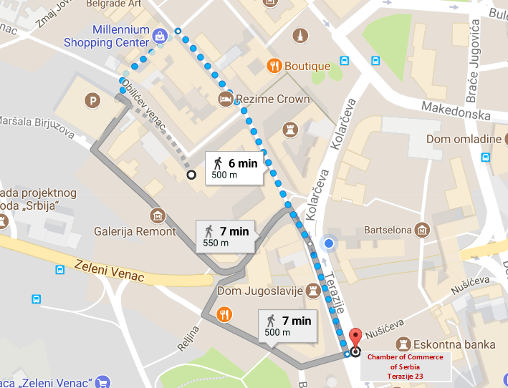

http://belgradearthotel.com/?lang=sr
Belgrade Art Hotel is located in Knez Mihailova Street, on a 5 minutes walking distance to The Belgrade Fortress.
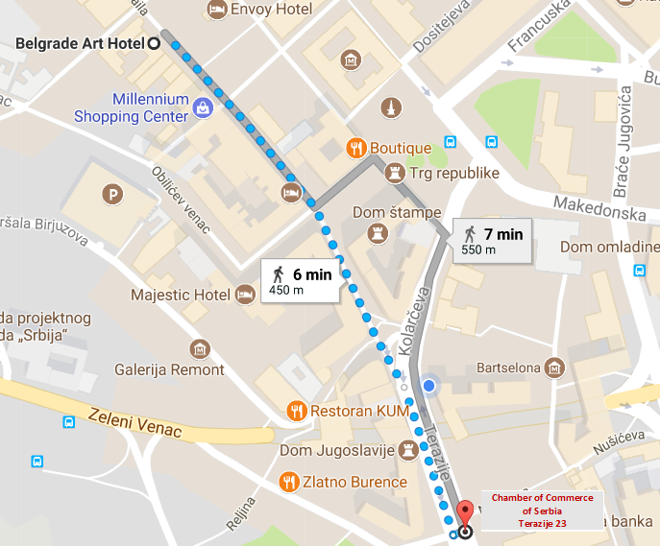

https://www.envoy-hotel.com/sr/
Envoy 4 star Hotel is located in the iconic Čika Ljubina street, a stone’s throw away from the central Republic Square.

