# How to get to Plaza Alta Hotel

The hotel is located on the corner of Ortenovo namesti and Plynarni street.

**The closest stations:**

* Ortenovo namesti (tram no. 6 and 12)
* Nadrazi Holesovice (metro line C (red); cca 400 m))

**Journey from the airport by Public Transport:**

* Airport Terminal: Bus no 119 to Nadrazi Veleslavin
* Nadrazi Veleslavin: Metro line A (green) to Muzeum, change to the metro line C (red) to Nadrazi Holesovice (direction of Letnany)
* Nadrazi Holesovice: tram 6 or 12 to Ortenovo namesti (or walk cca 400 m)

For the public transport please buy the ticket for 32 CZK.

**Journey from the airport by the Airport Express Bus:**

A special airport bus provides direct connection between the airport and Prague city centre **from 5:30 to 22:30. The bus comes every 15 - 30 minutes and the travel time takes about 41 minutes.**

The Airport express tariff 60 CZK (about 2 EUR) is not accepted in the public transport. For the public transport please buy the ticket for 32 CZK.

**Option 1:**

* Airport Terminal: Airport Express Bus to Prague Main Railway station (Praha Hlavni nadrazi)
* Hlavni nadrazi: the metro line C (red) to Nadrazi Holesovice (direction of Letnany)
* Nadrazi Holesovice: tram 6 or 12 to Ortenovo namesti (or walk cca 400 m)

**Option 2:**

* Airport Terminal: Airport Express Bus to Namesti Republiky
* Namesti Republiky: tram 6 to Ortenovo namesti (direction of Palmovka)

**Journey from the airport by taxi**

The transfer takes about 20 to 30 minutes and you should pay approx. 26 EUR (not more than 30 EUR.

You may contact hotel reception to book it – [reception@platahotelalta.com](mailto:reception@platahotelalta.com), or please follow airport guidelines <https://www.prg.aero/en/taxi>

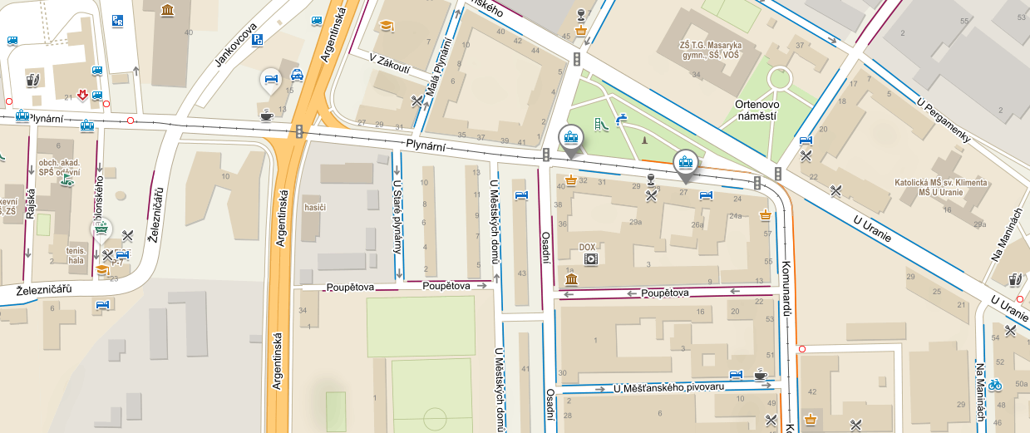

Ortenovo namesti

Plaza

Nadrazi Holesovice

Plaza

Hotel Plaza Alta

Plaza