**South Gas Regional Initiative**

**Balancing regime in the Region**

**From October 2015 to September 2017**

15 June 2018

**INDEX**

1 Background 3

2 Description of the balancing regimes in place 4

2.1 General principles 7

2.2 Virtual trading point 9

2.3 Trading platform. 10

2.4 Notifications. 11

2.5 Balancing actions and system flexibility 12

2.6 Nominations and renominations 19

2.7 Information provision 24

2.8 Imbalances charges 27

2.9 Financial neutrality of the Transmission System Manager: allocation of balancing actions costs 31

2.10 Transmission System Manager incentives 34

3 Functioning of the balancing schemes since its application (1st October 2015 in France and 1st October 2016 in Portugal and Spain) to 30th September 2017 35

4 Potential for application of cross-border balancing 61

5 Conclusions and recommendations 62

# Background

The South Gas Regional Initiative (`SGRI`) has developed Work Plans since 2011 in order to facilitate the compliance with the provisions of the EU 3rd Package and to promote the early implementation of Network Codes. The Work Plan for 2017-2018 focuses its attention on monitoring the implementation and performance supervision of Network Codes (‘NC’), in particular, the balancing NC.

The European Commission adopted the Commission Regulation (EU) No 312/2014 of 26 March 2014 establishing a Network Code on Gas Balancing of Transmission Networks. The balancing NC sets out gas balancing rules, including network-related rules on nomination procedures, imbalance charges, settlement processes associated with the daily imbalance charge and operational balancing between transmission system operators’ networks.

The Code seeks to improve the economic efficiency by shifting the responsibility of balancing from monopoly agents, namely the Technical System Manager, to individual network users and developing the corresponding market-based mechanisms.

The present report, which is the second target of the Work Plan 2017-2018, aims at describing, assessing and drawing learnings from the implementation of the balancing NC in the three countries of the Region. The timeframe of analysis covers from the entry into force of the regulation of balancing in each country of the South Region to September 2017, namely, from 1st of October 2015 to 30th of September 2017 in France and from 1st of October 2016 to 30th of September 2017 in Portugal and Spain.

The aim of the report is to provide an in-depth analysis of the functioning of balancing regimes in the three countries encompassed in South Region, taking into account the particularities of each country and assessing if there is room for further cross-border cooperation in the implementation. In no case, it tries to duplicate the content of the ACER IMR on balancing report. On the contrary, it seeks to align conclusions and findings with the ACER IMRs and deepen knowledge of those regulatory areas.

This report has been done jointly by the National Regulatory Authorities: Comisión Nacional de los Mercados y la Competencia (CNMC), Commission de Régulation de l’Energie (CRE) and Entidade Reguladora dos Serviços Energéticos (ERSE); and the Transmission System Operators: ENAGAS, Teréga (former TIGF), GRTgaz and REN.

# Description of the balancing regimes in place

The Commission Regulation (EU) No 312/2014 establishing a Network Code on Gas Balancing of Transmission Networks was passed on 26 of March 2014. The idea behind the Code is to introduce a market-based approach for balancing operations to gain economic efficiency. If each shipper is close to balance, the network should overall be close to balance. If the system is not sufficiently close to balance or whenever flow patterns envisaged by the network users cannot be accommodated in the system, then the TSO intervenes as a residual player. The Code promotes the creation of markets which allows both TSOs to procure balancing services from network users and network users to trade imbalance positions. In Spain the biggest TSO (ENAGAS) is the TSO in charge of making balancing actions (Technical System Manager, TSM). To ensure that network users are able to balance their accounts, network users require: a) information provided by the Technical System Manager (TSM) in Spain, or by TSOs in France and Portugal, about: the overall network status, the balancing actions and their portfolio information, b) access to flexible gas via physical flexibility (LNG and storage facilities) or via trading arrangements (VTP or trading platforms/exchanges) and c) access to network flexibility.

The balancing NC entered into force by 1 October 2015 in France and by 1 October 2016 in Spain and Portugal prior to the TSOs` request of a deferral.

With regard to the balancing areas in the Region, the contractual architecture of the gas system in France has been progressively simplified, from seven balancing zones in 2003 to two market areas with three balancing zones today. The developments included the merger of L and H gas market zones in 2013 (contractually speaking, 2 calorific values remain physically). Since 1 April 2015, there are two marketplaces in France, the PEG Nord and the Trading Region South (TRS), shared by GRTgaz and TIGF. The next step consists in the creation of a single market area for France (Trading Region France, TRF). Following an in-depth cost and benefit analysis, the merger of PEG Nord and TRS was decided in 2014 (CRE deliberation of 7 May 2014) with the completion of Val de Saône and Gascogne Midi projects, representing a total investment of 823M€. However, these developments do not allow to fully remove all congestions; contractual congestion relief mechanisms will be implemented on an ad hoc basis to ensure firm capacities are actually guaranteed.

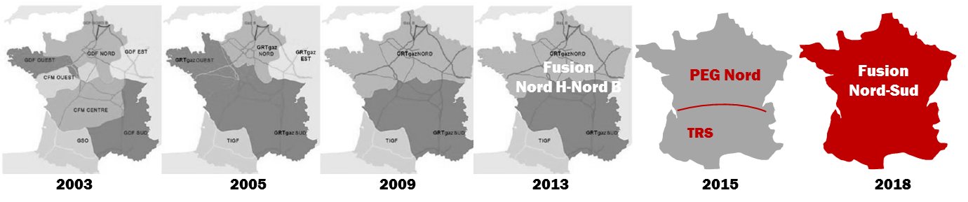

Figure 1: Evolution of market areas in France

In summary, currently there are five balancing areas in the South Gas Region: three in France (GRTGaz Nord, GRTGaz Sud and TIGF), one in Spain and one in Portugal managed by the corresponding TSOs, namely, GRTgaz, TIGF, Enagás and REN respectively. Each balancing area has its own balancing rules within the limitations provided by the Code reflecting the peculiarities of each area. For the time being there are three marketplaces in the Region: two in France (PEG Nord and TRS) and one in Spain (MIBGAS). The regulation currently under development in the Region foresees evolving to two marketplaces: TRF resulting from the merge of PEG Nord and TRS in France and MIBGAS in Iberia (Spain and Portugal).

With regard to the pieces of national regulation implementing the balancing NC in each of the three countries, in Spain, the Circular 2/2015[1], of 22 July, approved by Spain`s National Authority for Markets and Competition (CNMC) establishing the regulation on gas balancing of transmission networks, implements the Code and develops those aspects that the Code leaves to NRA`s criteria. The Circular was submitted to public consultation and the comments received were duly taking into consideration.

In France, the implementation of the provisions of the Regulation 312/2014 has been triggered by the CRE Deliberation of 10 September 2015. The current regime has been established by the Deliberation of 15 September 2016, regulating balancing as from 1 October 2016. The balancing regime within the future single Trading Region France has been established by the CRE Deliberation 2017-246 of 26 October 2017.

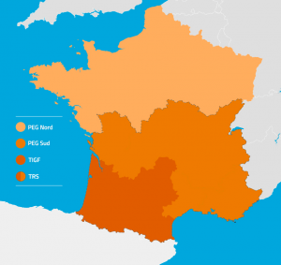>>>> 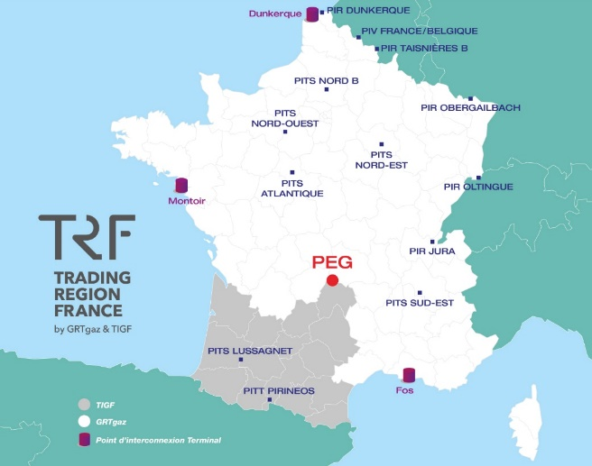

Figure 2: Balancing and market areas in France

In Portugal, the implementation of Commission Regulation (EU) No 312/2014 of 26 March established the need for an in-depth review of the National System of Natural Gas (NSNG) Manual of Global Technical Management Procedures[2] (MPGTG), since the rules for the transmission network compensation, as well as the scope of the NSNG's Global Technical Manager (GTG) and distribution system operators, were substantially different from the practices in force.

In this sense, ERSE started the discussion of the gas infrastructure’s compensation model, in the beginning of 2015, which resulted in an important contribution to the revision of the Regulation for Operation of Infrastructures (ROI), published in April 2016 (Regulation No.417/2016, of the 29th of April, approving the Regulation for Operation of Infrastructures in the natural gas sector[3]).

The subsequent amendment of the MPGTG integrated the procedures that consolidate the practices and competences of the GTG at the operational level, and its interaction with the operators of the infrastructures in the NSNG, with the market agents and with the market operators.

The MPGTG substantially reinforced the interaction between the transmission network compensation methodology and the operation of the future organized market (MIBGAS), aiming at greater individual accountability of market agents supported by an enhanced information provision and reporting obligations from the GTG. The public consultation of the MPGTG took place between July 22nd and September 7th with approval at 28th of September and entry into force on the 1st of October of 2016, through the publication of the ERSE Directive no. 18/2016.

Hereafter are the key elements of the balancing regimes in place in each of the three countries of the Region.

## General principles

Spain

The regulation on balancing in Spain follows the Network Code, promoting the development of the market increasing its liquidity and fostering competition.

Users are responsible for keeping their gas position balanced in the network and they are provided with the necessary tools, namely, day ahead and intraday information, nomination and re-nomination schedules, etc. ENAGÁS GTS (entity in charge of the security of supply and the correct coordination of the whole gas system in Spain) is responsible for keeping the network within the normal operational limits.

The timeframe for the individual balancing calculation for each user is the gas day (06:00h to 06:00h). ENAGÁS GTS calculates the imbalance position (inputs minus offtakes) of each user at the end of the gas day. Network users that are not in balance at the end of the day are charged the corresponding daily imbalance charges and their balancing accounts are set to zero. This involves that at the beginning of every day all the network users starts the gas day in balance.

France

In its Decision of 1 December 2013, CRE approved roadmaps for changing to a target balancing system proposed by GRTgaz and TIGF. In accordance with these paths and through decisions dated 21 June 2012, 20 September 2012, 5 February 2013, 4 April 2014 and 15 January 2015, CRE approved, in particular, changes concerning:

- the level and frequency of information made available to shippers by transmission system operators (TSOs);

- regulation of shipper imbalances, by gradually reducing imbalance tolerance levels;

- rules for TSO balancing actions on the market to incentivize shippers to be balanced by applying a marginal price to cash out imbalances.

In its Decision of 10 September 2015, approving balancing rules for GRTgaz and TIGF transmission networks on 1st October 2015, CRE validated the implementation of a balancing system complying with the balancing code which featured:

- invoicing from the 1st kWh imbalance at the daily marginal price/kWh, i.e. the maximum purchase price (with respective minimum sale price) of TSO trades on the markets if any, or the daily weighted average price with 2.5% small adjustment if the TSO did not take any balancing action or if the balancing action trades are within the 2.5% small adjustment threshold;

- the possibility for all shippers delivering gas to subscribe to a service of flexibility based on TSO’s linepack for the days when they do not intervene on the market.

In addition, CRE validated the launch of an experiment on the use of locational products for GRTgaz residual imbalances.

With the creation of the single market area in France scheduled for November 2018, GRTgaz will merge its North and South balancing zones; TIGF balancing zone remains identical. The distribution of imbalances between the two balancing zones will be identical to the TRS rules.

The principle is that the existence of two physical balancing zones is neutral for users, i.e. it works as if there was only one balancing zone. Accordingly, contractual imbalances of users will be calculated on the scale of the whole "trading region". Daily imbalances will then be split between the physical areas by the TSOs, depending on the type of user: end client supplier, importer/exporter or PEG trader. The objective is to reflect accurately the responsibility of the users in the actions taken by each of the TSOs to restore the balance. Consequently:

- the imbalance of a user who delivered gas to end users ("supplier" type user) would be divided between the two balancing zones in proportion to their allocations at the delivery points;

- the imbalance of a user with quantities allocated only as entry and exit of the Trading Region France (TRF) to the interconnections PIR, LNG terminals PITTM and storage PITS, i.e. not delivering an end user, ("importer/exporter" type user) would be distributed in proportion to the entry and exit allocations of the TRF at PIR, PITTM and PITS;

- the imbalance of an user having exclusively conducted transactions at the virtual trading point PEG (“trader” type user) would be entirely allocated to the GRTgaz zone.

The low level of storage subscriptions could result in significant and recurring imbalances some shippers. Consequently, CRE considers necessary to give the TSOs more scope to cover their residual balancing needs, with either notional or locational products. The costs incurred should be included in the imbalance settlement price so that the signal price properly reflects tensions in the network.

Portugal

Agents adjust their positions in the transmission network by modifying their inputs and offtakes or trading natural gas in the VTP. The regulatory framework in force ensures that all gas transactions in the Portuguese system materialize in physical delivery in the VTP. Transactions at the interconnection points are no longer allowed.

The natural gas transactions in the VTP are carried out on bilateral basis, since, presently, the Portuguese pole of the MIBGAS has not been implemented yet.

## Virtual trading point

Spain

Network users are responsible to keep in balance their portfolios. To this end, users can modify their physical inputs/offtakes in the transmission network or buy/sell gas in the virtual trading point[4] in both the trading platform MIBGAS (title products) or bilaterally.

In Spain, before the entry into force of the balancing NC, there already existed a virtual trading point called AOC where users were able to exchange gas without taking into account the physical location of the gas in the transmission network (all gas is considered to be located in a single virtual point). After the entry into force of the balancing NC, the AOC was renamed as PVB and it is the reference to trade title products and the virtual place where users have to keep balance (inputs=offtakes).

France

As from 1st of November 2018, there will be a single entry-exit system for France called TRF (Trading Region France), resulting from the merge of the current market places PEG Nord and TRS. At this date, current French virtual trading points will be merged into a single virtual trading point called PEG.

Portugal

In Portugal, a trading platform with adequate characteristics to support the balancing actions of the system’s Global Technical Manager (GTG) has not been implemented yet. However, it is expected that in the course of 2018 the MIBGAS Portuguese hub will be functional, allowing balancing actions as well as the application of prices in the determination of daily imbalance charges.

## Trading platform.

Spain

The trading platform (MIBGAS) started working in December 2015. Users can use this platform for both trading and balancing purposes. ENAGÁS GTS must use MIBGAS for the acquisition of normalized products. Since 1 October 2016, the trading platform allows to market two kind of Short Term Standarised Products (STSP) for ENAGÁS GTS balancing purpose: title products and locational products.

France

As part of its balancing system, both TIGF and GRTgaz sell and buy quantities of gas via Powernext’s PEGAS platform.

Portugal

In Portugal, a trading platform with adequate characteristics to support the balancing actions of the system’s Global Technical Manager (GTG) has not been implemented yet. However, it is expected that in the course of 2018 the MIBGAS Portuguese hub will be functional, allowing balancing actions, as well as the application of prices in the determination of daily imbalance charges.

## Notifications.

Spain

The VTP (PVB) effectively enables Trade Notifications to the Spanish Technical System Manager (ENAGÁS GTS) since November 2015. Notifications are made by the users (when it is on bilateral trade) and by the operator of the trading platform (when the transaction takes place on the trading platform). Day ahead, and within day notifications up to three hours before the end of the gas day, are possible.

The time when the Technical System Manager receives a notification to the time of registration and accounting may not exceed 30 minutes, except for notifications that are issued before the gas day, which may have a 2-hour extension to the processing period. When the notification quantities communicated by the users involved in the trade do not coincide, ENAGAS GTS will reject both notifications and it will be communicated for the users to correct the notification.

France

Portugal

Presently, the natural gas transactions carried out in the transmission network balancing area (VTP) are exclusively associated with bilateral trading. However, the regulatory framework in force takes into account the implementation of the Portuguese pole of MIBGAS and the implemented procedures are in compliance with Commission Regulation (EU) No 312/2014 of 26 March.

Trading notifications should be submitted by the market agents involved, in the case of bilateral trading, or by the market operator, if the transactions occur in an organized market.

Transaction notifications shall be confirmed by the GTG to the market agents within a maximum period of 2 hours, after receiving a pair of consistent notifications, except when trade occurs in the gas day where a maximum of 30 minutes must be applied. GTG must applied the same procedure to the trading notifications issued by a market operator.

## Balancing actions and system flexibility

The Technical System Manager, TSM must continuously evaluate if the system integrity is at risk. The TSM may carry out balancing actions with the aim of keeping the transmission network within normal operating conditions, or acquire a different quantity of gas in the network at the end of the day in order to have a linepack consistent with an efficient and economic operation of the system.

Spain

In order to facilitate the follow-up of the system, regulation has defined three operating bands: indifference, surveillance and alert that determine the thresholds of normal operation of the transmission network outside of which balancing actions are triggered[5]. ENAGÁS GTS has developed and published the corresponding procedure to calculate the parameters[6] defining the normal operation of the system. The procedure will be reviewed every two years. ENAGÁS GTS will update the parameters whenever necessary or 1) at least twice a year, once finished winter and summer periods to accommodate them to demand patterns and 2) when new infrastructures commissioning increases the linepack capacity by at least 2%. The new values will be published in ENAGÁS GTS website at least one month prior to their entry into force. The linepack flexibility is not currently marketed but the possibility is included in the Spanish regulation.

In the next graph are represented the operating bands abovementioned:

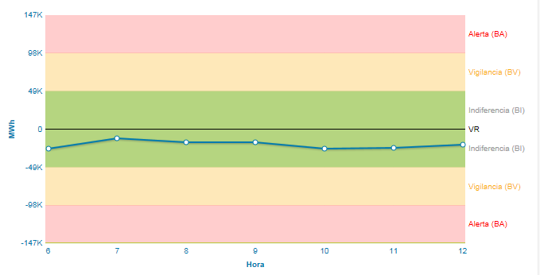

Figure 3. Operating bands

When the level of gas stored in the network is situated in the green zone, ENAGÁS GTS must not take balancing actions. ENAGÁS GTS is obliged to take a balancing action when the gas level is in the red zones and the decision is left to ENAGÁS GTS criteria when the level of gas is in the yellow zone. When taking a balancing action ENAGÁS GTS must take into account real demand at the moment and demand forecast for the gas day, users’ nominations and re-nominations, measurements of gas flows, network pressures and technical status of infrastructures. Balancing actions must be performed in an efficient, economical and not discriminatory manner.

ENAGAS GTS is responsible for undertaking the balancing actions following the next merit order:

* Within day title products
* Day ahead title products
* Within day locational product
* Day ahead locational product.
* Balancing services

With regard to the locational products, it must be noted that Regulation (EU) nº312/2014 designs locational products in order to allow TSOs to modify the quantity of gas at a specific entry or exit point and consequently, it can be used only when some risk appears at a specific point of the network.

Balancing services (duration no longer than one year) are also a possibility considered in the Spanish legislation when the acquisition of STSPs is not possible or they would not solve the operational risks of the network. ENAGÁS GTS will acquire the balancing services by a public tender mechanism and complying with requirements of the regulation 312/2014. Before its acquisition, ENAGÁS GTS must duly justify its necessity to both the Ministry and CNMC. CNMC is empowered to approve the conditions of the public tender.

France

With regard to the timing to make balancing actions, GRTgaz has currently 4 trading windows (10.25 am, 15.25 pm, 17.25 pm, 23.25 pm) and is allowed to trade outside these times to optimize the outcomes of its interventions. GRTgaz’s trading operations are carried out by an automated system managed by the gas exchange operator, Powernext. TIGF uses the same automated system to trade exclusively in the 5.25 pm window every day, including non-working days. Although the TSOs can both purchase or sell in the imbalanced days simultaneously, the way imbalances are allocated between the two balancing zones makes it impossible for a TSO to sell when the other buys.

To better reflect tensions in the network, CRE intends to amend the automated buying and selling parameters, which are currently restricted to avoid excessively high purchasing and low selling prices. Although a limit should be maintained, CRE wants this to be more flexible to enable TSOs to meet their needs in critical imbalanced situations. Sufficient liquidity and improved trading methods allow relaxing price constraints with a limited risk of manipulation or errors.

With regard to the products in use for balancing purposes, it is remarkable that GRTgaz and TIGF are allowed to use locational products to balance their network if title products are not enough for fulfilling TSOs’ needs. Since then, the TSOs have used these products several times, during winters 2015-2016 and 2016-2017, and in September 2017. Sixteen suppliers are allowed to take part in calls for tenders and several have in fact submitted bids for the aforementioned tenders. While bids were consistent with market prices, this mechanism effectively helped to resolve imbalances.

If TSOs were to request locational products more often, CRE considers that trade prices would have to be included in imbalance settlement prices on the days when the TSOs buy and sell locational products for balancing needs. This inclusion would foster the emergence of a clear price signal when the network is under significant strain.

Hereafter, it is explained in more detail the functioning of the balancing system in each balancing zones.

1. TIGF:

As part of its balancing system, TIGF sells and buys quantities of gas via Powernext’s PEGAS platform. From the 1st of October 2017, transactions are done by a robot in accordance with the intervention arrangements notified to the CRE and presented to the Concertation Gaz group. The price of those transactions is then used as the basis for the settlement of users’ imbalances.

TIGF has set up a balancing statement, recording what it spends and earns under aforementioned transactions and the balancing rules of the transmission contract. Since 1st of october 2015, the balance is allocated to shippers as a proportion of the quantities delivered, according to the Deliberation of the French Energy Regulatory Commission of 15 January 2015 approving the balancing rules. This balancing statement is published each month.

TIGF publishes on DATAGAS the indicator of forecasted Linepack (forecasted SEC) (link below). This indicator is updated on an hourly basis.

<https://tetra.tigf.fr/SBT/public/StockGazConduite.do?action=listePrev>

TIGF intervenes from 5.25 pm to 6.05 pm on PEGAS platform at TRS market place, based on the last level of forecasted SEC.

The level of forecasted SEC is compared to the thresholds of linepack which have been calculated on the basis of the value of measured linepack at 6 am (SEC 6h).

TIGF has defined four areas which can be consulted in the following figure:

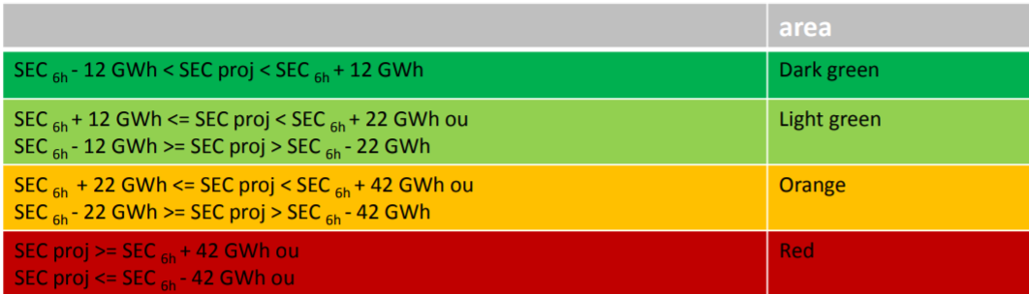

Figure 4. SEC areas of TIGF

The quantities for which TIGF intervenes depend on the area on which the level of forecasted SEC is positioned.

The utilisation of a robot allows TIGF to intervene 365 days per year. The evolution of the interventions set up is coordinated with Powernext and validated by CRE. On one given gas day D, the eligibility of the transport balancing service (SET, Service Equilibrage Transport or Transport Balancing Service) is now entirely depending on the interventions of TIGF. On week-ends and bank holidays, the eligibility of the SET does not depend anymore only on the level of forecasted SEC.

1. GRTgaz:

After the establishment of a need by GRTgaz, the balancing action itself is executed by a computer algorithm. Every operation within the trading window is designed to ensure that the algorithm always selects the best prices. Therefore, the need of GRTgaz may not be fully covered.

GRTgaz can trade seven days a week between 10:25 am and 10:45 am, between 2:25 pm and 2:45 pm, between 5:25 pm and 5:45 pm and between 11:25 pm and 11:45 pm on the Within-Day product. Effective action depends on “Projected Closing Linepack” position and schedule.

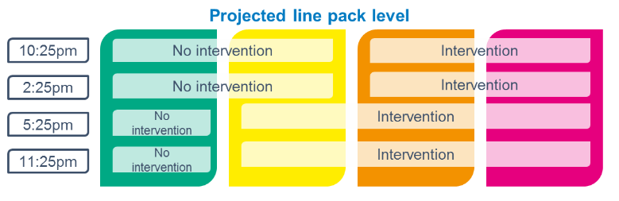

Figure 5. Schedule for GRTgaz intervention.

Within these trading windows, GRTgaz’s purchase or sell orders will take place at arbitrary times. GRTgaz intervenes several times in each trading window to cover its balancing gas needs.

The “Projected Closing Linepack” (PLC) position shows the stress of its transmission network. GRTgaz has defined several modes of balancing actions depending on the PLC position and the schedule.

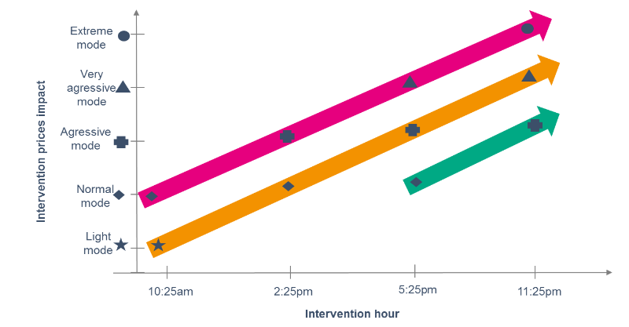 Figure 6. GTRgaz’s modes of balancing actions.

The more aggressive the mode is, the more the price obtained by GRTgaz may move away from the estimated market price during the trading window. In connection with French Regulation Authority (CRE), GRTgaz defined, for each mode, limits to this potential spread.

GRTgaz balancing actions are made primarily through short-term standard products. In case of title products were not sufficient and according to the merit order required by the Balancing network code, GRTgaz may trigger a balancing action via the locational product. The trigger criteria are as follows:

1. As soon as possible at the end of the 3rd stock exchange window
2. If the PCL level planned remains in the orange or red zone.

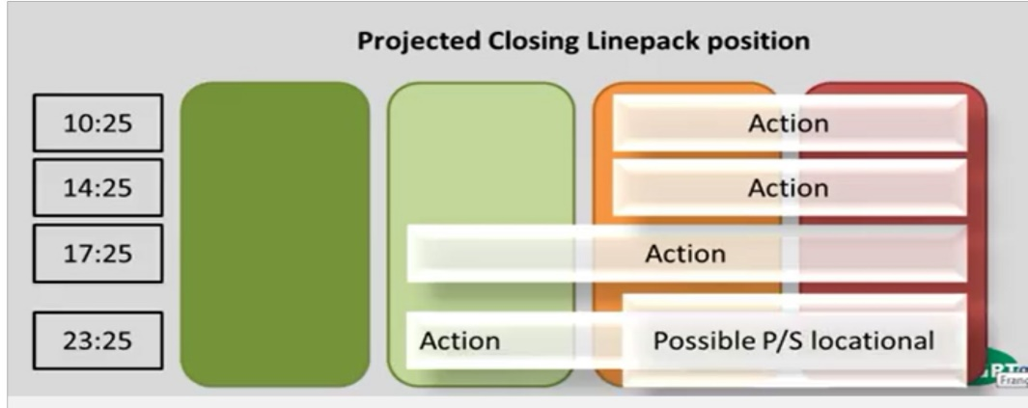

Figure 7. GTRgaz’s modes of balancing actions (hours and triggering areas).

More details regarding locational products can be found at:

https://www.youtube.com/watch?v=N8yy79ITEz4&feature=youtu.be

Portugal

The transport network has a linepack capacity that varies between 40 and 60 GWh depending on the operating conditions. In addition to this amount of natural gas, GTG has 60 GWh operational gas inventory in the storage infrastructures that allows him to manage the residual balance of the NSNG.

These quantities of natural gas, although quite limited, represent a 4-hour flexibility in the case of the linepack capacity and, considering the operational gas inventory in the storage facilities, approximately 10 hours considering the historical maximum daily demand [100 GWh represents 44.4% of the maximum daily demand (225GWh/d)].

In average terms, the aggregation of the daily imbalances in the transport network is much lower than the linepack, so the transport network's accumulation capacity allows the GTG to manage the gas operational stock on a weekly basis, resetting the linepack position via natural gas sales or purchases.

GTG buys or sells gas through individual balancing services, each one with individual contract between the GTG and the market agent that provides the service. The quantities of natural gas in each balancing service is limited to 5 GWh (in purchases and sales).

Balancing services are contracted as a result of a market mechanism (auction), approved by ERSE. The GTG (REN Gasodutos) is responsible to conduct the auctions, with OMIP assistance and a dedicated platform.

In year 2018 it is expected that the balancing actions will become mostly based on MIBGAS Portuguese hub trading platform. Likewise, one expects in 2018 a gradual reduction of the operating gas inventory in the system's storage infrastructures.

## Nominations and renominations

In accordance with the Code, rules and timelines of nomination and re-nomination procedures have been developed taking into account the coordination requirements in the interconnection points among the three countries of the Region.

Spain

Users may carry out nominations for the gas day D before 14:00 of the day D-1 (the day before the gas day). In the absence of valid nominations sent by the users, the last weekly program will be used as a nomination. ENAGÁS GTS will confirm the nominations no later than 16:00 of the day D-1. Once the nominations have been confirmed, the renominations cycles start. There will be one renomination cycle each hour from 16:00 (first renomination cycle) until three hours before the end of the gas day, namely, at 03:00 (last renomination cycle). Each renomination cycle lasts two hours. At VIPs, ENAGÁS GTS confirmation is provided after the first hour, but the nomination is effective after the second hour. At the rest of the points, ENAGÁS GTS confirmation of the new nominations and its effectiveness occur after the second hour. It means that these new nominations (renominations) will apply once they are confirmed, namely, two hours after the beginning of the renomination cycle, unless the user requests a later time.

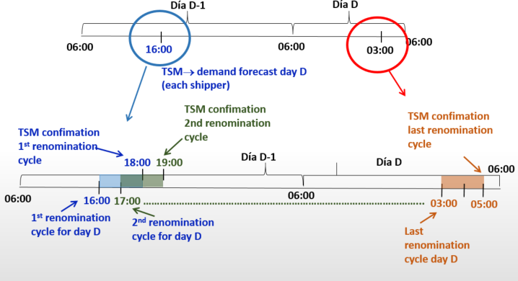

Figure 8: Timeline for nominations/renominations for all point except VIPs.

Nominations will be referred to entry/exit points to PVB, namely, underground storage facilities, LNG plants and Interconnections Points with other countries. In this sense, it is noteworthy that balancing nominations scheduled have been made compatible with capacity allocation mechanisms in both IPs and other facilities of the Spanish gas system.

The Technical System Manager may only reject a nomination or renomination in the following cases:

a) If it does not comply with the established content

b) If it is not sent by an authorized user

c) If it leads to a flow that cannot physically take place

d) If it surpasses the agent's contracted capacity

ENAGÁS GTS cannot reject a user's nomination because the nomination of inputs does not match with the nomination of offtakes. ENAGÁS GTS may only modify the quantity of nominations/renominations in a justified manner in exceptional situations and, in particular, in emergency situations.

Nomination and renominations are provided via SL-ATR, the IT system for the logistic of the Spanish gas system.

France

The following figure shows the schedule for nominations and renominations at TIGF network.

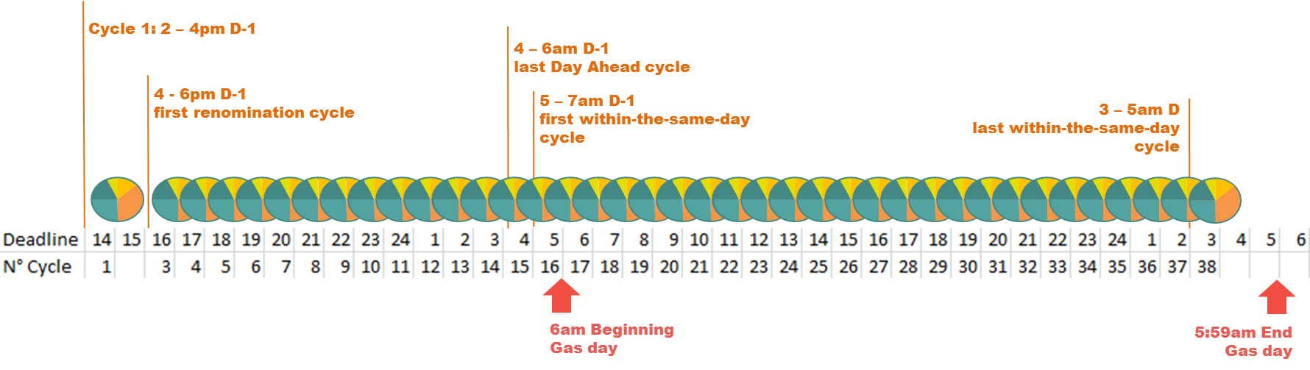

Figure 9: TIGF’s schedule for nominations/renominations.

TIGF has 37 continuous cycles from 2 pm on the day before the gas day D-1 to 3 am on the gas day D.

First cycle goes from 2pm to 4 pm during the day D-1 (there is no 3-5pm cycle). After 4pm, each hour is a deadline for the beginning of a cycle (overlapping 2-hour cycles).

Nomination is done before each hour H for a quantity applicable at H+2.

The cycles are 2 hours long with a scheduling in 1 hour. There is an agreement with ENAGAS GTS to carry out a matching for a 1-hour cycle at the Interconnection Points.

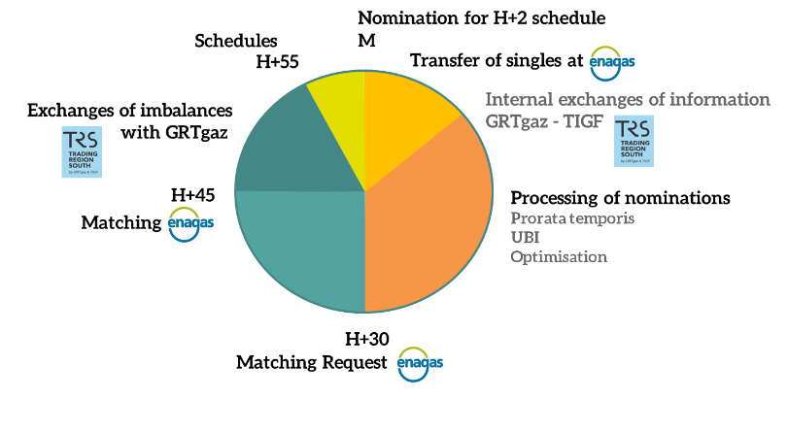

Figure 10: Nominations and renominations at Interconnection Points between France and Spain.

Nominations/renominations at TIGF’s network have an impact in the gas flow between TIGF and GRTGaz infrastructure. GRTGaz must communicate TIGF the following information:

* Need for transport given the nominations at GRTGaz
* Calculation and dispatch of an “average” flow (Implicit Flow) between the two TSOs

On the other hand, GRTgaz operational procedures pertaining to nominations and renominations fully comply with the provisions of the Balancing network code. This has been the case even before the entry into force of this network code.

Portugal

Commission Regulation (EU) No 312/2014 of 26 March is very prescriptive in these matters, so the regulatory framework adopted in the Portuguese system (MPGTG) implements the schedule and an information exchange procedure as set out in that European Regulation.

The following figure shows schematically the information flows and schedules established in the MPGTG.



Figure 11: Nominations/renominations schedule in Portugal.

Market Agents (MA) should submit the nominations for the gas day d to the GTG no later than 13:00 h in the day *d*-1. GTG must provide the confirmed quantities no later than 15:00 h in the day *d*-1.

The renomination period opens at 15:00 h in the day *d*-1 and remains open until 03:00 h in the gas day d. GTG must provide the confirmed quantities in a maximum of 2 hours after receiving renominations from MA.

Additionally, the criteria for validation of nominations and renominations is almost fully defined in the Commission Regulation (EU) No 312/2014 of 26 March, being the Portuguese regulatory framework consistent with those provisions.

It should be underlined that, under the current MPGTG, nominations and renominations are limited to contracted capacity and may be subject to possible constraints if the capacity is contracted on an interruptible basis or if a congestion management procedure is triggered.

The MPGTG foresees the possibility of implicit capacity allocation by a market operator (MIBGAS) at the Interconnection Points with Spain, referring to a specific procedure in the Portuguese Access Code.

## Information provision

The provision of information allows the users` network to manage exposures and opportunities, which it is crucial in a balancing regime where users have a central role in the balance of the system. The NC offered three possible models for information provision. French and Spanish regulation have implemented the so called “base case” model, where the information on non daily metered off-takes consists of a day ahead and within day forecasts, while Portugal has implemented the “variant 2”, where the information on non daily metered off-takes is a day ahead forecast.

Spain

In Spain, ENAGÁS GTS provides network users the best available information with regard to their balance the day before (D-1), during the day (D) and the day after (D+1). The day before ENAGÁS GTS publishes the overall system demand forecast together with the hypotheses used for the calculation. Afterwards, the distributors and TSOs submit to ENAGAS GTS their demand forecast break down by user. With this information, ENAGÁS GTS recalculates the overall forecast demand for the gas day (D). During the gas day (D), ENAGÁS GTS will provide each network user at least twice (14:00 and 21:00) with information about their inputs and offtakes in both transport and distribution networks, including user’s intraday metered demand and an updated estimate of its daily and non-daily metered demand. The day after (D+1) ENAGÁS GTS will calculate a first estimate of the individual imbalance of each network user and will inform them separately. These estimates are updated twice, the first one after the real measures of non-daily metered consumption are available, and the second one after results of meters revisions correct mistakes in the measures due to a malfunction of the meter. Information is provided via SL-ATR, the IT system for the logistic of the Spanish gas system.

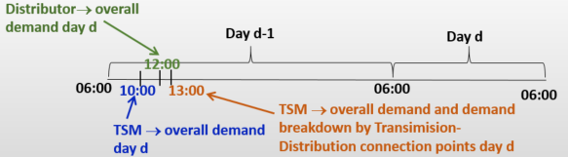

Figure 12: Timeline for information provision

France

Portugal

The information provision from the GTG to the market agents (MA), regarding the application of Commission Regulation (EU) No 312/2014 of 26 March, in particular concerning the balancing status on the transmission network, occurs the day before the gas day *d* (gas day *d*-1), during the gas day *d* and after the gas day *d*.

On the gas day d-1, the GTG must provide the MA relevant information concerning forecasts for the non-daily metered (NDM) portfolio’s off-takes, for the gas day d. This process involves the GTG, the Distribution System Operators (DSOs) and the Entity Responsible for Forecasting (ERP). The following figure presents the procedure applicable to the information provision on the gas day *d*-1, concerning the NDM off-takes.



Figure 13: Timeline for information provision in Portugal.

The GTG must receive relevant information from the DSOs with the composition of the NDM costumer’s portfolio of each MA and, also updates from the forecasting party regarding the daily consumption profiles to be applied on gas day *d* to NDM consumers.

The DSOs and the forecasting party must submit the information referred in the previous paragraph, during the gas day *d*-1, until 9:30 and 11:00, respectively. If the GTG does not obtain the previously mentioned information from the DSOs and from the forecasting party, it must apply the data available in the last communication.

Once the relevant data is gathered, the GTG must aggregate for each MA the respective NDM off-take forecast. These forecasts must be provided to the MA during the gas day *d*-1, until 12:00.

On gas day *d*, GTG must provide information on intraday metered (IM) intakes and off-takes (which, in the Portuguese system, concerns the consumers supplied directly from the transmission network), including a minimum of three updates, namely:

1. Until 13:00 h, concerning the period from 05:00h to 10:00h of gas day *d*;
2. Until 20:00 h, concerning the period from 05:00h to 17:00h of gas day *d*;
3. Until 01:00 h, concerning the period from 05:00h to 22:00h of gas day *d*.

The following figure shows schematically the information provision from the GTG to the MA on gas day *d*, concerning the IM inputs and off-takes.



Figure 14: Timeline for information provision on intraday metered consumption.

In the day after de gas day, the day *d*+1, the GTG must provide the MA information on gas day *d* inputs and off-takes, including the initial allocation for the IM and daily metered (DM) inputs and offtakes as well as a better estimate for the NDM costumers. Also, the GTG must provide information on the initial daily imbalance quantity as well an estimate for the daily imbalance charge.

On the third day of each month, the GTG must provide each MA the final daily imbalance quantity for each gas day *d* of the previous month, as well as the respective daily imbalance charges.

## Imbalances charges

Spain

All users begin each gas day with zero imbalance in the transmission network. One day after the gas day (D+1), ENAGÁS GTS will calculate each user´s provisional imbalance for the gas day. ENAGÁS GTS has developed the corresponding methodology to calculate imbalance charges[7]. According to this methodology, users with a negative imbalance (short of gas) must pay ENAGÁS GTS the result of multiplying their provisional individual imbalance amount by the daily imbalance tariff for that gas day (marginal buy price[8]). On the other hand, users with positive imbalance (long of gas) are entitled to receive from ENAGÁS GTS the result of multiplying their provisional individual imbalance amount by the daily imbalance tariff for that gas day (marginal sell price[9]). The marginal buy and sell prices are calculating according to rules established in the Balancing NC, considering 2.5% as the value for the small adjustment.

Cashouts corresponding to users imbalances are invoiced weekly. The invoice can be positive or negative for the user, depending of the sign of its imbalance quantity. Provisional users’ imbalances are revised twice, after 3 and 15 months, with the best information available at that moment. Imbalances charges are then recalculated and differences with the previous ones invoiced to users.

France

TIGF :

In accordance with current regulatory provisions (European gas networks code and the latest deliberation of the Energy Regulatory Commission approving changes in balancing rules on the TIGF transport network at 1st April and 1st October 2015, the imbalance tariffs on a given Day are the following:

a) When TIGF has not traded on the market for delivery on day D (withouth balancing actions):

i. The Average Price of gas transactions less a 2.5% discount, in the case of positive imbalances;

ii. The Average Price of gas transactions plus a 2.5% premium, in the case of negative imbalances.

For each day D, the Average Price of gas is the weighted average price of Within-Day transactions of all traders on the Powernext Gas Spot's TRS (Trading Region South) for delivery on day D, as calculated by Powernext.

If Day D falls on a weekend and there are no Within-Day transactions for delivery on day D in the TRS, the Average Price is the weighted average of transactions made in the TRS by all traders on Powernext for the weekend maturity date that includes day D, as calculated by Powernext.

If Day D is a Bank holiday in the sense of the Powernext calendar, and there are no WithinDay transactions for delivery on Day D in the TRS, the Average Price is the weighted average of Bank Holiday product transactions made in the TRS for the maturity date of Day D.

b) When TIGF and/or GRTgaz have traded on the market for delivery on day D (with balancing actions):

i. If the Transmission System Operator purchases gas from the users, the imbalance tariff for negative imbalances is the highe of the following two prices:

* the highest of all the purchases of gas by TIGF and/or GRTgaz on the Powernext trading platform in respect of balancing for the gas day in question
* the Average Price of gas transactions for the gas day in question, plus a 2.5% premium.

For positive imbalances then, the imbalance tariff is the the Average Price of gas transactions less a 2.5% discount.

ii. If the Transmission System Operator sells to the user at the Marginal Purchase Price, the imbalance tariff for positive imbalances is the lowest of the following two prices:

* o the lowest of all the sales of gas of Teréga and/or GRTgaz on the Powernext trading platform in respect of balancing for the gas day in question
* o the Average Price of gas transactions for the gas day in question, less a 2.5% discount

GRTgaz :

Marginal Price of purchase for th South Balancing area is the highest of the two following prices:

* the highest of all buying prices offered by GRTgaz and/or TIGF and concerning the TRS Perimeter on the Balancing Gas Exchange for the gas day concerned;
* the Average Price for the TRS perimeter and the gas day in question plus a 2.5% small adujstment.

Marginal Price of sale for the South Balancing area is the lowest of the two following prices:

* the lowest of all selling prices offered by GRTgaz and/or TIGF for the TRS Perimeter on the Balancing Gas Exchange for the gas day concerned;
* the Average Price for the TRS perimeter and the gas day concerned minus a 2.5% small adjustment.

Distribution of TRS imbalance quantities to be cashed out by GRTgaz : these quantities are the TRS daily imbalance multiplied by the ratio between the total quantities delivered to the consumer delivery points connected to the South Balancing area and the total quantities delivered to the consumer delivery points connected to the GRTgaz south balancing area and to the TIGF balancing area.

Portugal

The daily imbalance charges are determined taking into account the final daily imbalance quantities, determined by the real flows from IM inputs and off-takes and DM off-takes and also the forecasts of the NMD off-takes provided by the GTG to the MA on gas day *d*-1. The determination of the final daily imbalances also considers the linepack flexibility service.

The daily imbalance charges results from the application of the average prices from MIBGAS, the Spanish trading platform, to the final daily imbalance quantities, for each day gas *d*. The daily imbalance charges are positive or negative in case of excess or default of gas in the balance area (transport network), respectively.

The imbalance prices corresponds to the weighted average prices for natural gas purchase or sale in MIBGAS, adjusted by plus/less 2.5% respectively. The daily imbalance charges also includes interconnection tariffs in the direction of Spain-Portugal (in the case of an imbalance by default) or Portugal-Spain (in case of an imbalance due to excess of gas in the transport network).

The application of daily imbalance charges reconciles the MA position in the transmission network at the end of each gas day *d*.

## Financial neutrality of the Transmission System Manager: allocation of balancing actions costs

The balancing actions are performed by the TSOs without any benefit or cost, provided that these are performed efficiently. Impact of users’ imbalance charges are also neutral to TSOs.

Spain

The balancing actions of sales/purchases of title products in PVB performed by ENAGÁS GTS are settled monthly. ENAGÁS GTS calculates the overall net financial result of the settlement of users’ imbalances for the month M and the balancing actions performed by ENAGÁS GTS (sales/purchases of title products in PVB) during that month. Additionally, for each user ENAGÁS GTS calculates the sum of their absolute values of imbalance quantities accumulated during the month. Where the net financial result (as calculated in the paragraph above) is negative for ENAGÁS GTS, the network users with an accumulated monthly imbalance will pay ENAGÁS GTS proportionally to their accumulated monthly imbalance. On the contrary, if the result is positive the result will be considered as an income for the gas system and used to reduce system’s costs and TPA tariffs in the future.

France

**TIGF:**

An overall calculation is made for each user’s contractual imbalance in the Trading South Region (TRS). To determine the contractual imbalance, the TSOs distribute each user’s imbalance between the two balancing zones (TIGF and GRTgaz) using a specific code for each user depending on the total amount of its capacity allocations at exit points (delivery points, PIR, PITS) in each balancing zone.

This code takes into account the segmentation of users into 4 categories, on a monthly basis, depending on their portfolio capacities:

- users with delivery capacities to end users or to the PITDs make up segment 1;

- users with transport capacity but no delivery capacity to end users or to PITDs make up segment 2;

- users with no transport capacity (pure traders) make up segment 3;

- inactive users make up segment 4.

Each day, the procedure is applied as follows:

- a user’s imbalance after delivery to end users is distributed pro-rata between the two balancing zones (TRS TIGF, TRS GRTgaz) to the allocations at delivery points, using a segment-specific formula;

- a user’s imbalance with only volume allocations at the entry and exit of the TRS, is distributed pro-rata to allocations at the entry and exit of the TRS (PIR, PITTM, PITS), using a segment-specific formula;

- a user’s imbalance, after having exclusively conducted transactions within the TRS, is entirely allocated to GRTgaz South zone;

- for reasons of practicality and simplicity in IT implementation, TIGF and GRTgaz agree to join forces for the operational management under the “traders” and “inactive shippers” categories.

GRTgaz:

The balancing result for a given month is equal to the difference between, on the one hand:

* the amount of natural gas sold by GRTgaz on the Balancing Gas Exchange deducting the variable proportion of transaction costs on the Balancing Gas Exchange with some users delivered between the first and the last day of the month,
* the amount of natural gas sold by GRTgaz to the users under the transmission contracts for each day of the month,
* the sale by GRTgaz of the difference between the quantities purchased and the quantities sold by the latter via the Balancing Gas Exchange under the transmission contracts, should this difference be positive,

and, on the other hand,

* the amount of natural gas purchased by GRTgaz on the Balancing Gas Exchange including the variable proportion of transaction costs on the Balancing Gas Exchange with some users delivered between the first and the last day of the month,
* the amount of natural gas purchased by GRTgaz from the users under the transmission contracts for each day of the month,
* the purchase by GRTgaz of the difference between the quantities purchased and the quantities sold by the latter via the Balancing Gas Exchange under the transmission contracts, should this difference be positive.

The balancing result for the month is broken down between the users holding a valid transmission contract with GRTgaz during the month, in proportion to the quantities delivered to the consumer delivery points that they have been allocated for each day of the month.

If the balancing result is greater than zero (0), GRTgaz shall pay to the user the portion the user is entitled to of the balancing result as defined above.

Otherwise, if the balancing result is lower than zero (0), the shipper shall pay to GRTgaz the said portion of the balancing result as defined above.

Portugal

The regulatory framework (MPGTG) contains the rules and methodology for allocating costs and revenues related to the payment (or receipt) of daily imbalance charges, balancing actions and revenues from the linepack flexibility service, assuring the neutrality of revenues (and costs) of the GTG.

The costs and revenues taken into account for the purpose of establishing a neutrality methodology are the following:

1. The daily imbalance charges.

2. Balancing actions, via purchase and/or sale of natural gas in short-term markets or through balancing services (currently the only option).

3. The revenues related to the linepack flexibility service.

4. Other variable costs, such as the cost of access to trading platforms for the purchase and sale of gas.

With regard to the cost-sharing methodology, the GTG should assess the neutrality charges by adding, for each month, the costs and revenues associated with the balancing activity of the transmission network, considering the referred costs/revenues.

The model for allocating the neutrality charges by MA is proportional to the sum of inputs and off-takes of natural gas in the balancing area (transmission network) over the course of each month.

As regards to transparency obligations, the GTG's should publish on his website the neutrality charges, sending monthly detailed invoices to the MA, and relevant information to ERSE, on a quarterly basis.

## Transmission System Manager incentives

Spain

Enagas GTS has already submitted for approval to CNMC a proposal of incentives mechanism that is currently in CNMC under review. The mechanism has been recently approved and will apply as from the next gas year, starting on 1 October 2018.

Portugal

According Regulation for Operation of Infrastructures (ROI), published in April 2016, ERSE can approve incentives to NSNG's Global Technical Manager (GTG). The aim of this incentive is to GTG efficiently carry out compensation actions or to maximize the performance of compensation actions using standardized short-term products.

The granting of an incentive scheme shall be preceded by prior consultation with the interested parties, promoted by the ERSE. So far, ERSE was not been asked to implement any incentive mechanisms by the GTG.

# Functioning of the balancing schemes since its application (1st October 2015 in France and 1st October 2016 in Portugal and Spain) to 30th September 2017

* 1. **Operational balancing**

**SPAIN**

* Number of days balancing actions taken: 80
* Number of balancing actions (acquisition of STSP) per day

Product DA:

* + Sell balancing actions: 4
  + Buy balancing actions: 17

Product WD:

* + Sell balancing actions: 13
  + Buy balancing actions: 46
* Volumes of STSP acquired, by type and indicating sells and buys, per day.

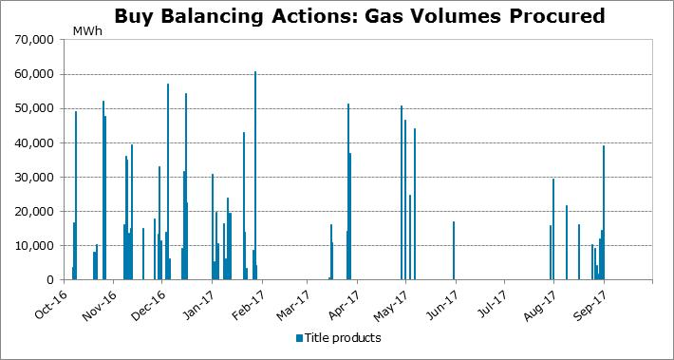

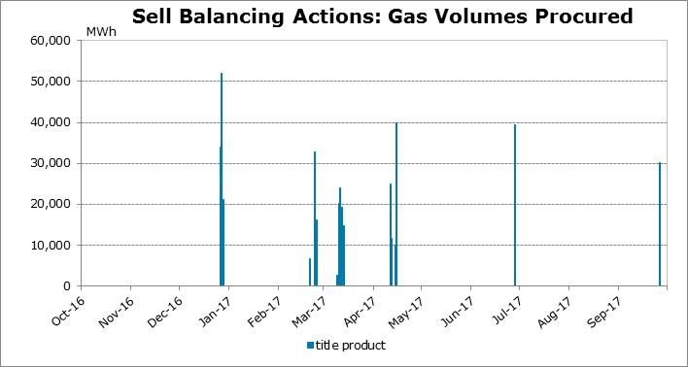

* Days when STSP selling and buying gas were necessary (in the same day): None.
* Maximum, minimum and average sell/buy quantities and costs and revenues by STSP. (MWh and € namely).

|  |  |  |  |  |  |
| --- | --- | --- | --- | --- | --- |
| Purchase Balancing Actions | | | | | |
| Value |  | **Within-Day** | | **Day-Ahead** | |
|  | **Volume** | **Expenditure** | **Volume** | **Expenditure** |
| Maximum |  | 52,018 | 1,632,776.80 | 49,088 | 1,593,911.25 |
| Minimum |  | 480 | 7,872.00 | 3,500 | 85,088 |
| Average |  | 17,728 | 401,352.97 | 19,751.53 | 511,415.18 |

|  |  |  |  |  |  |
| --- | --- | --- | --- | --- | --- |
| Sell Balancing Actions | | | | | |
| Value |  | **Within-Day** | | **Day-Ahead** | |
|  | **Volume** | **Income** | **Volume** | **Income** |
| Maximum |  | 40,000 | 658,744 | 49,000 | 863,600 |
| Minimum |  | 2,500 | 41,030 | 10,000 | 158,250 |
| Average |  | 20,416.85 | 350,309.27 | 19,056.14 | 341,606.97 |

* The TSOs’ balancing action defines the marginal price: number of days, spread with average users’ trades’ prices, etc.

Number of days the TSOs´ buy balancing actions defines the marginal price: 21

Number of days the TSOs´ sell balancing actions defines the marginal price: 3

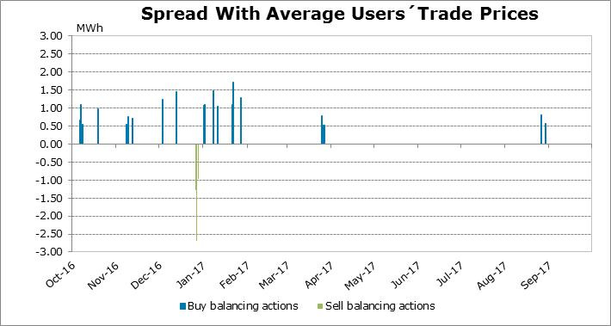

* Main reasons for balancing actions

The transmission network aggregated imbalance (DQA), calculated according to users’ nominations for the gas day, at the begining of the gas day was located into the Monitoring or the Alert Band. Into the Monitoring Band, the balancing action execution has taken into account:

• The linepack.

• The forecast of future evolution of linepack.

• The liquidity and the gas prices at the organised gas market.

* Use of balancing services: description of the balancing services, reason of its necessity, quantities and cost involved, number of occasions that it has been used and reasons for its use.

Balancing services were not considered necessary and therefore, not provided.

* Information provided to users:

- Network Imbalance Index (IDQ): Network’s aggregated imbalance forecast at the end of the current gas day.

- Daily Projected Closing Imbalance (DBP): Network users’ daily imbalance forecast at the end of the current gas day.

- Network’s Estimated Aggregated Imbalance (DQA): Last update of the network’s aggregated imbalance previous to the beginning of the current gas day.

- Information about the Technical Manager of the Gas System balancing actions: Quantity, Cost, Average Price, Min. Price, Max. Price, Justification

* Conclusions that can be drawn from the figures (e.g. potential for cross-border balancing actions).

The number and the volume of sell balancing actions is around the 27% of the buy balancing actions.

**FRANCE**

Period from October 2015 to October 2017:

* Sum up of the 23 buying interventions on PEGAS platform;

|  |  |  |
| --- | --- | --- |
| Oct2015-Oct2016 | 19,500 | MWh 25°C |
| Oct2016-Oct2017 | 17,930 | MWh 25°C |
| Total | **37,430** | MWh 25°C |

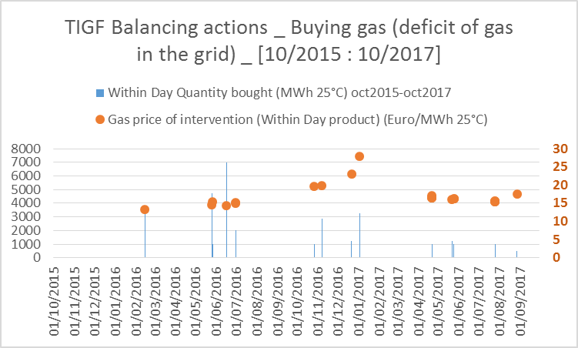

* Sum up of the 116 selling interventions on PEGAS platform;

|  |  |  |
| --- | --- | --- |
| Oct2015-Oct2016 | 149,940.4 | MWh 25°C |
| Oct2016-Oct2017 | 61,730 | MWh 25°C |
| Total | **211,670.4** | MWh 25°C |

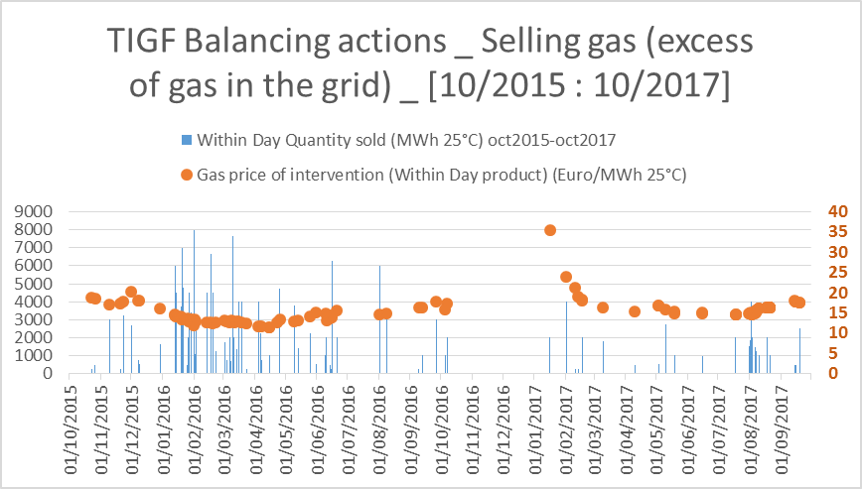

**GRTgaz**

Thanks to the Concertation Gaz group gathering users, clients and the French energy regulatory commission, a continuous assessment of the balancing regime of GRTgaz is in place. Permanent interactions with the market enable evolutions of the balancing regime as required by the participants, taking duly into account the feedback from stakeholders.

From October 2016 to October 2017, GRTgaz did 132 balancing actions corresponding to TRS zone, with almost a perfect balance between buy and sell actions. There actions were performed on PEGAS except on 2 days where locational products were used.

It appears that the system worked well to ensure that users are balanced. The balancing actions of GRTgaz sent an effective signal to encourage users to be balanced.

**PORTUGAL**

|  |  |  |  |  |  |  |  |  |  |
| --- | --- | --- | --- | --- | --- | --- | --- | --- | --- |
| MWh | Annual Quantity | % of annual entries | Number of days | Average daily Quantity | Max Daily Quantity | Min Daily  Quantity | Max price  (€/MWh) | Min price  (€/MWh) | Average Price (€/MWh) |
| **System Buys** | 42 000 |  | 7 | 6 000 | 6 000 | 6 000 | 19,57 | 18,51 | 19,13 |
| **System Sells** | 0 | - | 0 | - | - | - | - | - | - |

According to the national methodology for the determination of the quantities due to be bought/sell for balancing actions by the TSO as a means of repositioning of the conditions for operating the network, and considering there is no trading platform available, all the balancing actions were made through balancing services by auctions.

Total Balancing Actions: buy of 42 000 MWh

30/Jun

23/Jun

20/Apr

12/May

05/May

After an initial period of adaptation of the overall stakeholders to the new balancing scheme, there was an improvement on the behavior of the system. The first winter period and the lack of gas that affected some of the users at Iberian Peninsula caused an accumulated imbalance that took an amount of operational gas to be compensated by balancing services.

The total amount of balancing actions taken on this first year totalized a purchase of 42,000 MWh. This amount of gas was acquired through seven auctions performed over the first year of implementation of the network code, which were triggered when the accumulated deviations were affecting the operational gas available at the TSO disposal.

|  |  |  |  |
| --- | --- | --- | --- |
|  | **Quantity [MWh]** | **Auction Price [€]** | **Expenditure [k€]** |
| 20/04 | 6 000 | 19,00 € | 114,00 k€ |
| 28/04 | 6 000 | 19,55 € | 117,30 k€ |
| 05/05 | 6 000 | 19,57 € | 117,42 k€ |
| 12/05 | 6 000 | 19,15 € | 114,90 k€ |
| 08/06 | 6 000 | 18,51 € | 111,06 k€ |
| 23/06 | 6 000 | 19,15 € | 114,90 k€ |
| 30/06 | 6 000 | 18,99 € | 113,94 k€ |
| **TOTAL** | **42 000** |  | **803,52 k€** |

Table: Purchase balancing actions

No sell balancing actions were made since it was not considered necessary for the purpose of reestablishment of the operational gas amount.

All information concerning the auctions was made available to the users. In the following internet site it was published the methodology and all the technical rules applicable and commercial information regarding the process of applying to the auction:

<https://www.ign.ren.pt/web/guest/gestao-comercial1>.

In the following internet site, users and public in general could find the results of each auction that took place, including each one of the calls and the respective results:

<https://www.ign.ren.pt/acoes-de-compensacao-do-gtg?p_p_id=listAllocationYear_WAR_renatrportlet&p_p_lifecycle=0&_listAllocationYear_WAR_renatrportlet_implicitModel=true>

* 1. **Imbalances charges**

**SPAIN**

* Daily imbalance cashout quantities of shippers that are long (entries higher than exits)
* Daily imbalance cashout quantities of shippers that are short (entries lower than exits)

They both are directly correlated with the gas price and seasonality. As gas price rises on winter approaching, the imbalance cashout quantities increase in absolute values.

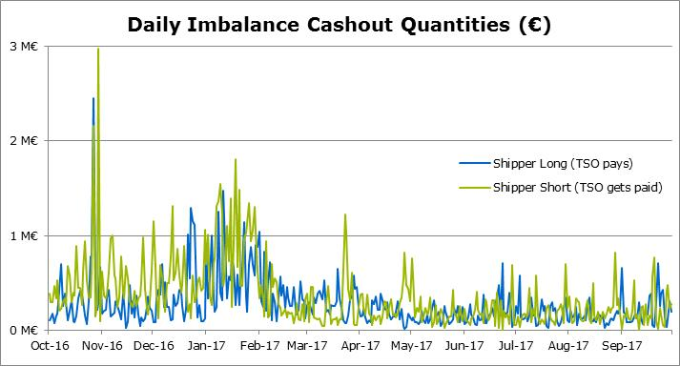

* Maximum and Minimum imbalance quantities.

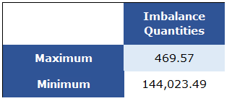

* Information on imbalance tariffs: calculation, small adjustments, maximum, minimum and average imbalances tariffs, evolution of imbalances tariffs, etc.

|  |
| --- |
| Marginal Purchase Price |
| This price is calculated as the highest between:   1. The highest price of purchases of title products by the GTS in PVB for the day of gas. 2. The weighted average price of the gas of that gas day plus a minor adjustment of purchase. The minor purchase adjustment is 2.5%.   Marginal Sale Price  This price will be calculated as the lowest between:   1. The lowest price of the transactions of the sales of title products by the GTS in PVB for the day of gas. 2. The weighted average price of the gas of said gas day less a minor adjustment of sale. The minor sale adjustment will be 2.5%. |

* Conclusions that can be drawn from the figures.

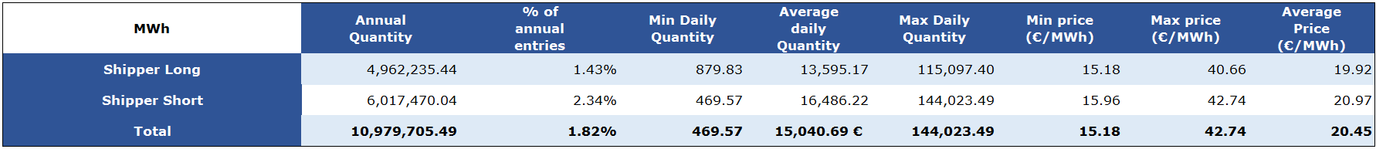

Generally, users stay short of gas rather than long, meaning that the GTS must take more buy balancing actions than sells. In comparison with their entries the imbalance is very small.

Throughout the analyzed period, the marginal purchase price has been calculated as the highest price of the purchases of the GTS in the PVB in 21 times. However, the marginal sale price has only been calculated as the lowest price of the sales of the GTS in the PVB in only 3 times.

**FRANCE**

**PORTUGAL**

In the beginning of the gas year 2016/2017, some imbalances, short and long, occurred due to the lack of experience of stakeholders with the new balancing scheme. Considering the high impact of this implementation, it was decided by the NRA, after proposal of the system operators, that the total imbalances accumulated in the first month of implementation should not be charged. Instead, the amounts incurred by each user were compensated by operational gas that was reseated at that time.

|  |  |  |  |
| --- | --- | --- | --- |
| **NU Long** | **Energy  [MWh]** | **€** | **Date** |
|
| Highest | **4 902** | **71 738** | 05/08/2017 |
| Average | **246** | **4 678** | (-) |

|  |  |  |  |
| --- | --- | --- | --- |
| **NU Short** | **Energy  [MWh]** | **€** | **Date** |
|
| **Highest** | **7 840** | **322 243** | **19/01/2017** |
| **Average** | **417** | **9 890** | **(-)** |

|  |  |  |  |  |  |  |  |  |
| --- | --- | --- | --- | --- | --- | --- | --- | --- |
|  | Annual Quantity | % of Annual Entries | Min Daily Quantity | Average Daily Quantity | Max Daily Quantity | Min Price (€/MWh) | Max Price (€/MWh) | Average Price (€/MWh) |
| **Long** | **70 639** | **0,1%** | **8** | **304 481** | **4 902 028** | **14,07** | **39,17** | **19,02** |
| **Short** | **119 680** | **0,2%** | **-322 243** | **9 164** | **0** | **17,99** | **46,51** | **23,73** |

By January 2017, there was difficult situation for some of the users to purchase gas, which led them to be short on the system for several times. Another consequence of this occurrence was an increase of the prices at MIBGAS. This situation lasted until the following month.

The rules defined to the determination of the applicable prices to imbalances were the following:

* Marginal sell price: determined by the minimum between the lowest sell price of any title product traded by the TSO and the weighted average price multiplied by 0,975;
* Marginal buy price: determined by the maximum between the highest buy price of any title product traded by the TSO and the weighted average price multiplied by 1,025.

Meanwhile, since there is no trading platform available for the Portuguese system, the weighted average price was determined considering the weighted average price at the Spanish VTP affected by the corresponding transport tariffs at VIP Ibérico.

* 1. **TSOs’ neutrality**

**SPAIN**

* Evolution of incomes and expenditures of the TSO during the year, distinguishing the 5 economic flows that affect neutrality: STSP acquisition (buy and sell), shippers’ imbalances cashout (long and short positions) and use of balancing services.

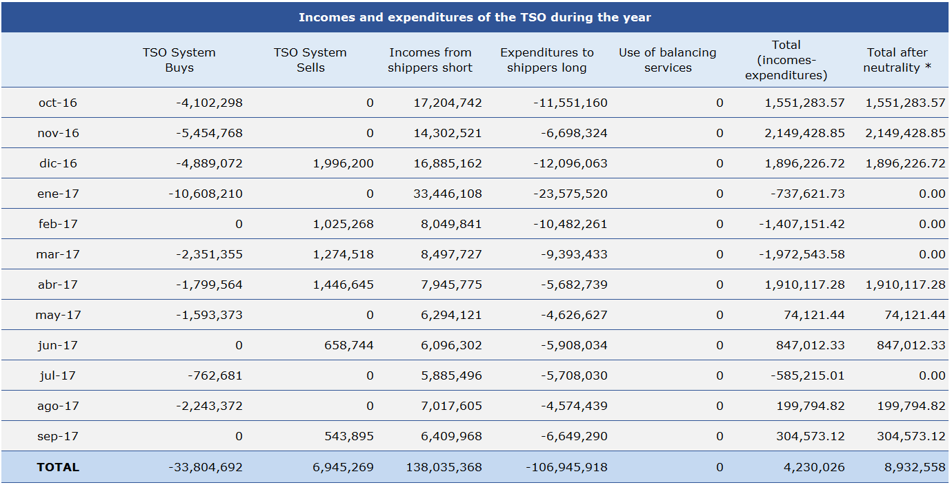

The incomes or expenditures from users’ imbalances have been calculated with the best information available on the balance in each month.

(*) According to Spanish regulation, when the result of incomes-expenditures for one month is negative, the TSO distributes the resultant quantity between all the users that have operated that month.

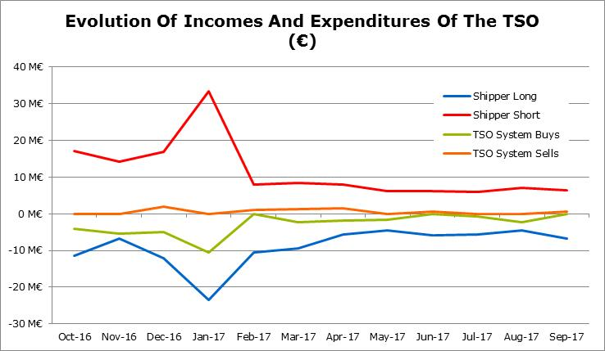

* Maximum, minimum and average cumulative neutrality (unadjusted financial position) during the year

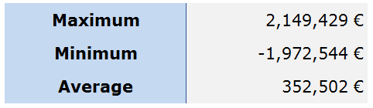

Average calculated with Total (incomes-expenditures).

* Net financial position corresponding to the end of the year.

The net financial position defined as the difference between incomes and expenditures during the year.



According to Spanish regulation, when the result of incomes-expenditures for one month is negative, the TSO distributes the resultant quantity between all the users that have operated that month. Therefore, the quantity after neutrality is zero. It took place four times in the analyzed period. Considering such application of neutrality, the net financial position after recovering the negative quantities from users is 8.932.558 €.

* Conclusions that can be drawn from the figures.

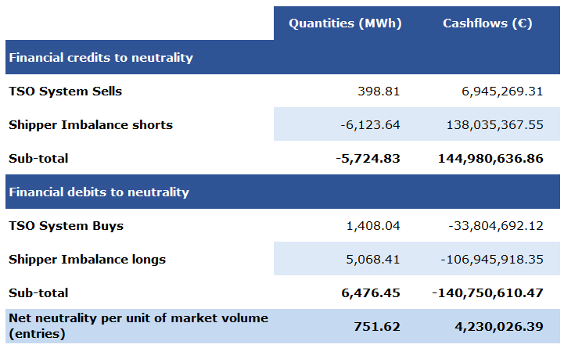

**FRANCE**

**PORTUGAL**

|  |  |  |
| --- | --- | --- |
| **Cashout** | **€** | **Date** |
|
| Highest | **71 738** | 05/08/2017 |
| Average | **3 667** | (-) |

|  |  |  |
| --- | --- | --- |
| **Cashout** | **€** | **Date** |
|
| Highest | **322 243** | 19/01/2017 |
| Average | **8 084** | (-) |

Balancing services that took place in the first gas year.

|  |  |  |  |
| --- | --- | --- | --- |
|  | **Quantity [MWh]** | **Auction Price [€]** | **Expenditure [k€]** |
| 20/04 | 6 000 | 19,00 € | 114,00 k€ |
| 28/04 | 6 000 | 19,55 € | 117,30 k€ |
| 05/05 | 6 000 | 19,57 € | 117,42 k€ |
| 12/05 | 6 000 | 19,15 € | 114,90 k€ |
| 08/06 | 6 000 | 18,51 € | 111,06 k€ |
| 23/06 | 6 000 | 19,15 € | 114,90 k€ |
| 30/06 | 6 000 | 18,99 € | 113,94 k€ |
| **TOTAL** | **42 000** |  | **803,52 k€** |

By the end of the gas year, the global financial credits to neutrality were 119,680 MWh while the global financial debts to neutrality were 112,639 MWh. The final difference of 7,041 MWh was still considered within the margins of operational gas available to the TSO.

As the TSO’s neutrality is calculated every month taking into account the expenditures and incomes in the same period, the eligible costs and revenues to neutrality are sum up and proportionately imposed to the users according to the extent the users makes use of the relevant entry and exit points to/from the network.

|  |  |  |
| --- | --- | --- |
|  | Quantities [MWh] | Quantities [€] |
| **Financial Credits to neutrality** |  |  |
| TSO System Sells | 0 | 0 |
| Shipper Imbalance Short | 119 680 | 2 950 804 |
| Sub-total | 119 680 | 2 950 804 |
|  |  |  |
| **Financial Debits to neutrality** |  |  |
| TSO System Buys | 42 000 | 803 520 |
| Shipper Imbalance Long | 70 639 | 1 338 549 |
| Sub-total | 112 639 | 2 142 069 |

* 1. **Information provision**

**SPAIN**

* Percentage of successful communication of information to users per month (measures in number of successful updates in the month/total updates to be provided in the month).

Information Provision process came into force in Spain in June 2016. There have not been significant incidents since the implementation of the process. The communication of information to users has been available for users in 100% of landmarks.

* Number of days of communication failure per month

No relevant. Communication has been successful in 100% of landmarks.

* Quality of information provided

As it is stablished in the Resolución de 23 de Diciembre de 2015 de la DGPEyM por la que se aprueba el Protocolo de Detalle PD-17 “Provisión de Información sobre el balance del gas en las redes de transporte”, indicators for the measure of quality and compliance of the timetables by operators and Enagas GTS must be proposed by the Spanish Working Group for updating, modification and review of the Spanish Gas Code (NGTS) before June 2016. Those indicators are waiting to be approved and published by the Spanish Regulator and will be included in the detail protocol PD-17 as an annex. Further information about quality of information provided will be available once these indicators come into force.

* Analysis of incidents and their solutions

No relevant. There have not been significant incidents since the implementation of the process.

* Preliminary CBA

Information Provision process came into force in Spain in June 2016. Enough background and historical data is necessary before develop the CBA. As it is stablished in Circular de Balance 2/2015 (Chapter 16.5), an Information Provision analysis will be carry out by Enagás GTS in coordination with transmission system operators (TSOs) and distribution system operators (DSOs) before the 30th of September 2018.

* Conclusions that can be drawn from the figures (e.g., the need for more withinday information)

No relevant.

**FRANCE**

**PORTUGAL**

The quality of the information provided was generally good. However, there were some incidents that caused unavailability of correct information in the appropriate time which occurred with greater incidence in the initial period. Following each incident, an assessment was made in order to identify and correct the anomalies and to avoid future incidents motivated by the same reasons.

We can group the causes of the incidents into three groups:

* Incidents occurring due to the immaturity of the BAL implementation processes mainly because of computer bugs and inexperience of stakeholders;
* Unavailability of input data at the appropriate time by DSOs. For the purpose of handling with this matter, were promoted meetings with concerned parts in order to improve the processes, in particular, by requesting the automation of communication and backup processes implementation.
* Technological issues that were solved at each time occurred.

The unavailability periods registered are presented in the table below.



* 1. **System status**

**SPAIN**

* Highest, lowest and average opening linepack level

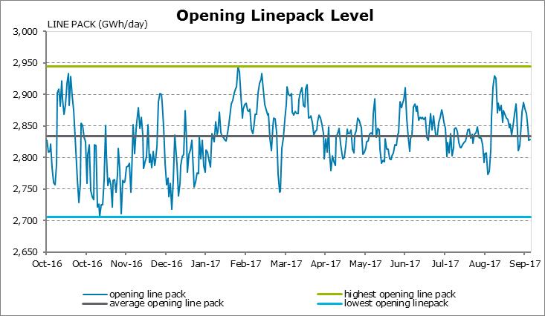

* Variations in cumulative commercial imbalance position (differences between the opening and the end of the gas day).

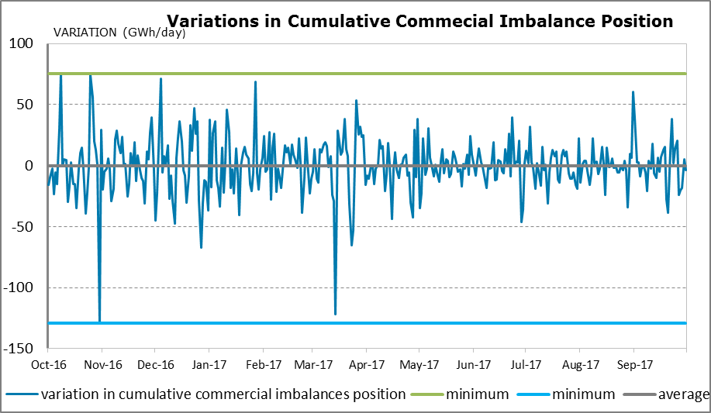

* Variations in cumulative physical linepack (differences between the opening and the end of the gas day)

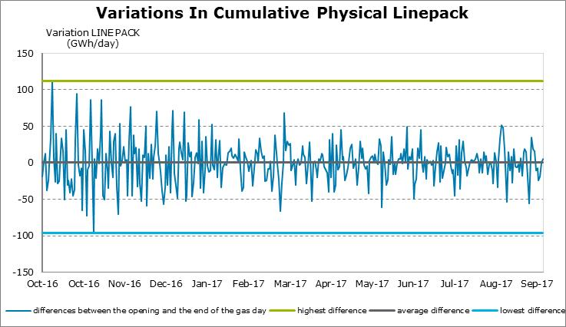

* Maximum, minimum and average values of variation in cumulative physical linepack and commercial position.

|  |  |  |  |
| --- | --- | --- | --- |
|  | GWh/d | | |
|  | Maximum | Minimum | Average |
| Variations in cumulative physical linepack | 111.93 | -96.71 | 0.02 |
| Variations in cumulative commercial position | 46.87 | -128.96 | -2.20 |

* Highest, lowest and average expected impact of commercial regime on physical linepack.

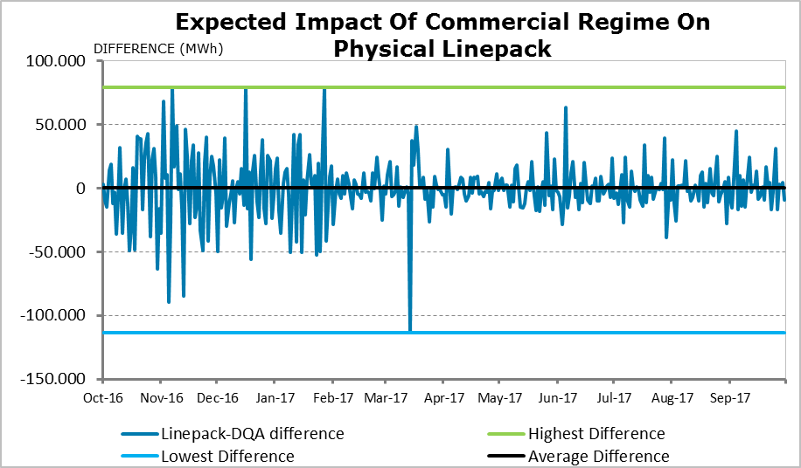

* Maximum and Minimum values of commercial imbalance position and linepack.

The requested values have already been shown above.

* Description of other aspects apart from commercial imbalances that affect linepack.
  + Purchases of new cushion gas needs.
  + Purchases of Working Gas
  + Leakages and measurement differences.
  + Operational Gas

The impact of these aspects on the linepack is residual except for the new cushion gas that is time by time punctual and lasts the time period between its purchase and subsequent injection.

* Conclusions that can be drawn from the figures.

The oscillations shown at the impact of commercial regime on physical linepack during the first months are compensatory between the different infrastructures, since operation was managed by OBA=0 at each infrastructure. Since February 2017, managing changed to global OBA=0 resulting in less oscillations.

**FRANCE**

TIGF:

TIGF has set up a balancing statement, recording what it spends and earns under aforementioned transactions and the balancing rules of the transmission contract. Since the 1st of october 2015, the balance is allocated to users as a proportion of the quantities delivered, according to the Deliberation of the French Energy Regulatory Commission of 15 January 2015 approving the balancing rules.

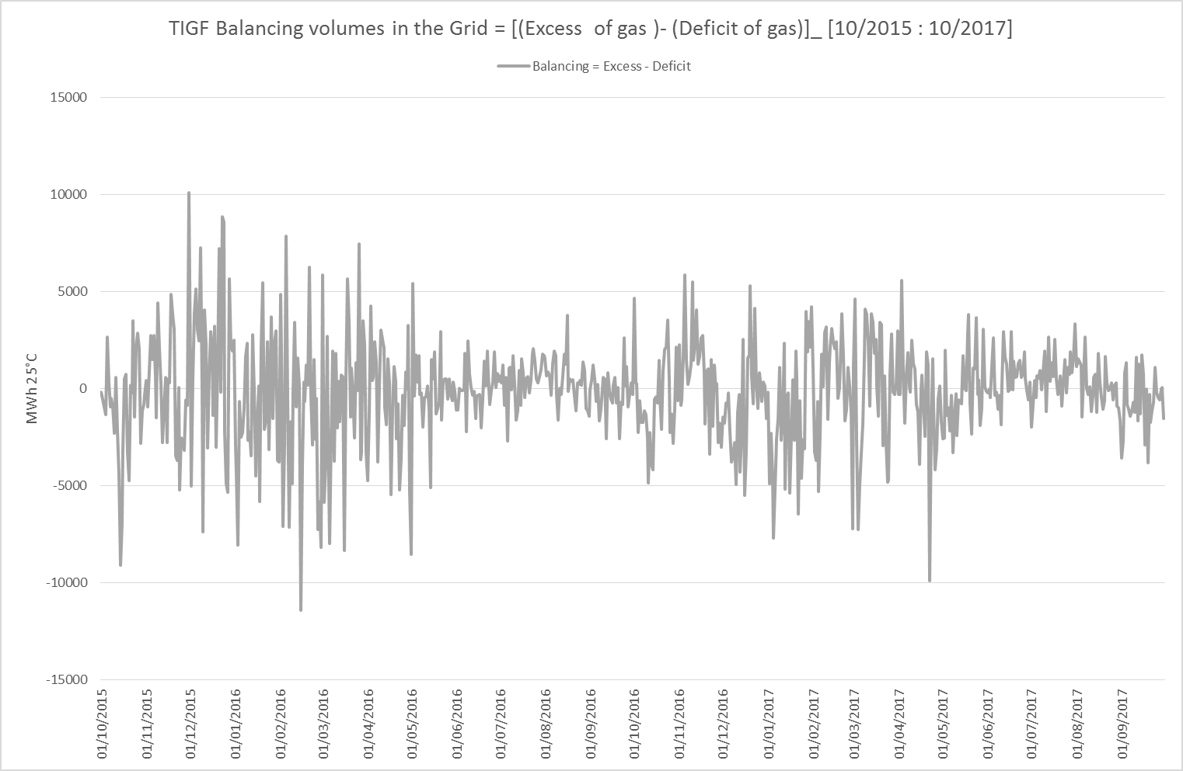

The graph here above shows the net balance of gas volumes (Excess of gas – Deficit of gas in the grid) from users.

A positive position on the graph indicates that users are long, and a negative position indicates that users are short. We can notice a seasonal envelope where users are better balanced during summer than in winter.

According to this net balance compared to TIGF linepack flexibility detailed in part 2.5, interventions on PEGAS platform may occur. The full balancing debt is then repaid/refund by the billing done in M+2 for M with the pricing described in part 2.8.

**PORTUGAL**

Although the picture shows a very high frequency of variation for the Opening Linepack it is found an average of around the reference value.

|  |  |
| --- | --- |
|  | **Daily Variation** |
|
| Reduction | **-60 311** |
| Increase | **53 300** |

|  |  |  |  |
| --- | --- | --- | --- |
| Data  Analysis | **Agents Short** | **Agents Long** | **Daily** |
|
| Lowest | **-12 071** | **0** | **-12 048** |
| Highest | **0** | **4 902** | **4 843** |

* 1. **Linepack flexibility.**

**SPAIN**

NA

**FRANCE**

**PORTUGAL**

In the period under analysis, users were entitled to an amount of linepack flexibility service determined considering a portion of the available flexibility of the transmission system.

The highest value verified of global utilization by the users in module was 13,306 MWh on 17th of April 2017.

# Potential for application of cross-border balancing

In order to move towards greater market integration, SGRI could explore the potential for application of cross-border balancing. The balancing NC establishes that the balancing actions must be undertaken in a market-based manner through short term standardized products on a trading platform or using balancing services through public tender procedures. Opening up the possibility for TSOs to use trading platforms in neighboring countries can contribute to operate the network in most efficient and cost-effective way as well as to foster competition in gas markets.

SGRI may explore different regulatory developments to allow TSOs for undertaking balancing actions in different trading platforms such as:

* Registration of TSOs as agent in other organized markets to buy/sell gas following price signals.
* Assessing the possibility for the TSOs to use savailable cross-border capacity for free or nearly free cost.

# Conclusions and recommendations

Currently there are five balancing areas in the South Gas Region: three in France (GRTGaz Nord, GRTGaz Sud and TIGF), one in Spain and one in Portugal managed by the corresponding TSOs, namely, GRTgaz, TIGF, Enagás and REN respectively.

The Spanish gas balancing zone comprises all the transmission gas network. The PVB is the virtual trading point and the trading platform for balancing actions is MIBGAS.

With the creation of the single market area in France, envisaged by November 2018, there will be a single market area for users although from the physical perspective it will remain two balancing areas: one in the North where GRTgaz will merge its North and South balancing zones and another in the South where TIGF balancing zone remains identical. The distribution of imbalances between the two balancing zones will be identical to the current rules.

The new French single market zone will work as if there was only one balancing zone from the user’s point of view. Accordingly, users’ imbalances will be calculated on the scale of the whole "trading region". Daily imbalances will then be split between the physical areas by the TSOs, depending on the type of shipper: end client supplier, importer/exporter, trader, etc.

As from 1st of November 2018, there will be a single entry-exit system for France called TRF (Trading Region France), resulting from the merger of the current market places PEG Nord and TRS. At this date, current French virtual trading points will be merged into a single virtual trading point called PEG.

As part of its balancing system, both TIGF and GRTgaz sell and buy quantities of gas via Powernext’s PEGAS platform.

The Portugal gas balancing zone comprises all the Portuguese transmission gas network. Market agents adjust their positions in the transmission network by modifying their inputs and offtakes or trading natural gas in the VTP.

In Portugal, a trading platform with adequate characteristics to support the balancing actions of the system’s Global Technical Manager (GTG) has not been implemented yet. However, it is expected the MIBGAS Portuguese hub will be functional, allowing balancing actions as well as the application of prices in the determination of daily imbalance charges.

Balancing actions in Portugal are provided through auctions. REN Gasodutos is responsible for conducting the auctions together with OMIP (operator of the electricity market) assistance and a dedicated platform.

Technical System Managers continuously evaluate if the global position (total inputs-total offtakes) put the system integrity at risk. The TSM may carry out balancing actions with the aim of keeping the transmission network within normal operating conditions.

System flexibility conditions vary between balancing zones.

Spain has three operating bands: indifference, surveillance and alert. The indifference band, inside which there is no balancing actions, is 98 GWh wide, around 10% of the daily gas demand on average.

In France, TIGF has four operating bands: dark green, light green, orange and red. The dark green band, inside which there is no balancing actions, is 24 GWh wide, around 2% of the daily gas demand on average. The dark green plus light green band is 44 GWh/d wide, around 4% of the daily gas demand on average.

In Portugal, the transport network has a linepack capacity that varies between 40 and 60 GWh, depending on the operating conditions. These bands represent between 30% or 44% of the daily gas demand on average.

Hence, France (TIGF) has the smallest band of tolerated variability in linepack, followed by Spain and Portugal. Portugal has the laxest tolerance in its linepack variation. Consequently, the number of balancing actions expected may be higher in France, followed by Spain and Portugal.

With regard about rules and timelines on nomination and re-nomination procedures, the three countries of the region follow the same pattern. Users can carry out nominations before 14:00 h (13:00h for Portugal because of the time difference with respect to UTC) of the day D-1, with a period of two hours for the confirmation.

The re-nomination cycle starts at 16:00 h of the day D-1 (15:00h for Portugal because of the time difference with respect to UTC) until three hours before the end of the gas day D, namely, at 3:00 h (last re-nomination cycle). Each re-nomination cycles lasts two hours.

With regard to the information provision French and Spanish regulation have implemented the so called “base case” model, where the information on non-daily metered off-takes consists of a day ahead and within day forecasts, while Portugal has implemented the “variant 2” where the information on non-daily metered off-takes is a day ahead forecast.

With regard to imbalance charges, in France and Spain, when TSOs do not make balancing actions, users are paid (or charged) for their daily imbalance the weighted average gas price of their respective markets (TRS and PEG Nord for France and MIBGAS for Spain) minus the same minor adjustment 2.5% (or plus 2.5% respectively).

In Portugal, imbalance prices corresponds to the weighted average price for gas purchase or sale in MIBGAS, also adjusted by the same percentage plus/less 2.5% respectively. But, Portuguese daily imbalance charges also includes interconnection tariffs in the direction from Spain to Portugal (in the case of a default imbalance) or from Portugal to Spain (in case of an excess imbalance).

In the case TSOs have done balancing actions (gas traded in the market to keep the system balanced) Spanish and French TSOs charge network users with the marginal price of their respective markets (higher price of the daily weighted average price plus the adjustment and the purchase price of the gas traded by the TSO). Portuguese TSO develops its balancing actions through an auction mechanism done by OMIP (operator of the electricity market and gas derivatives market) on a dedicated platform. It is foreseen these balancing actions will become based on MIBGAS in the near future.

With regard to the financial neutrality of TSOs, balancing settlements (imbalance charges and balancing actions) are performed by TSOs without any benefit or cost, apart from possible incentives to TSOs’ efficiency.[10] In the light of the evidence, the incentive scheme will be followed, periodically assessed and it will be updated if needed.

TIGF and GRTgaz make their balancing actions through a computer algorithm (robot). ENAGAS GTS and REN through a manual surveillance.

In order to move towards greater market integration, SGRI could explore the potential for application of cross-border balancing. The balancing NC establishes that the balancing actions must be undertaken in a market-based manner through short term standardized products on a trading platform or using balancing services through public tender procedures. Opening up the possibility for TSOs to use trading platforms in neighboring countries can contribute to operate the network in most efficient and cost-effective way as well as to foster competition in gas markets.

NRAs and TSOs will keep on working in monitoring and gathering data to gain knowledge from practical experience in order to identify those areas where there is room for improvement.

**LIST OF ACRONYMS**

AOC – Almacenamiento Operativo Comercial (former Spanish VTP)

CNMC - Spanish NRA

CRE - French NRA

DA – Day Ahead

DBP – Daily Projected Closing Imbalance per user (Spain)

DM – Daily metered

DQA – Transmission network estimated aggregated imbalance Index (Spain)

DSO – Distribution System Operator

ENAGAS - Spanish TSO

ENAGAS GTS – Spanish TSM

ERP – Entity responsible for forecasting

ERSE - Portuguese NRA

GRTgaz - French TSO

GTG – Global Technical Manager (Portugal)

IDQ – Network Imbalance Index (Spain)

IM – Intraday metered

IMR - Implementation Monitoring Report

LNG - Liquefied Natural Gas

MA - Market agent

**MIBGAS – Mercado Ibérico de Gas (Gas exchange)**

MPGTG – Manual of Global Technical Management Procedures (Portugal)

MS – ATR – IT platform for secondary market

NC - Network Code

NDM – Non-daily metered

NRA - National Regulatory Authority

**NSNG – National System of Natural Gas (Portugal)**

**NU – Network user**

OMIP – Iberian Power Derivatives Exchange

OBA – Operating Balancing Agreement

OTC – Over the Counter (off-exchange trading)

PEG Nord - Point d’échange de gaz – **Nord (Gas exchange, France)**

PIR – Crossborder Interface point (France)

PITD – Interface points transmission-distribution (France)

PITS – Interface points with storage (France)

PITTM – Interface Point with LNG terminal (France)

PLC – Projected Closing Linepack (France)

PMargV – Marginal Price of sale

Powernext’s PEGAS platform – Balancing platform (France)

PVB – Punto Virtual de Balance (Name of Spanish VTP)

REN - Portuguese TSO

SEC – Indicator of forecasted linepack (France)

SET – Transport balancing service (France)

SGRI - South Gas Regional Initiative

SL-ATR – Sistema Logístico de Acceso de Terceros a Redes (Spain) IT system for the logistic of the Spanish gas system.

STSP – Short Term Standarised Products

TIGF - French TSO

TPA – Third Party Access

**TRF – Trading Region France (Gas exchange)**

TSO - Transmission System Operator

TRS - Trading Region South (Gas exchange)

TSM - Technical System Manager

UGS – Underground Storage

VIP – Virtual Interconnection Point

VTP - Virtual Trading Point

WD – Within Day

**REGULATION ON BALANCING OF TRANSMISSION NETWORKS**

European Union

Commission Regulation (EU) No 312/2014 of 26 March 2014 establishing a Network Code on Gas Balancing of Transmission Networks[11].

France

CRE deliberation of 10 September 2015 “Deliberation of the Regulatory Commission of Energy of 10th September 2015 relating to developments of the balancing rules on gas transport networks on 1st October 2015”[12].

CRE deliberation of 15 September 2016 “Deliberation of the French Energy Regulatory Commission of 15 September 2016 relating to changes in the balancing rules of gas transmission networks on 1 October 2016”[13].

CRE deliberation 2017-246 of 26 October 2017. “Deliberation of the Energy Regulatory Commission of 26 October 2017 on the creation of a single gas market area in France on 1st November 2018”[14].

Spain

Circular 2/2015[15], of 22 July, by Spain`s National Authority for Markets and Competition (CNMC) establishing the regulation on gas balancing of transmission networks[16].

Portugal

ROI- Regulation for Operation of Infrastructures (Portugal). Regulation No.417/2016, of the 29th of April, approving the Regulation for Operation of Infrastructures in the natural gas sector[17].

1. https://www.cnmc.es/sites/default/files/1568003_3.pdf
2. <http://www.erse.pt/pt/gasnatural/regulamentos/operacaodasinfra-estruturas/Documents/Diretiva%2018_2016%20de%2027%20de%20outubro.pdf>.
3. <https://dre.pt/application/file/74305613>
4. Virtual location in the transmission network where the network users can exchange gas. It is the virtual place where the balance of each network user (inputs minus offtakes) is calculated.
5. See PD 18: http://www.enagas.es/stfls/ENAGAS/Gestión%20Técnica%20del%20Sistema/Documentos/PD%20-actualización.v8.pdf
6. <http://www.enagas.es/enagas/es/Gestion_Tecnica_Sistema/Consulta_publica/Propuesta_Procedimi>ento_Calculo_Parametros_Tecnicos_PD-18
7. http://www.enagas.es/stfls/ENAGAS/Documentos/Metodolog%C3%ADa%20de%20c%C3%A1lculo%20de%20tarifas%20de%20desbalance.pdf
8. The higher price of a) the highest price of any purchases of title products in PVB in which TSO is involved in respect of the gas day or b) the weighted average price of gas in respect of that gas day, plus an small adjustment (currently 2,5%). To calculate the weighted average price only day ahead and intraday trades in respect of the gas day are considered.
9. The lower price of a) the lowest price of any sales of title products in PVB in which TSO is involved in respect of the gas day or b) the weighted average price of gas in respect of that gas day, minus an small adjustment (currently 2,5%). To calculate the weighted average price only day ahead and intraday trades in respect of the gas day are considered.
10. In May 2018, CNMC has approved an incentive scheme to TSO’s efficiency in the use of balancing actions.
11. http://eur-lex.europa.eu/legal-content/EN/TXT/?uri=CELEX:32014R0312
12. http://www.cre.fr/en/documents/deliberations/(annee)/2015
13. http://www.cre.fr/en/documents/deliberations/(annee)/2016
14. http://www.cre.fr/en/documents/deliberations/(annee)/2018
15. https://www.cnmc.es/sites/default/files/1568003_3.pdf
16. https://www.cnmc.es/expedientes/cirde00215
17. <https://dre.pt/application/file/74305613>