Information about exchange rate in Serbia and transport from airport to Belgrade city center
Travelers to Serbia at many places can pay with credit/debit cards, but still there are also shops, caffes which do not accept cards and you might need some cash - Serbian Dinars.
Exchange rate for 15.04.2019: 1 EUR = 117,96 RSD (Serbian dinars).
Belgrade Nikola Tesla Airport is located 18 kilometers away from the city center.
Taxi from airport
For the use of taxi services from Belgrade Nikola Tesla Airport to any destination in Belgrade area, please contact the city service TAXI INFO desk, located in the baggage reclaim area.
Please take a taxi receipt at the information desk which contains the name of your destination and appropriate price for the taxi service.
Taxi from Airport to City Center is 1.800 RSD (about 15 EUR)
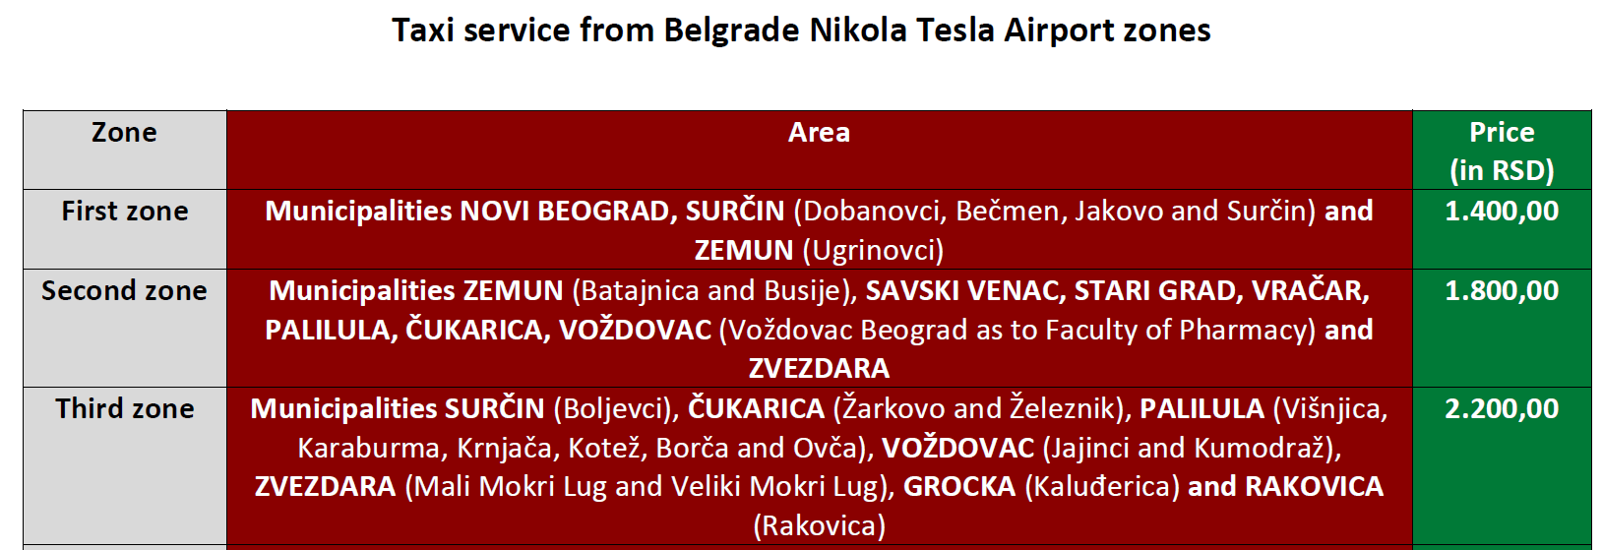

Taxi | Phone number | Web address
Alfa taxi Koja | 19 807
Alo taxi | 19 988; (+381 11) 3564 555
Aurora taxi club | (+381 11) 3699 333
Belgrade business taxi | 19 801; 0800 119 801 | http://www.beogradski-taxi.com/
Belgrade taxi drivers | 19 801; 0800 119 801
Bell | 19 808
Beonaxis | 19 804
Beotaxi | 19 700 | http://ww.radiobeotaxi.co.rs/
BG taxi | 19 800
Blue taxi Čukarica | 19 805; (+381 11) 3555 333; (+381 64) 1555 333
City taxi | (+381 11) 3940 022
Confident taxi Belgrade | 19 898: (+381 60) 9800 | http://www.stbtaxi.com/
Deluxe taxi | 19 944; (+381 11) 3033 123; (+381 65) 3033 123 | http://www.luxtaxi.rs/
Evro gold | 19 806; (+381 65) 5559 806; (+381 65) 3291 818
Evro gold star | 19 806
Inbaco | 19 801; 0800 119 801
Joker | (+381 11) 3970 764
Naj company Čubura | (+381 11) 3977 566
NBA | (+381 11) 3185 777; (+381 60) 3185 777
Pink | 19 803; (+381 65) 4889 977 | http://www.pinktaxi.info/
Super taxi | (+381 64) 9875 257
Taksi taxi | 19 919 | http://www.taksi.rs/
Taxi drivers Novi Beograd | (+381 11) 2698 899
Yellow taxi | 19 802; (+381 65) 9802 000 | http://www.taxi.rs/

Public transport from airport
There is a bus line PTC Belgrade Line 72 Airport to Zeleni Venac (city center).
Line 72 has 31 stations and take 47 minutes.
Ticket price | RSD 89 (if ticket bought in kiosk), RSD 150 (if ticket bought in the bus).  RSD 89 = 0,75 €; RSD 150 = 1,25 €
Timetable from the Airport to Zeleni Venac (city center)

Line 72 time table from AEREODROM NIKOLA TESLA
Hours | Minutes (working days) | Minutes (Saturday) | Minutes (Sunday)
4 | 50 | 50 | 50
5 | 25 | 25 | 25
6 | 00 35 53 | 00 35 53 | 00 35 53
7 | 20 45 | 15 50 | 15 50
8 | 19 37 | 25 | 25
9 | 00 30 | 00 30 | 00 30
10 | 05 40 | 05 40 | 05 40
11 | 15 50 | 15 50 | 15 50
12 | 25 | 25 | 25
13 | 00 36 | 00 36 | 00 36
14 | 12 48 | 12 48 | 12 48
15 | 25 | 25 | 25
16 | 02 39 | 02 39 | 02 39
17 | 16 53 | 16 53 | 16 53
18 | 30 | 30 | 30
19 | 06 41 59 | 06 41 59 | 06 41 59
20 | 17 52 | 17 52 | 17 52
21 | 27 45 | 27 45 | 27 45
22 | 03 41 | 03 41 | 03 41
23 | 20 | 20 | 20
24 | 00 | 00 | 00

